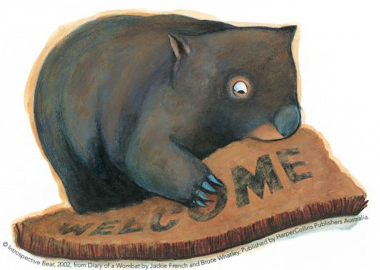

Phonics Activities Week 2

L.O. We are learning to segment the sounds in simple words and blend them together again.

Warm up: Listen to and join in with the Jolly Phonics song https://www.youtube.com/watch?v=W8Jp5MutVlQ and then play ‘I spy the sound’. For example, “I spy with my little eye, something beginning with the sound ch.” Play this with an adult or a sibling and take turns finding objects in the house that match the chosen sound.
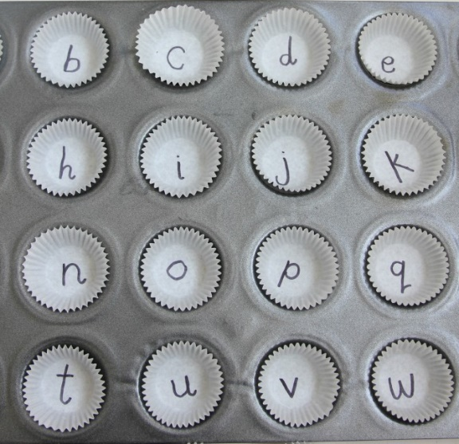

Activity 1: Using cupcake cases or just circles on a large piece of paper, insert different phase 2 and 3 sounds onto the case or in the circle. Find a small object you can use (a pom pom or dice works well) to throw into the cases or onto the circles. When you throw the object into the case you must read aloud the sound it has landed on. Next, think of a word that begins with that sound or a word that includes the sound. Challenge: can you write the word down using your phonic knowledge?

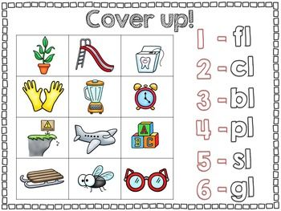
Activity 2: This activity is all about blending. Sometimes when two sounds are next to each other such as ‘b’ and ‘l’ we can blend them together to make ‘bl’. These are not diagraphs because you can still hear both individual sounds. Take a look at the different blends numbered 1-6, can you match them to the correct picture?

Activity 3:

Match the ar words with their pictures:
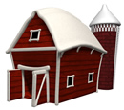 |  | 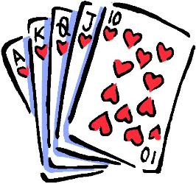
_ _ _ _ | _ _ _ | _ _ _ _ _
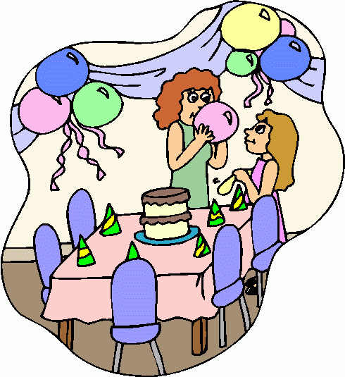 |  | 
_ _ _ _ _ | _ _ _ _ | _ _ _
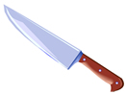 | 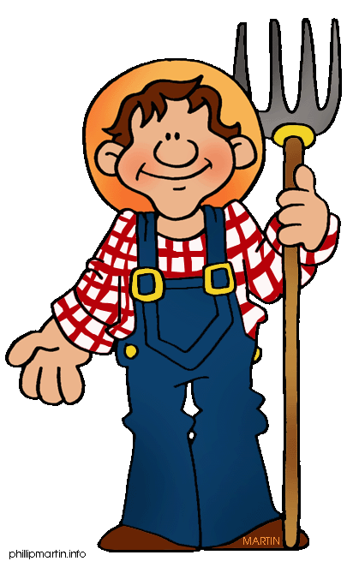 | 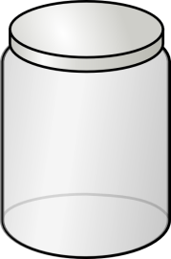
_ _ _ _ _ | _ _ _ _ _ _ | _ _ _

star jar sharp party cards car barn art farmer

Reading Activities Week 2

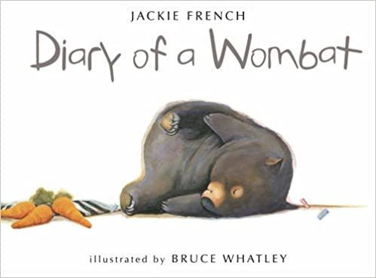

L.O. We are learning to talk confidently about picture books using prediction, asking questions, expressing opinions.

Warm up: Before you read the book take a look at the front cover and think about who the creature is? Where did the creature come from? What do you think he/she likes to do? What do you think the creature is like? Discuss the image on the front cover with your adult and if you would like to, why don’t you draw a large picture of the creature and around the picture write some words that describe who they are!

Activity 1: Listen to or read the whole story https://www.youtube.com/watch?v=7qMMhJ4iiu8. Have a go at re-telling the story to your adult or sibling and then draw out a story map that shows the different events of the story.

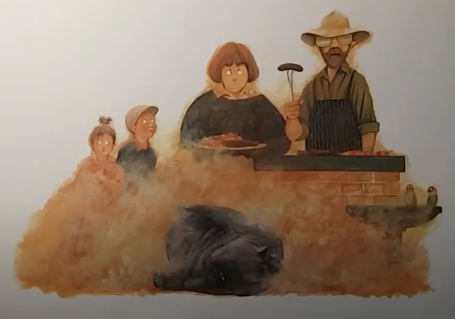

Activity 2: Can you remember where Mothball’s perfect dust bath was? How do you think the family were feeling when Mothball created all that dust right next to their barbecue? Can you think of a better place for Mothball to have his dust bath? Why don’t you draw a picture of a perfect spot that Mothball could have a dust bath?

Activity 3: Listen to the story again. What naughty things does Mothball get up to throughout the week? You could use your storymap to help you remember! If you had a wombat living in your garden what would you say to them? Would you keep feeding them carrots? How would you persuade them to stop digging up your garden? What food do you think Mothball will demand next? Why do you think he wanted to be closer to the humans?

Please keep up the daily reading as much as possible, there are many great books on the Oxford Owl website that are suitable for a range of levels.

My class login Username: saxonreception Password: reception
Writing Activities Week 2

L.O. We are learning to write simple sentences using capital letters and full stops

Warm up: Talk about the title of the book ‘The Diary of a Wombat’ and discuss what the word diary and wombat mean. https://www.youtube.com/watch?v=1-63RDy0CQA&safe=active
https://www.youtube.com/watch?v=F_XdY-XJZfg&safe=active
Watch these videos about wombats and talk about which country they live in. Can you find Australia on a map?

Activity 1: https://www.youtube.com/watch?v=QYNg6voiFXE&safe=active
Write a fact file using the information you have learnt about wombats. Once you have done that maybe you could write a fact file about another animal you would find in Australia?
https://www.youtube.com/watch?v=TkCq54_ho-A&safe=active

Activity 2: A diary is from a person’s point of view and in this case it is the wombat talking. Can you write about your day or an adventure? Maybe you could write a diary entry for each day of your week? There is a template on the next page that you can use.
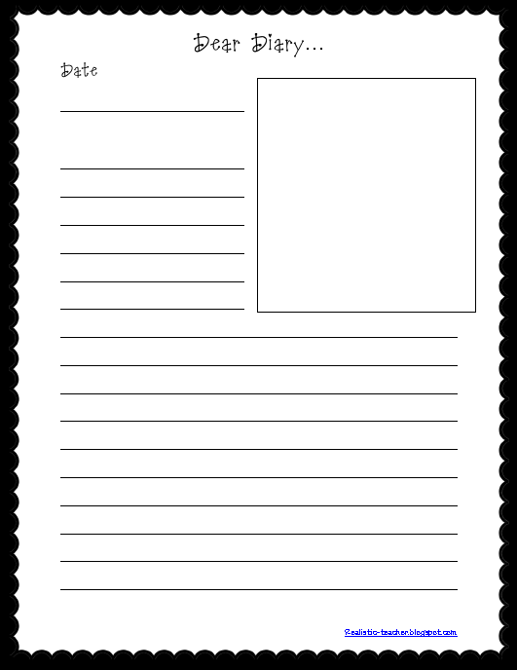

Activity 3: https://www.youtube.com/watch?v=R17lFCTNDw8&safe=active
https://www.youtube.com/watch?v=TkCq54_ho-A&safe=active

Can you find out some interesting facts about Australia? What is the weather like? Are there any beaches? What are some of the special places you can visit there? What food do they like to eat in Australia? What animals live in Australia?

Once you find out some facts can you pretend that you are in Australia? Could you write a postcard to one of your Reception teachers about what you have been up to there?

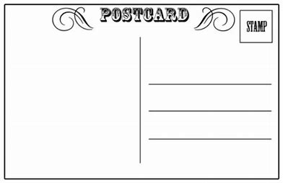

Maths Activities Week 2

L.O. We are learning to name and describe the properties of 2d and 3d shapes

Warm up: Listen to the 2d and 3d shape songs:
https://www.youtube.com/watch?v=pfRuLS-Vnjs&safe=active
https://www.youtube.com/watch?v=2cg-Uc556-Q&safe=active

Activity 1: Go on a shape hunt around your home, in your garden or even on your daily walk. What shapes can you see?

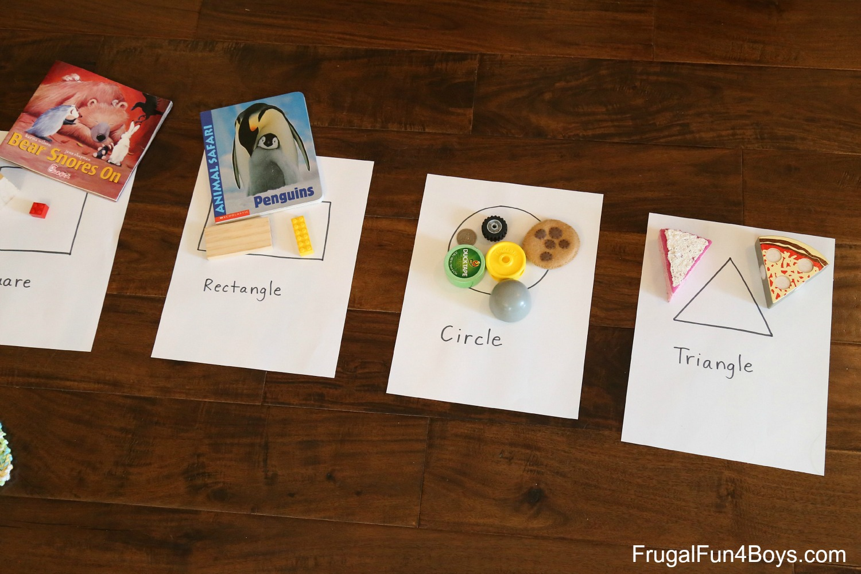
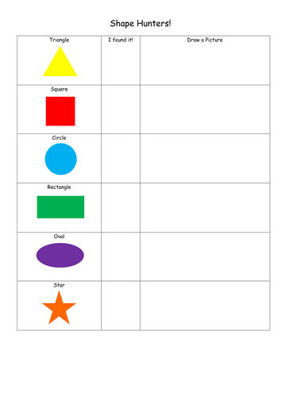

Can you take some pictures of different shapes and send them to us by email?

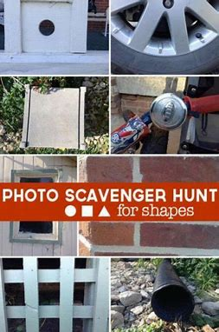

Activity 2: Can you draw/paint or collage some different shape pictures. Can you record how name and how many different shapes you use?

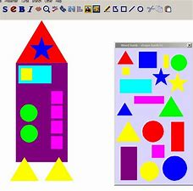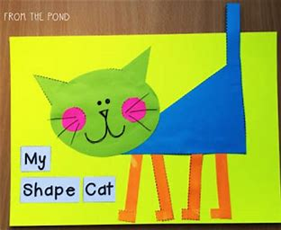

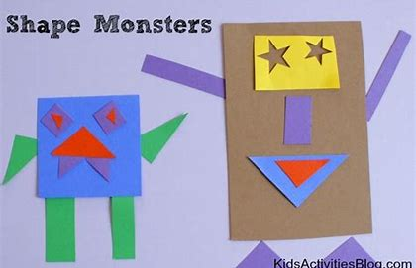

Activity 3: Can you have a go at making some of these 3d shapes? You can use straws or lollipop sticks with playdough or blu tac to stick the corners together.
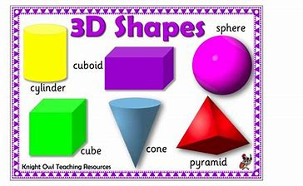

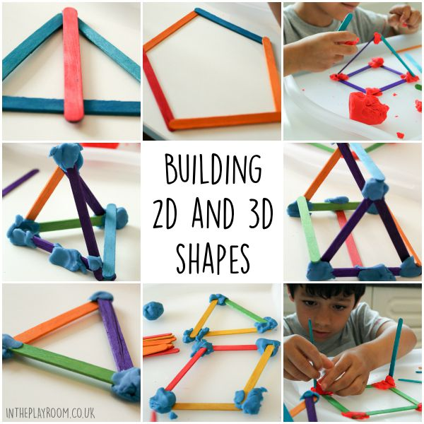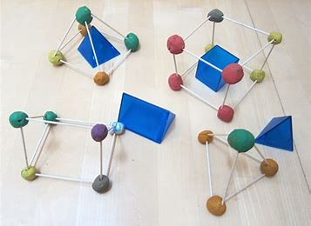

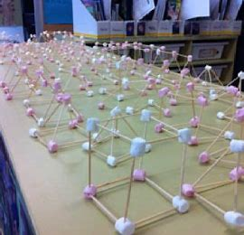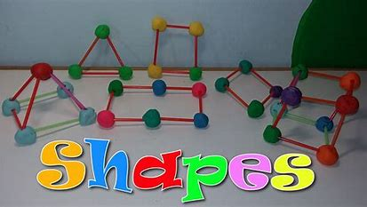

Challenge: Can you describe the properties of these 2d and 3d shapes?
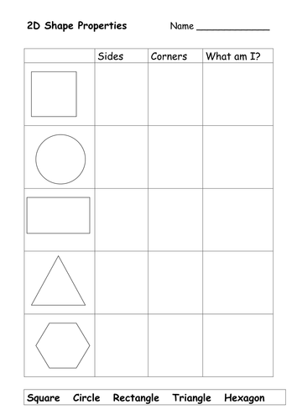

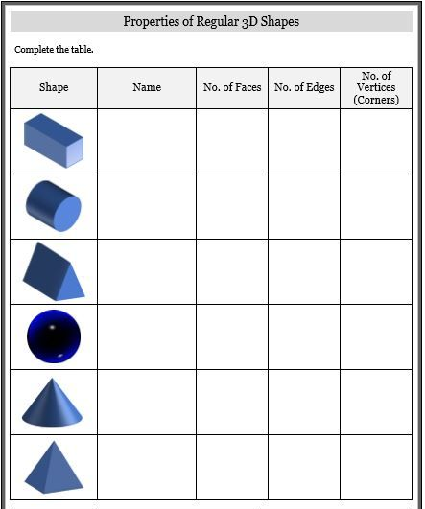

Project Week 2

Aboriginal Boomerang Craft

L.O. To be able to use what they have learnt about media and materials in original ways, thinking about uses and purposes.

Australia is very much known for the boomerang. These were originally used by the Aborigines as a hunting weapon because of their shape. It revolves at speeds that one cannot see when thrown.
Today, boomerangs are mostly used for sport or as artwork. It is quite common to see hand painted boomerangs in Australia today, such as this one:
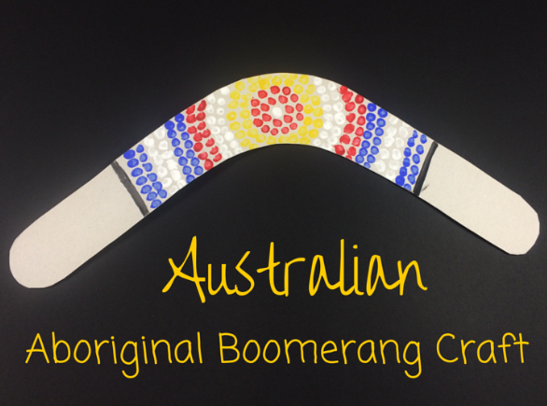
This week we would like you to make an Aboriginal Boomerang.

What you need for this Aboriginal Boomerang Craft:
- Cereal box or any cardboard with a large flat surface
- Scissors
- Pencil
- Cotton buds
- Paint
First ask an adult to draw the shape of the boomerang on an empty cereal box, then cut it out.
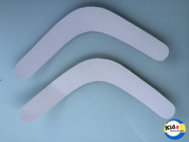
You are now ready to paint and design. Simply dip a cotton bud into some paint. Then create patterns on the boomerang just by putting dots of paint. Try and create circular patterns as inspired by the Aboriginal artwork featured above.

