Maths Week Two.
This week your Maths learning videos are on the White Rose Website and the learning sheets are below. The learning sheets can be accessed through the BBC Bitesize if you would like to download them directly. There will be three different sessions - see how many you can do! The learning all links to BBC’s Daily lessons for 24th May and 1st and 2nd June.
Session 1.
Warm up | Our focus this week is measure. It is still important to keep practising our counting. Make sure you are pronouncing ty and teen numbers correctly.  https://www.youtube.com/watch?v=e0dJWfQHF8Y
Main activity | Go to the White Rose Maths website.  https://whiterosemaths.com/homelearning/year-1/  Select lesson Summer Term Week 5 Lesson 4. ‘Introduce Weight and Mass’.  Watch the video and join in with the activities it asks you to do.  Complete the learning sheet below or you can download it here.  https://www.bbc.co.uk/bitesize/articles/z428wty  There are also extra activities on BBC Bitesize lesson 21st May, if you would like to do those too!  ‘Compare mass: lighter or heavier’
Game | For today’s game, you are going to practise your place value, number sense. Can you order the numbers from smallest to largest?  http://www.snappymaths.com/counting/counting2/interactive/countto100ord/countto100ord.htm
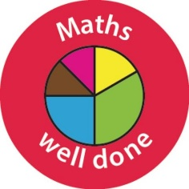 Well done Year One!

Help sheet:
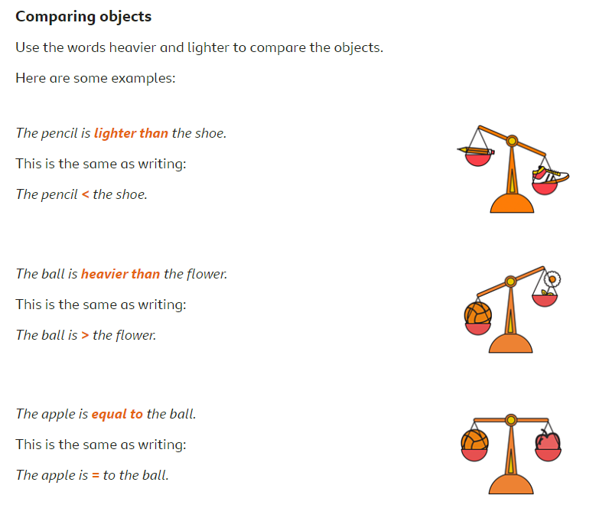

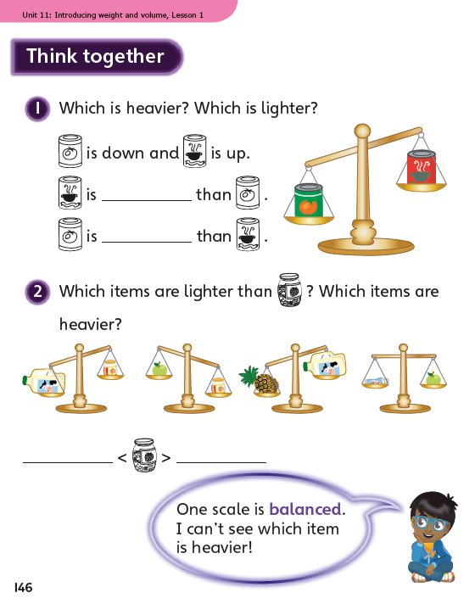

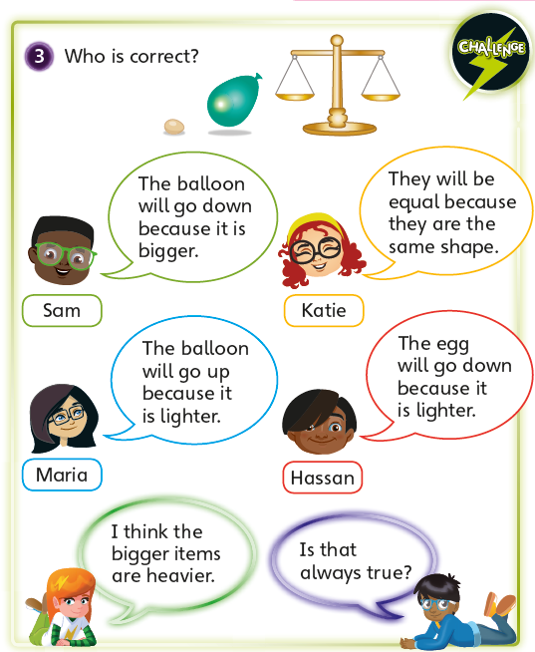

Session 2.
Warm up | Our focus this week is measure. It is still important to keep practising our counting. Make sure you are pronouncing ty and teen numbers correctly.  https://www.youtube.com/watch?v=yTeUqWGCKjA
Main activity | Go to the White Rose Maths website. https://whiterosemaths.com/homelearning/year-1/  Select lesson Summer Term Week 2. Lesson 1 ‘Measure Mass’.  Watch and join in with the video, then complete the learning sheet below.  You can download the learning sheet and do extra activities here on the BBC Website (Lesson 1st June).  https://www.bbc.co.uk/bitesize/articles/zdtq2sg
Game | Practise your days of the week knowledge. This is how we measure time passing. In days, months and years.  https://www.roythezebra.com/reading-games/high-frequency-words-days.html

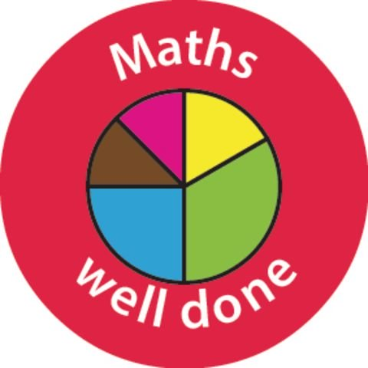

Question and prompt cards for adults.
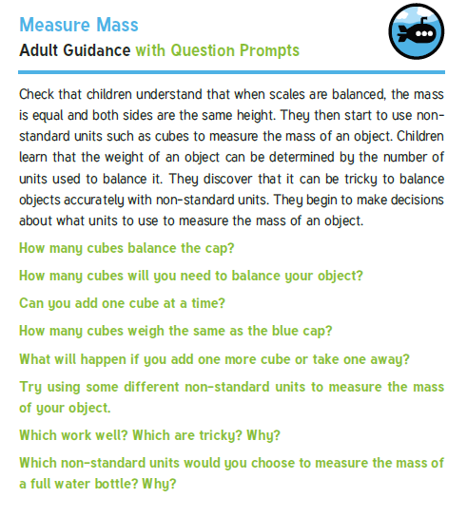
Sheet 1.

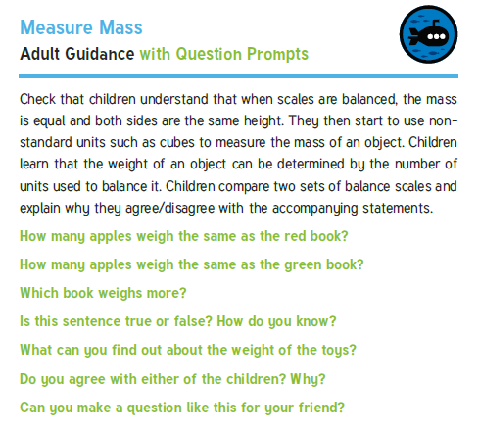
Sheet 2.

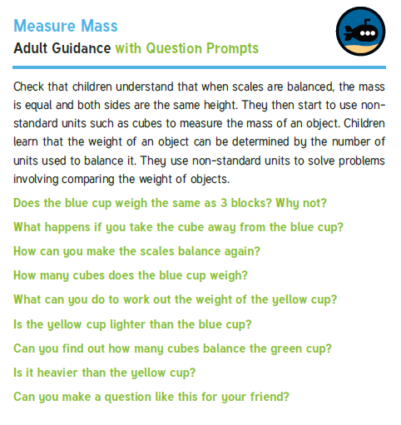
Sheet 3:

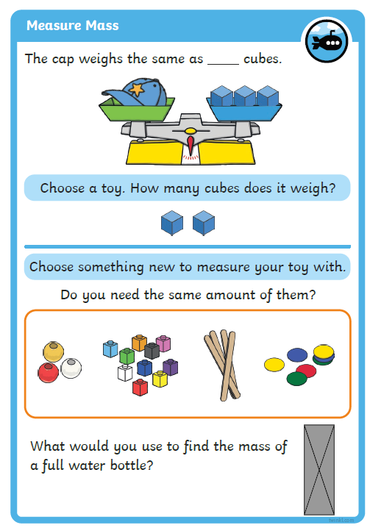
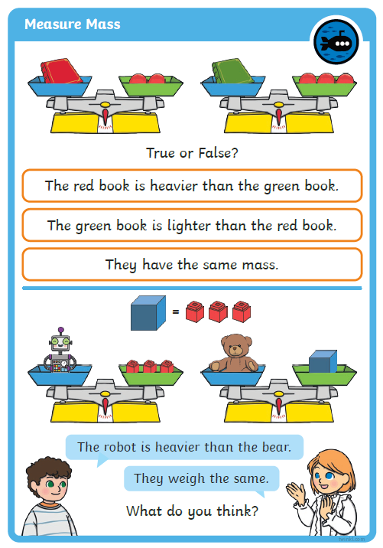
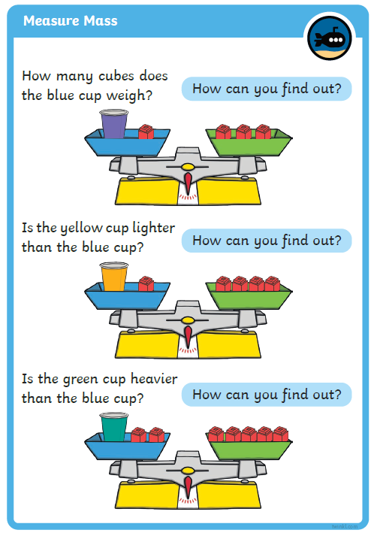
Session 3.
Warm up | Our focus this week is measure. It is still important to keep practising our counting. Make sure you are pronouncing ty and teen numbers correctly.  https://www.youtube.com/watch?v=3txltaYkTyE
Main activity | Go to the White Rose maths website: Week 2 lesson 2. ‘Compare Mass’.  https://whiterosemaths.com/homelearning/year-1/  On BBC Bitesize, lesson 2nd June. You can download the learning sheets here too.  https://www.bbc.co.uk/bitesize/articles/zmytpg8
Game | Practise the time using the game. Choose to either tell the time to the hour, half hour or challenge yourself to see if you can tell the time to the quarter hour.  https://mathsframe.co.uk/en/resources/resource/116/telling-the-time

Well done Year One! You have done so well this week.



