Map of Shepperton
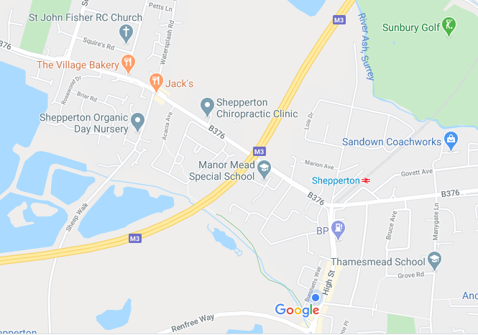

Places I like to visit in my local area
My local area is ____________________________________

