LO: We are learning to multiply and divide by 10, 100 and 1000

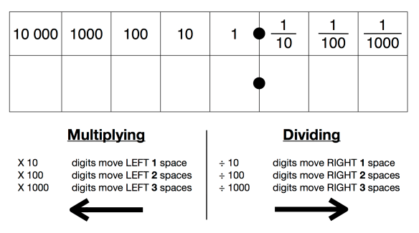
Top Tips
- Read the number carefully
- Choose a method: mental or written
- Written method: Draw a place value grid
- Digits move left for multiply
- Digits move right for divide
- Remember to use 0 as a place holder
- Double check you have included a decimal point in the right place

Mathematical Talk

Discuss these questions with someone at home and/or record your written answers.

Multiplying by 10, 100, 1000 Dividing by 10, 100, 1000

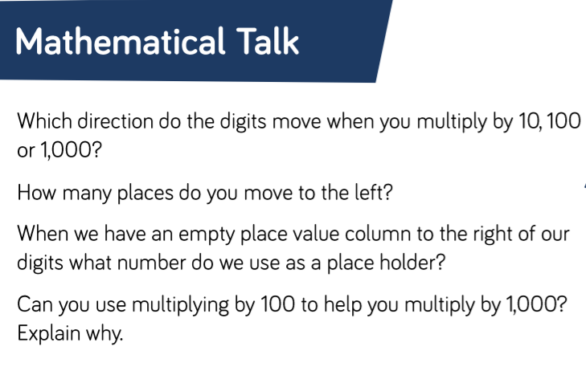
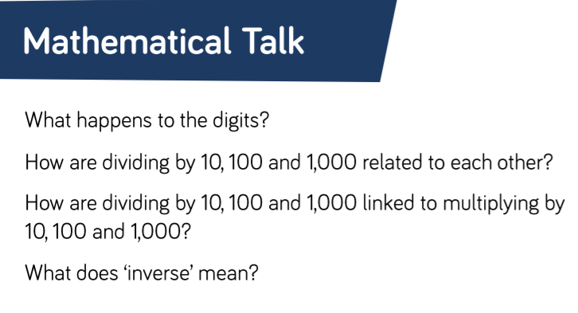

Varied Fluency
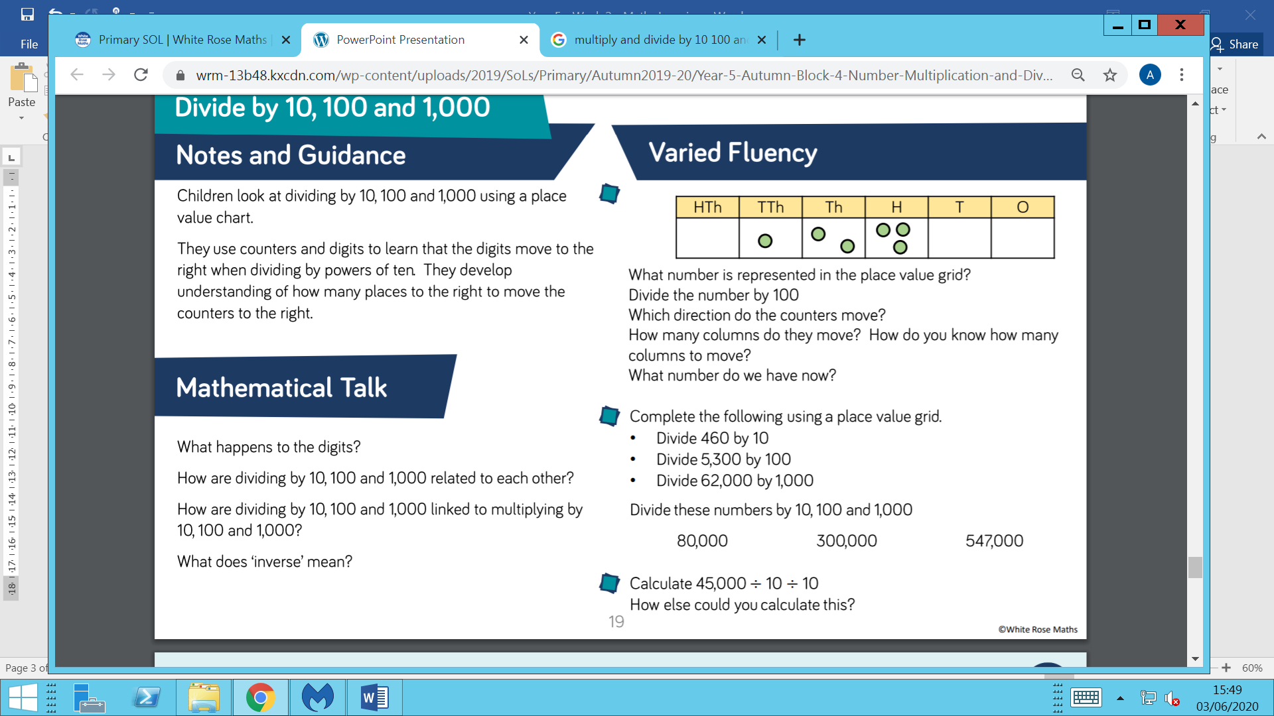

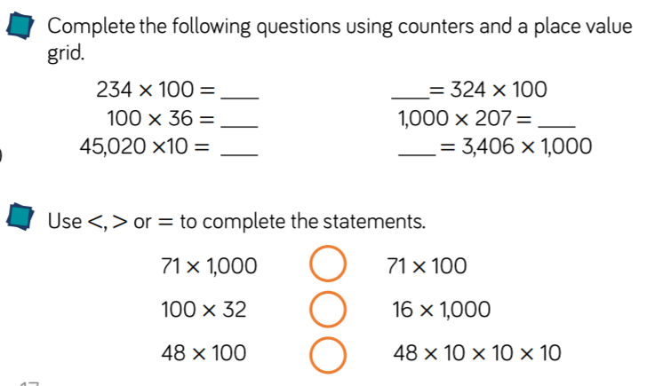

Reasoning and Problem Solving
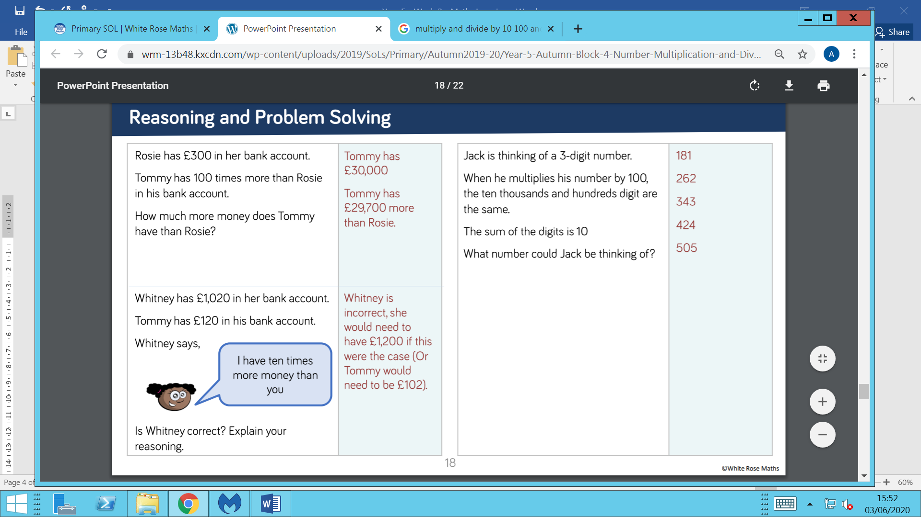

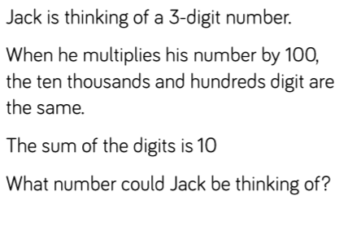
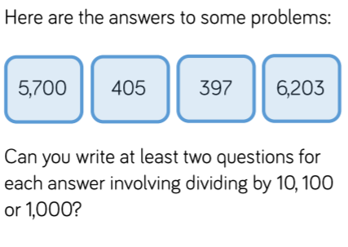

Challenge Questions


