Read Write Inc. Spelling 4
Unit 3: Adding the prefix auto-

President Alpha Welcome, Earthlings! You are about to enter the Spelling Zone.
Our Star Speller for today is… Mu!

Mu What a week I’ve had! I was doing a bit of time travelling and ended up in the year 1969.
That was the year that Neil Armstrong became the very first human to walk on the moon. He is a hero of mine. Well, guess what? I managed to meet him and he gave me a photo and his autograph. Let me show you.
I was so excited I had to put the Spelling Shuttle on autopilot to get me back to the future.

Anyway, here I am again in the present for now. I think we should look a bit more closely at a prefix I have already used twice today...
autograph autopilot

Can you spot the prefix? Turn to your partner.
Now tell me. After three: one, two, three… Go!
Yes. The prefix is -a-u-t-o, auto. Let’s find out a bit more about auto-.

Auto means ‘self’ or ‘own’. It can be added to the front of some root words.

Let's do My turn/Your turn to say these words. I'll say them first, then you say them.
biography
graph
pilot

We can just add the prefix auto- to these root woods. There is no need to swap, double or drop any letters. Now let’s do My turn/Your turn again:
autobiography
autograph
autopilot

Did you know that the word ‘graph’ is to do with symbols, diagrams or writing? An autobiography is a piece of writing about the writer’s own life, and an autograph is a piece of writing which is the writer’s own signature.

Here are some more words with the prefix auto-. Let’s see the words matched to the meanings.

definition | word with prefix auto-
something that works by itself, without anyone controlling it | automatic
an American word meaning ‘car’ | automobile
a screen that shows a presenter’s or actor’s script | autocue

Well, it’s time for me to sign out now, Earthlings. I’ll leave you with my autograph.

President Alpha You are about to leave the Spelling Zone. Take your new spelling knowledge with you. Goodbye, Earthlings…

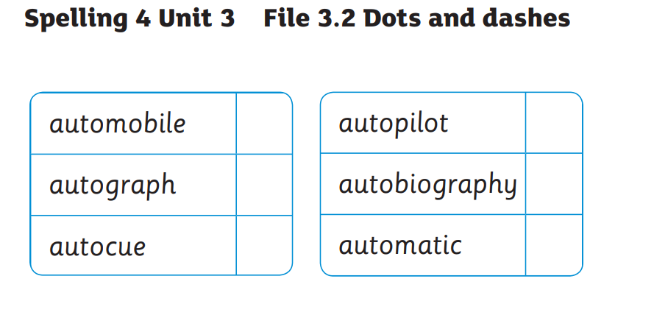

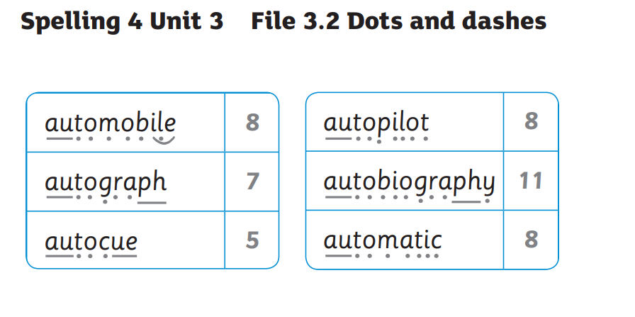

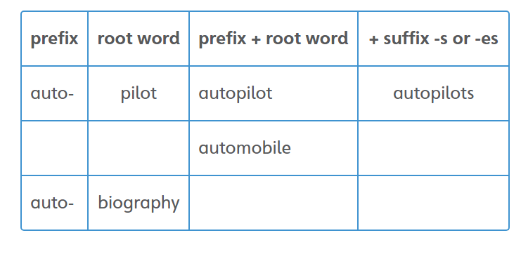

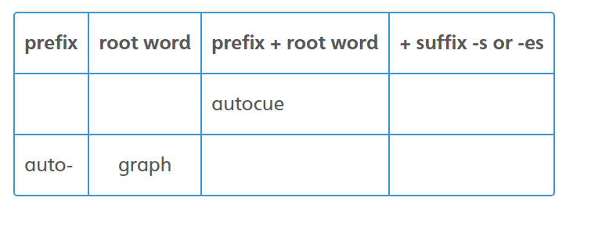

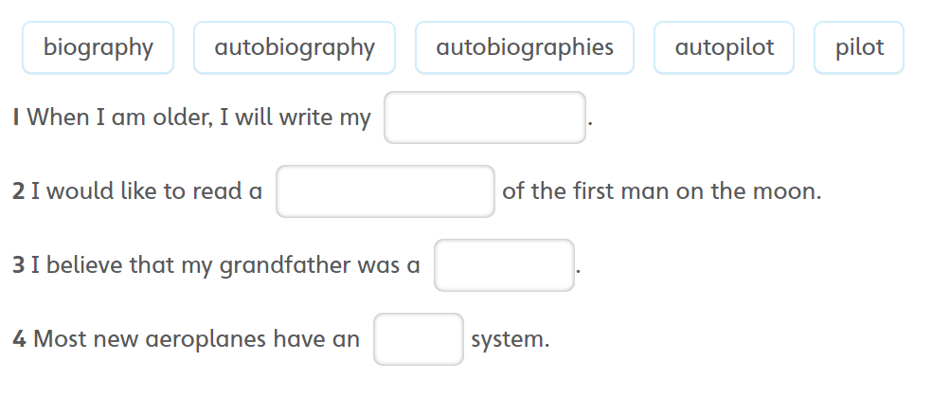

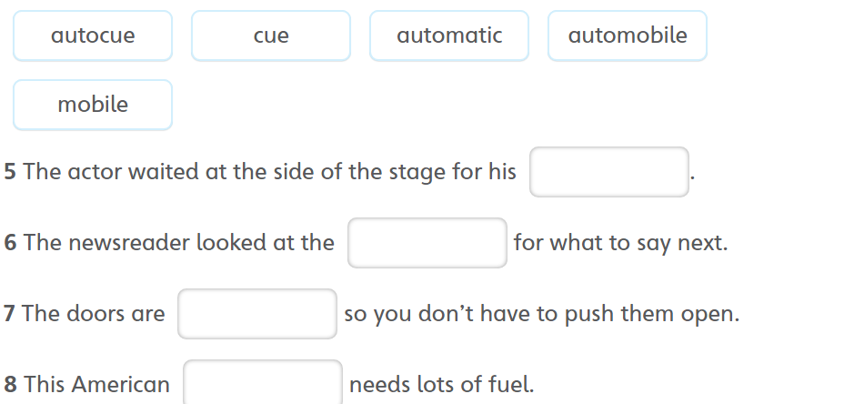

Look, Say, Cover, Write and Check!
Tick the columns as you follow the instructions from left to right. Make sure you spell the words in the ‘write’ column. If you spell the word incorrectly, write it again in the 'correction' column.
 | Look | Say | Cover | Write | Check | Correction
autograph
automatic
autofocus
autocorrect
autonomy

Cursive Handwriting Practice
Practise your weekly spelling words using cursive handwriting.
autograph autobiography automatic
autofocus autocorrect
autopilot
autorotate automobile
autonomy

