Writing task 1:

LO: We are learning to use a range of cohesive devices in our writing.

How to Play Your Favourite Game

This week you have been asked to make a book of instructions, to explain how to play your favourite game. These might be games you play at home or school. It could be a game you enjoy playing with your friends or your family. Try to use a range of cohesive devices to add clarity for the reader.

(examples of cohesive devices are below)

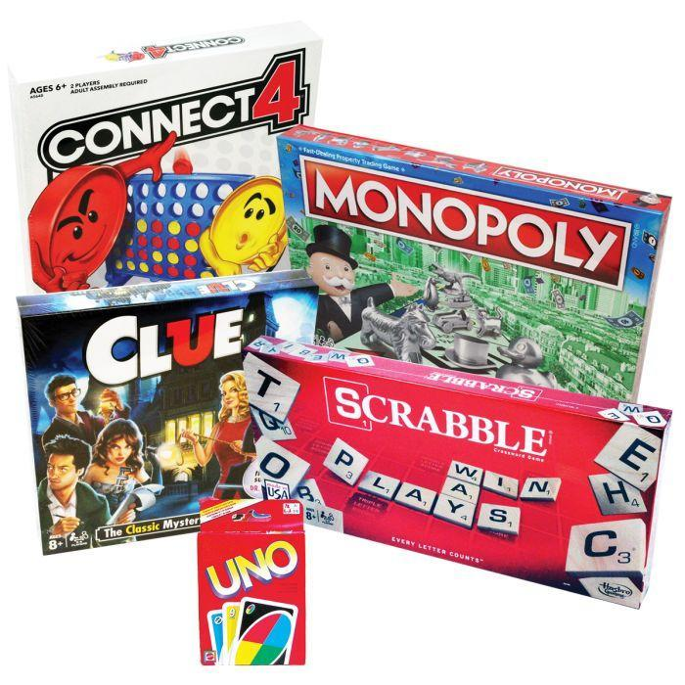
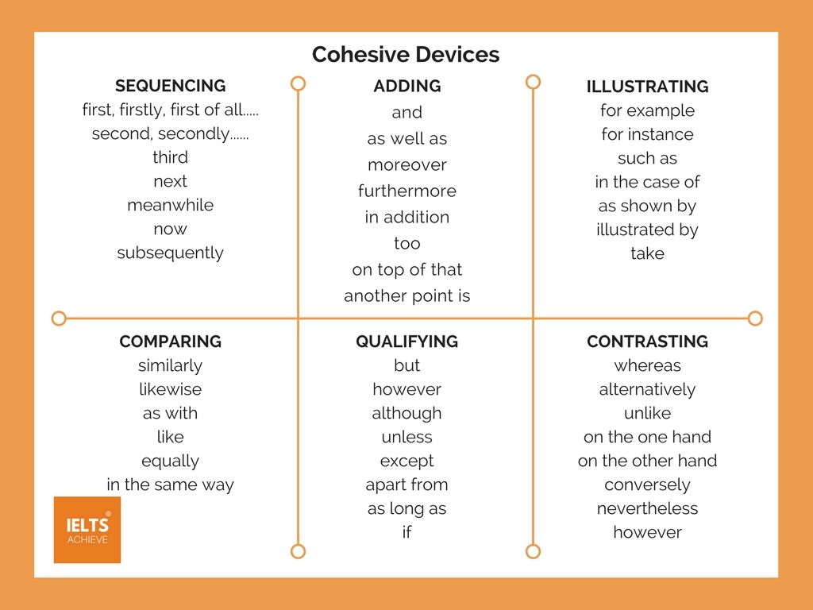

Task
Your task is to write a set of exact instructions to explain how to play your favourite game. Remember, the person who will be reading your instructions may never have played this game before.

Planning ideas:

Title of the game, equipment needed, aim of the game, step-by-step details.

Writing task 2:

LO: We are learning to use a range of cohesive devices in our writing.

Task: This week the theme of your project learning is Sikhism. For this piece of writing, we would like you to research a guru of your choice and create a fact file, presentation or poster.

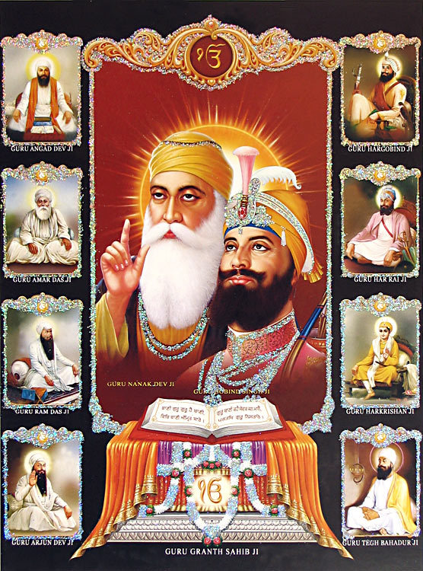
Questions you could answer in your learning:
Why are they important to Sikhs?
What is a guru?
When were they born?
What did they achieve?
How are they remembered?
Where were they born?
Who were their family?
What did they believe?

* Remember to use a range of cohesive devices to make your writing flow and to ensure it is clear for the reader.

Writing task 3:

LO: We are learning to use a range of cohesive devices in our writing.

Task: Create your own adventure story using one of the photos provided. Try planning the themes of the paragraphs using the story mountain on the next page. Remember to use a range of cohesive devices to add clarity for the reader.


