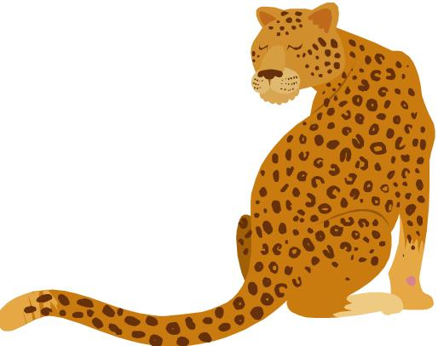

Phonics Activities Week 3

L.O. We are learning to segment the sounds in simple words and blend them together again.

Warm up: Watch alphablocks and join in practising letter blends
https://www.youtube.com/watch?v=BxtUFEFkSas

Activity 1: For this activity you need a ball and you will practice more L – blend words. You can practise inside or outside by tossing the ball up in the air for each sound in the word. Here is a list of words for you to practise segmenting and blending, slip, slim, plan, glass, flap, plot, slim etc.

Activity 2: Race Car Blending. For this activity you need to find a toy car and drive over the letters slowly while saying the sounds. After practising, you can speed up so that the word is blended at a normal speed. Just remember you need to write the sounds first before beginning the activity.

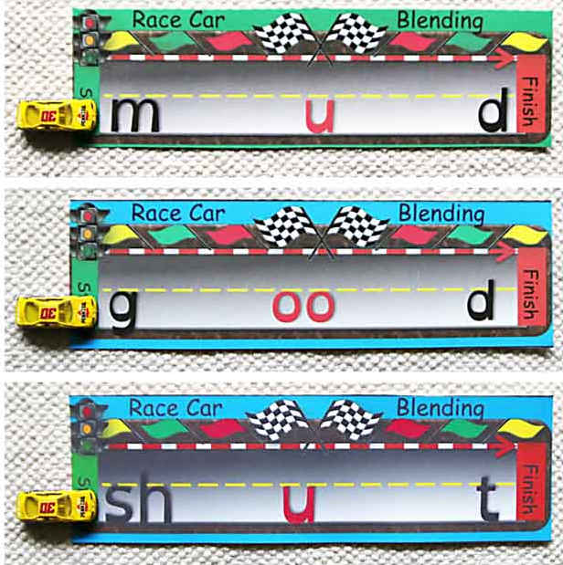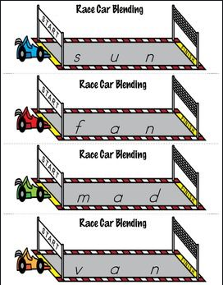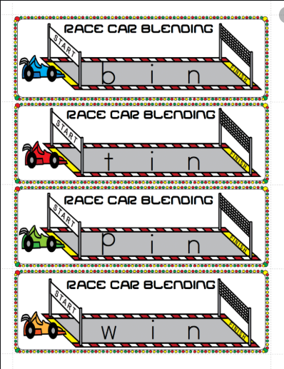
Activity 3:
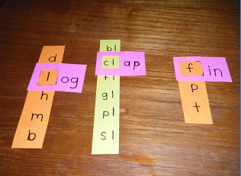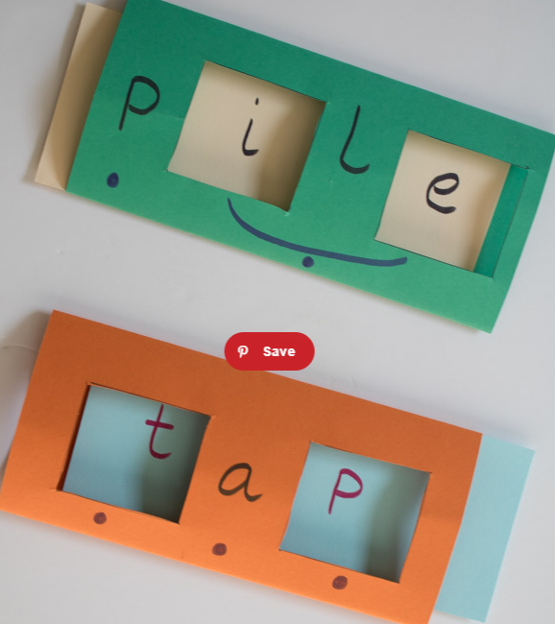
Try this fun, engaging sliding word card activity that can be used for an infinite number of graphemes and spelling patterns. The best part is you can use and practise by yourself!
You will need: felt pen, coloured card (at least two contrasting colours) and scissors.
- Fold a piece of card into 3 equal parts.
- Cut a different colour piece of card to fit inside the folded card.
- Cut out rectangles for the letters that will be changing.
- On the folded card, write the letters you wish to remain the same.
- On the card inside, write your needed letters or letter, slide the card along until the letter is gone and write the next letter. Repeat until the card is full.
- You are ready to get reading!

Reading Activities Week 3

L.O. We are learning to talk confidently about picture books using prediction, asking questions, expressing opinions.

Warm up: Before you read/listen to the story, look at the cover and think about what is going to happen in the story.
Do you think it is going to be a happy or sad ending?
Read the full story. What type of book is this?
What do you think it is about?
Do you think you will enjoy this story? why?
What characters do you think you will see in the story?
If there is a leopard, who else might we see in the story?
Where do you think the story is set?
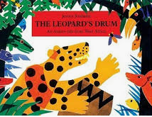

Activity 1: Listen to or read the story. Stop halfway through the story and predict what might happen https://www.youtube.com/watch?v=RfRozk7Fl0o . Have a go at re-telling the story to your adult or sibling. Discuss the characters in the story and any descriptive words used to describe them.
Which animal is going to get the drum? Why? Reassure the children that this is just a guess and there isn’t a right answer. Finish the story and talk about the ending. Were you surprised by the ending?
What characters were in the story? Think about the character of the tortoise. How clever do you think the tortoise was? Draw a line and decide where you would place the tortoise and why.

Not at all clever Very clever

Activity 2: Re-read the story and think about the characters from the story as you go through. Tell your adult or sibling your favourite character and why you have chosen that animal. Talk about the names of the various characters and look around the house if you can find any. Think what you would choose as a reward from Nyame for getting the drum. What do you think happened to Osebo with her tough new shell? Does this story remind you of any other stories that you know? (Other African trickster tales, stories with a tortoise as a character). You might remember a tale from CBeebies Tinga Tinga Tales, which is based on African animal stories and trickster tales. You can watch it again and talk about the different animals and try and describe their characters. https://www.bbc.co.uk/iplayer/episodes/b00wg01c/tinga-tinga-tales

Activity 3: Research with your adult books about Ghana and animals that you might find in West African rainforests or read an animal poem each. With adults’ help, use the computer or map to find where the story is from and find Ghana. Some children in our school come from this part of Africa. Read the story again and chat about your likes, dislikes, puzzles and connections. You can draw pictures of the things you found out.

Please keep up the daily reading as much as possible, there are many great books on the Oxford Owl website that are sutiable for a range of levels, check the Saxon website for the username and password.
Username: saxonreception Password: reception

Writing Activities Week 3

L.O.

Warm up: Listen to this musician playing the drum. https://www.youtube.com/watch?v=OrgkYn8_aCI
This Ghanaian musician is playing the drums, what comes into your minds when you listen to the music? What does it sound like? How does it make you feel? Discuss with your adult or your sibling what you thought of the drumming. Did it make you think of a particular animal? Did you enjoy listening to it?

Activity 1: Colour in the drum below. Around the drum write words and phrases that you thought of when you listened to the Ghanaian musician playing the drum.



Activity 2: Take a look at the front cover of the story ‘The Leopard’s Drum’. What animals can you see? You can find all of these animals in West Africa which is where the story is set. Are there any animals that you recognise? Do you have a favourite animal you can see on the front cover?
Have a go at writing a sentence (or two) about the animals you can see on the front cover of the book. You can use this sentence opener to help: I can see a…
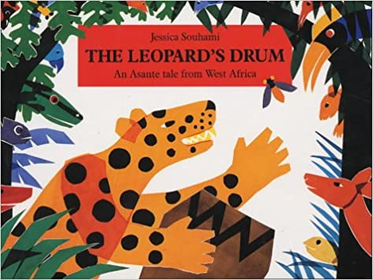

Activity 3: Imagine you are the turtle and you have just taken the drum from the Leopard and given it to Nyame. What would you choose to be your reward? Can you write a sentence telling your teacher what you would like to be rewarded with?

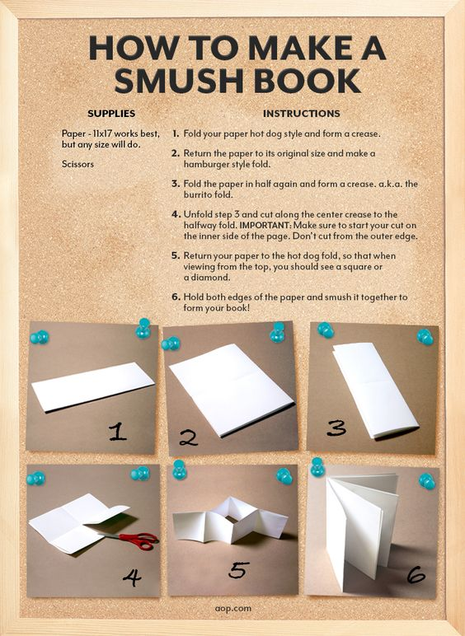

Challenge: Using one of the other characters in the story, have a go at writing a mini story about them. It could be about an adventure they go on in the jungle or maybe they have to retrieve a different musical instrument. If you would like to make a folding book again for your story the instructions are on the right. We can’t wait to hear what imaginative ideas you come up with!

Maths Activities Week 3

L.O. We are learning to use everyday language related to time.

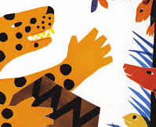
Warm up: Can you count how many spots the leopard below has on his body? Write the number next to the leopard.

As this week is sports week, we are going to practise measuring and timing different sporting activities!

Activity 1: For this first activity, you are going to need to ask someone to help you - either an adult or your sibling. Begin by hopping on one foot, see if you can complete 10 hops. If that is to easy see if you can complete 20 hops. Ask your partner to have a go too. Are you faster or slower than your partner? Record your answer in the table below!

 | Name: | Name:
10 hops | Faster or slower? | Faster or slower?
20 hops
30 hops

Activity 2: For this activity, you will need to be outside either in your garden or local park. First of all set up a start line, you could use a piece of rope for this, a jumper or just a stick you can find! This is where you must be standing for this activity. Using a ball or beanbag, see how far you can throw it. To measure the distance, you are going to count the number of steps from the start line to where your ball or beanbag landed. Ask a friend, sibling or adult to have a go to and see who can throw the ball furthest!

Activity 3: For this final activity you again will need to be outside. Using the same start ask an adult to count 20 large steps forward, where they stop will be your finish line!
Gather your family to take part in this activity! Each person will need to run as fast as they can from the start line to the finish line. Your job is to count how long it takes for each person to run the same distance. When you are counting time it is important that you count steadily e.g. try not to speed up or slow down. To make sure you are counting the whole second some people find it helpful to count in elephants! Have a look at this video before you begin the activity in order to practice your timing.
https://www.bbc.co.uk/teach/class-clips-video/maths-ks1-ks2-how-long-is-a-second/z7fxpg8

Below is a table you can use to record everyone’s time.
Why don’t you see if you or any of your family can beat your times?

 | Round 1 (record seconds taken) | Round 2 | Round 3
Name:

Name:
Name:
Name:
Name:



Project Week 3

As you may have been aware, Sports Day was due to take place this week. Whilst this cannot take place in the usual way, we are still very keen to ensure the children still have opportunities to take part in sports activities throughout the week and most importantly to have fun and feel part of a team. Mr Howick and our SSA have been very busy planning a range of activities and events to take place throughout the week, including the following:

1. Daily diet and fitness challenges: choose one diet challenge and one fitness challenge for each day. You will find lots of ideas in the menu e.g. Day 1, 100 squats and 2L of water etc. See pages 2-3 of the attached document.

2. House km Competition supported by the SSA’s Summer Family Fun Run: We will be using this event as an opportunity to hold a House Competition – a significant part of our usual Sports Day and something that the children love to be involved in. In addition to this, the SSA have organised a fantastic fundraiser event – please see their flyer below for more details. Children can send their total weekly distance (bikes, running, walking, scooters etc) with the name of their house (Roman, Tudor, Celtic Victorian). We will then total up the scores from each house; the house that has travelled the furthest distance wins. See pages 4-5 of the attached document for further details.

3. Home/Park Sports Day: tailored sports day activities you can complete in your garden or at home. Please see links to instructional videos, a scoring system, description of activities and a scoring chart on pages 6-12 of the attached document.

4. Healthy Selfie: A picture of the children in action either cooking healthy meals or mid exercise. Please see page 13 of the attached document.

Further information is provided in the attached document marked ‘Sports Week

