Focus: to identify and use the ‘i-e’ split digraph sound.
Write in the words to the pictures below and then complete
the sentences by filling in the gaps.
  __ __ __ __ |   __ __ __ __ |   __ __ __ __
  __ __ __ __ |   __ __ __ __ | 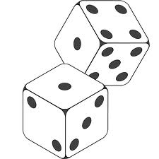  __ __ __ __
  __ __ __ __ __ |   __ __ __ __ __ |   __ __ __ __ __ __
  __ __ __ __ |   __ __ __ __ |   __ __ __ __ __
  __ __ __ __ __ |   __ __ __ __ __ | 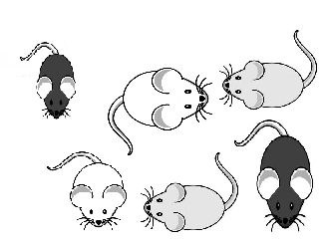  __ __ __ __

Focus: to identify and use the ‘i-e’ split digraph sound.
- I must wear my helmet and my knee pads if I want to ride my _____________ to school.
- My sister has a red and blue _____________ that flies high in the sky.
- The postman said my dog likes to ____________ him when he tries to deliver letters. I can’t believe my dog would ever __________anyone!
- My favourite game is ____________ and seek. Your friend covers their eyes and then you run and __________.
- There is a leak coming from under the bathroom sink. I think it must be coming from a ___________________.
- To play snakes and ladders you must first roll the ___________ to see how many spaces you should move.
- One day, when I get married, I am going to be a _____________ and wear a veil and hold a bunch of flowers.
- You should be careful to find some shade if the sun ___________ brightly as you may get sunburn.
- A zebra is a beautiful creature with black and white ___________.
- Tomorrow is my birthday! I am very excited as I will be ___________ years old and I will have ___________ candles.
- My friends and I are going swimming, we are learning how to _________ from the side of the swimming pool.
- We are going on holiday tomorrow, my mummy will ____________ us all in the car. In France people _________ on the other side of the road.
- You must be careful not to cut your finger when you are using a ____________.
- You must ____________ when you are having your photo taken.
- A mouse likes to eat cheese. When there are lots of these animals we call them ______________.

Extension
Complete the following words using the split diagraph i-e

L __ k __ r __ d __ f__ v __

m __ n __ t __ m __ pr __ z __

tw __ c __ w __ d __ outs__d__
Now can you use these words in a sentence?
_________________________________________________
_________________________________________________
_________________________________________________
_________________________________________________
_________________________________________________
_________________________________________________
_____________________________________________________________________________________________________
_________________________________________________
_________________________________________________
_________________________________________________
_________________________________________________
_________________________________________________
_________________________________________________
_________________________________________________
_________________________________________________
_________________________________________________


