Maths Week Three.
This week your Maths learning videos are on the White Rose Website and the learning sheets are below. The learning sheets can be accessed through the BBC Bitesize if you would like to download them directly. The first two sessions of learning link to BBC’s Daily lessons for 3rd and 4th June.
This week’s third session is linked to our Sports Week learning enjoy!
Session 1.
Warm up | Our focus this week is measure. It is still important to keep practising our counting. Make sure you are pronouncing ‘ty’ and ‘teen’ numbers correctly.  https://www.youtube.com/watch?v=e0dJWfQHF8Y
Main activity | Go to the White Rose Maths website.  https://whiterosemaths.com/homelearning/year-1/  Select lesson Summer Term Week 6 Lesson 3. ‘Introduce Capacity and Volume.  Watch the video and join in with the activities it asks you to do.  Complete the learning sheet below.  There are also extra activities/videos on BBC Bitesize lesson 3rd June, if you would like to do those too!  https://www.bbc.co.uk/bitesize/articles/zkrf382
Game | Have a jumping competition with someone in your family. Who can jump the furthest? See if you can use non-standard units of measure to measure your jumps. (a non-standard unit can be anything you like eg your hand, foot, pencils, books….etc)
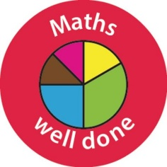 Well done Year One!

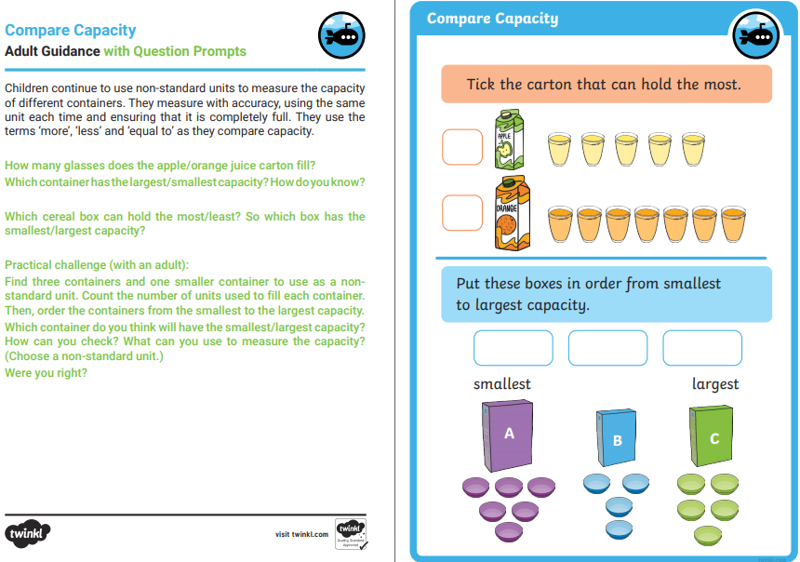
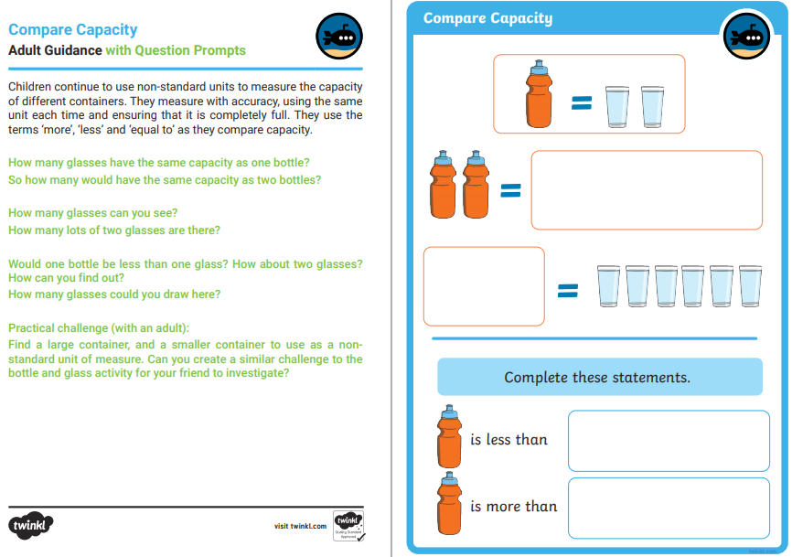

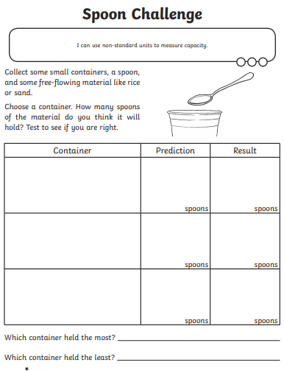

Session 2.
Warm up | Our focus this week is measure. It is still important to keep practising our counting. Make sure you are pronouncing ‘ty’ and ‘teen’ numbers correctly.  https://www.youtube.com/watch?v=yTeUqWGCKjA
Main activity | Go to the White Rose Maths website. https://whiterosemaths.com/homelearning/year-1/  Select lesson Summer Term Week 6. Lesson 4 ‘Measure Capacity’.  Watch and join in with the video, then have a go at some of the challenge cards below.  You can download the learning sheet and do extra activities on a farm here on the BBC Website (Lesson 4th June).  https://www.bbc.co.uk/bitesize/articles/zhgsy9q
Game | Guess one minute!  In this game you and one member of your household both need to see who can count 60 seconds and say ‘stop’ when you think a minute has passed. You can use a timer on a phone or the second hand on a watch and say when to start. The person who guessed closest to how long a minute is with their eyes closed is the winner! It’s harder than you think.

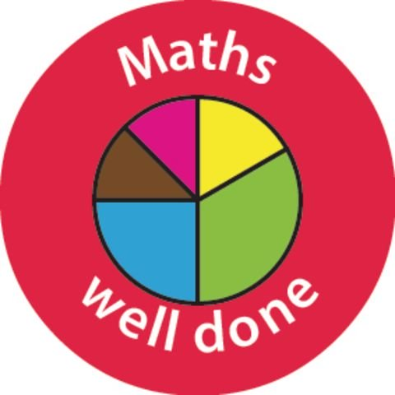

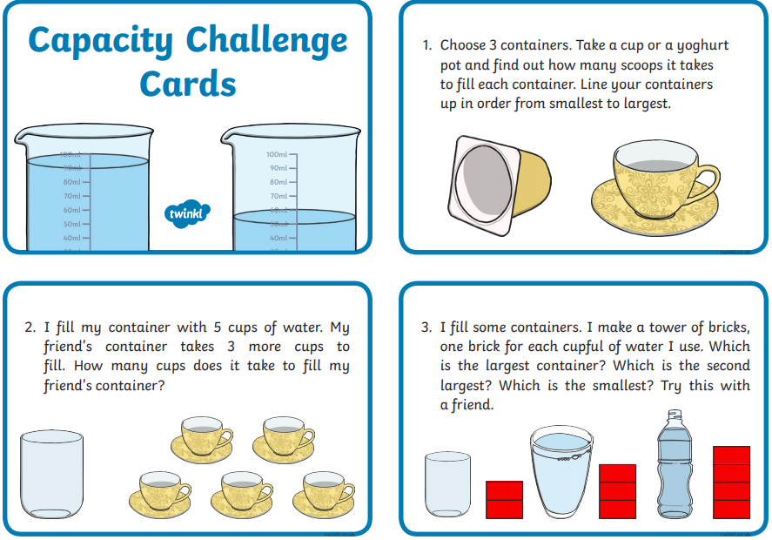
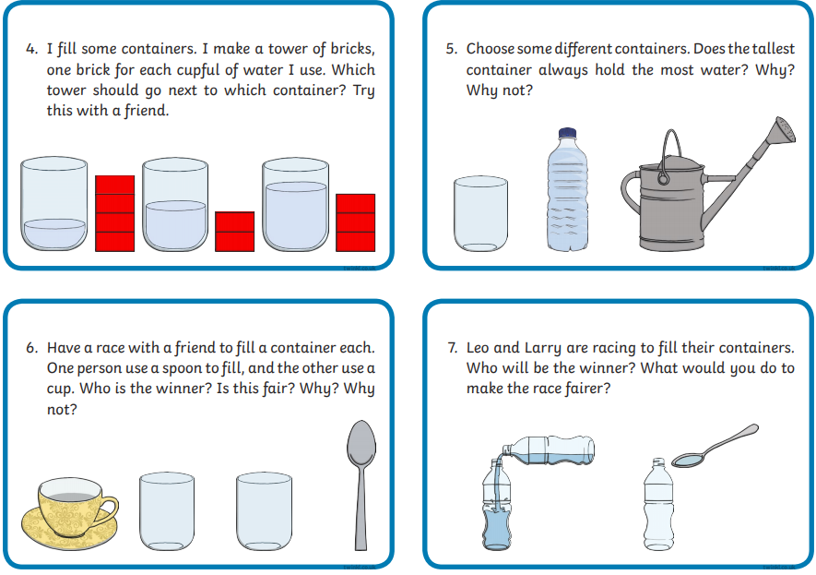

Session 3. – Sports Week Maths
Warm up | Our focus this week is measure. It is still important to keep practising our counting. Make sure you are pronouncing ‘ty’ and ‘teen’ numbers correctly.  https://www.youtube.com/watch?v=umCltEyu0rA
Main activity | Read The Animal Sports Day and answer the questions. (An adult can help you to read it together). You need to explain your answers too! This activity helps us to think about how important language is in our maths learning!  The Animals' Sports Day  One day, five small animals in my garden decided to have a sports day.  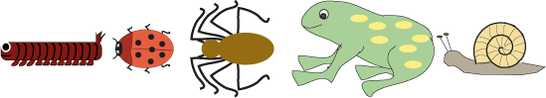  They were a large, sleepy caterpillar, a busy little ladybug, a long-legged spider, a small, jumpy frog and a slow, slimy snail.  They decided to have a swimming race, a running race, a high jump and a long jump. Who do you think won each event?  Why do you think this?  The next day four of the animals wanted another sports day, but the caterpillar had gone to sleep and would not wake up!  "When he wakes up, we'll have another sports day!" said the frog. The three others agreed.  Some days later the caterpillar did wake up. He crawled out of his sleeping bag. He looked quite different!  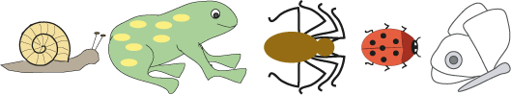  What had happened?  Again, they decided to have a swimming race, a running race, a high jump and a long jump.  Who do you think won each event this time?  Has the caterpillar's change made any difference?  Why do you think this?
Game | Can You Do it Too?  Age 5 to 7  Here are some pictures of people throwing things in Olympic events.  The first one shows a man throwing a hammer and the second shows a man throwing a discus.  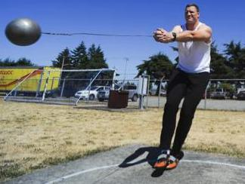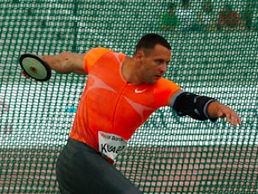  They can throw them a long way. A recent Olympic record for throwing the hammer was about 80 adult paces and for throwing the discus was about 70 adult paces.  How far can you throw a beanbag or pair of socks?  Can you throw a beanbag or pair of socks 70 paces?  Can you throw a beanbag or pair of socks 80 paces?
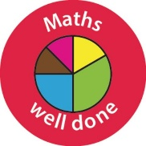
Well done Year One! You have done so well this week.

Bonus Activity!
Look at the pictures below from the Olympic games. What different shapes can you see in the pictures? If you follow the link you will be able to see even more pictures!

Some of the pictures show lots and lots of people in lines, or squares, or circles.
Can you (and lots of your friends!) make shapes like these?
Can you plan your own opening ceremony?
https://nrich.maths.org/8286







