Reading task 1: We are learning to interpret themes in the text.


Lily is a little girl, who is shy and reserved. But she enjoys playing soccer. Her friends and classmates ridicule Lily for her interest in soccer. Nonetheless, she is determined to pursue her passion and become a successful soccer player.
Every day, after returning from school, Lily quickly finishes her homework and practices soccer. Her mother understands the love Lily has for the sport and supports her in every way.
When the interschool competitions are announced at the school, Lily decides to participate. She takes part in the selection trials, and her classmates mock her once again. But they are shocked when Lily performs well and the judges select her to represent the school. Lily’s commitment and hard work mute every person who mocked her
Questions:
- What do you think an appropriate title for this story would be?
- What is Lily’s personality like? Explain how you know.

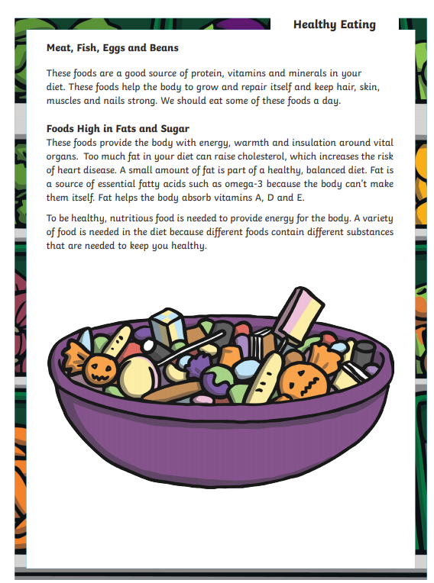
Questions:
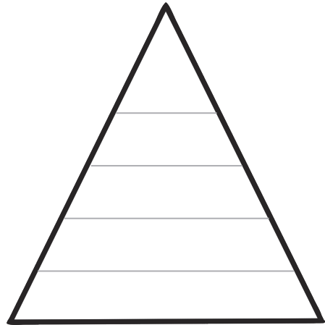
- After reading the information above, please create a food pyramid containing the advised food groups and the suggested portions. Remember the foods that you should eat most of are at the bottom of the pyramid. Challenge - can you draw pictures of different food that belongs in each food group?

Food pyramid answer:
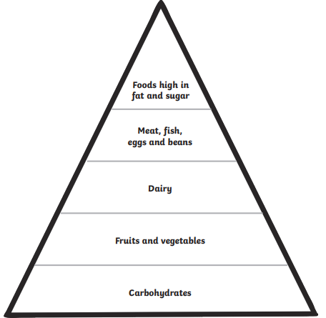

Questions:
- Why is a balanced diet important?

- What is the function of protein?

- Can you give examples of foods that we should try and avoid eating excessive amounts of? Why should we limit our intake of these foods?

- Choose the word closest in meaning to the underlined word. With a balanced diet, your body obtains the fuel and nutrients it needs to function properly.

- rest (b) work (c) eat (d) healthy

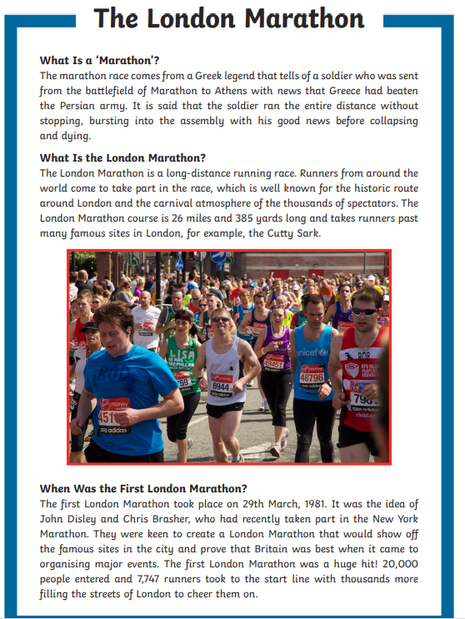
Reading task 2: We are learning to retrieve information from the text:
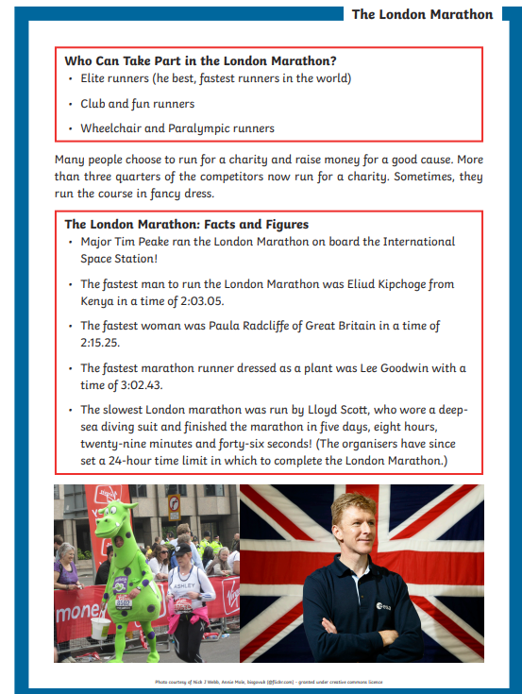

Questions

- Where did the term marathon come from?

- What is the London Marathon?

- Why might people take part in the London Marathon?

- When was the first London Marathon?

- Which even inspired John Disley and Chris Brasher to create the London Marathon?

- Why did they want to create the London Marathon?



