Introduction to Translations

What does it mean to translate a shape?
In geometry moving a shape into a different position, without changing it in any way is called translation.
For example, below, the blue rectangle has been moved or translated 5 squares down and 6 squares across to the right, resulting in the rectangle in red:
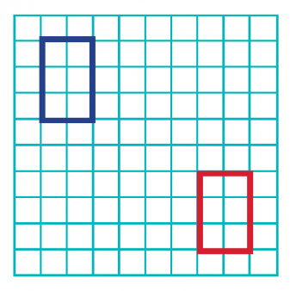
A good way to start making this concept clear to children is to give them a cut-out shape to physically move across the page.

Children will be asked questions that combine coordinates with translation, for example, they will be given a shape on a coordinates grid:
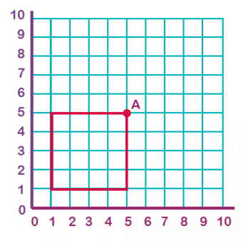

An example question they may be asked could be:
What will the co-ordinates of point A be when this square is translated 3 to the right and 4 up?
To answer this, they would need to translate the square and then give the co-ordinates of point A on the new shape, which would be (8, 9).
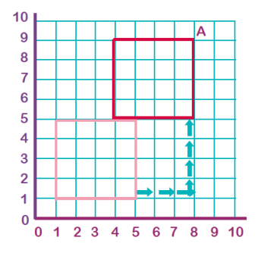

Maths Activity 1: Translation of a point

Graph the new position of each point using the translation given:

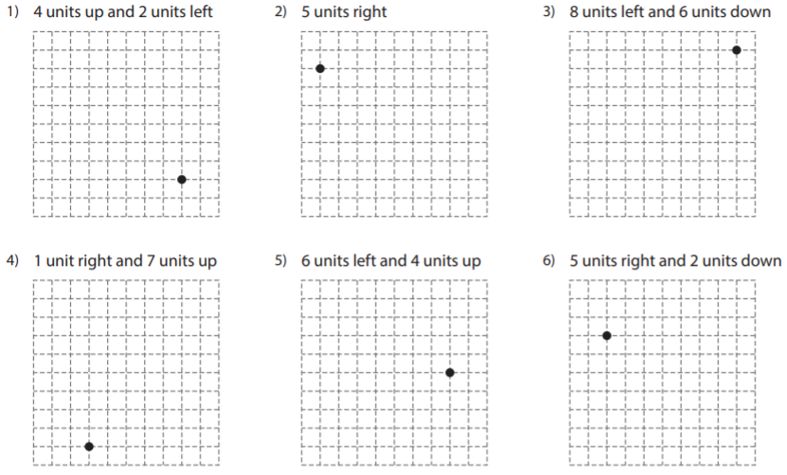
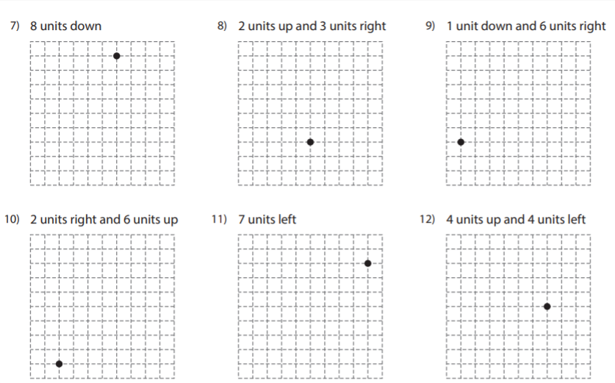

Select the correct multiple choice answer:
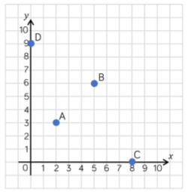
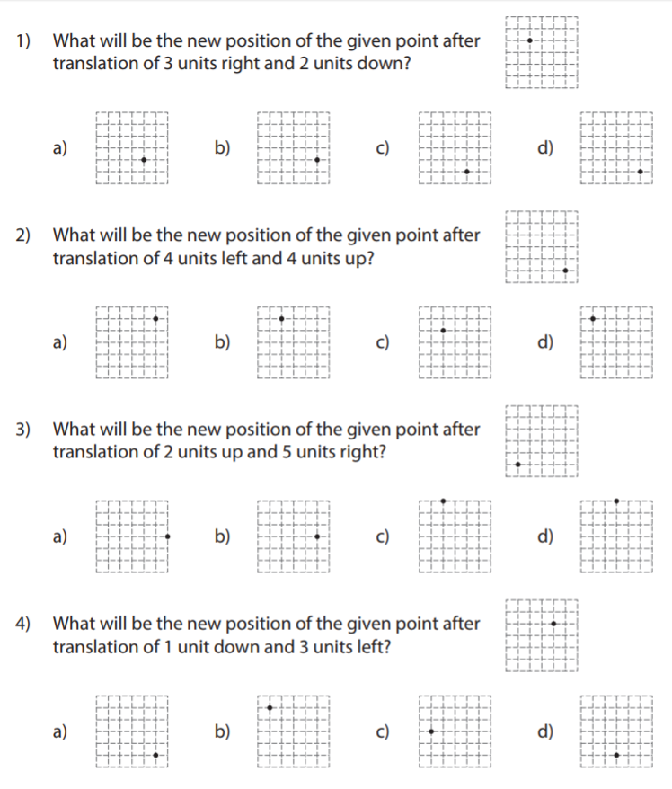
-Translate A 6 right and 3 down.
Record the coordinates before ( _ , _ )
and after ( _ , _ )
-Translate B 4 left and 3 up.
Record the coordinates before ( _ , _ )
and after ( _ , _ )
-Translate C 5 left and 2 up.
Record the coordinates before ( _ , _ )
and after ( _ , _ )

Maths Activity 2: Translation of a Shape

Translate each shape by moving the labelled point of the shape to the point with the same letter.
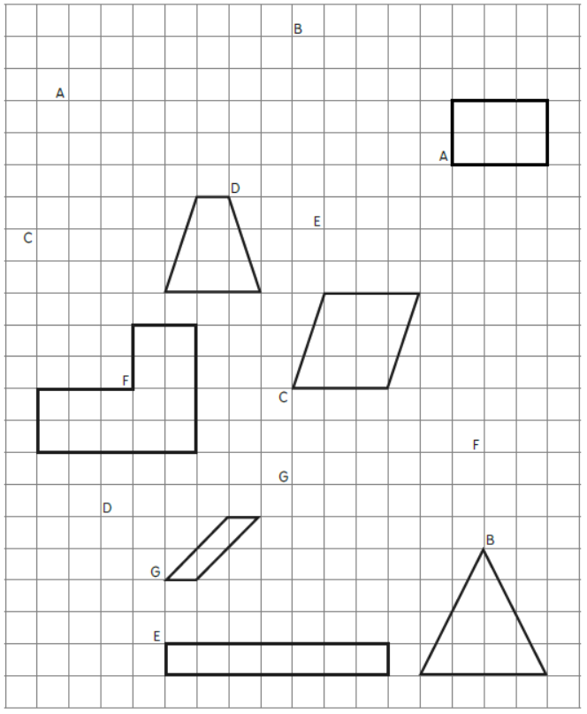

Translate the shape on the coordinate grid to the new coordinate grid.
Describe the translation each time. The first one has been done for you
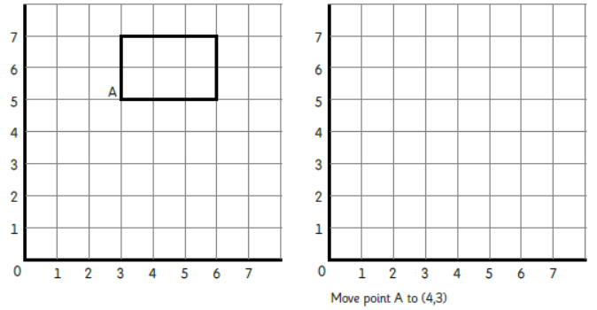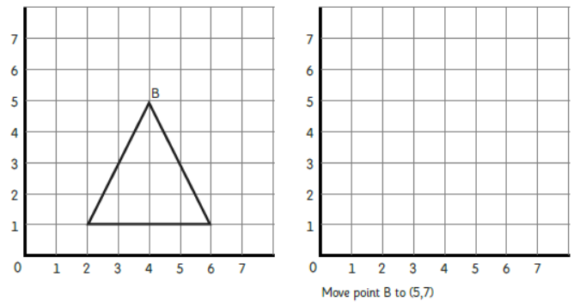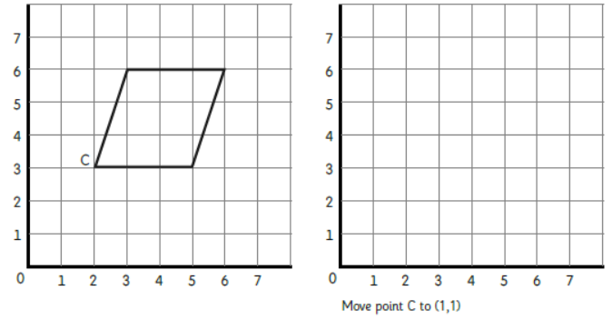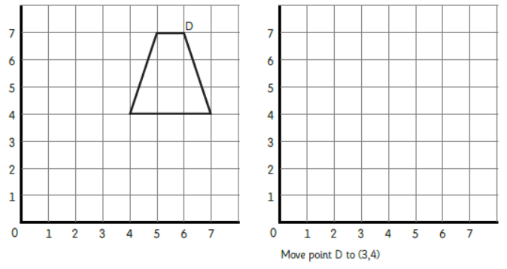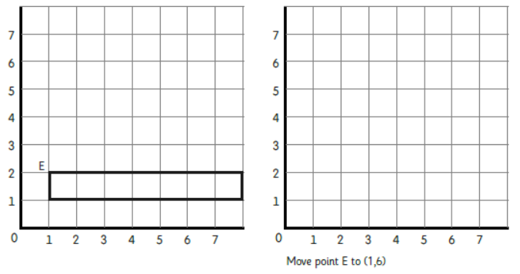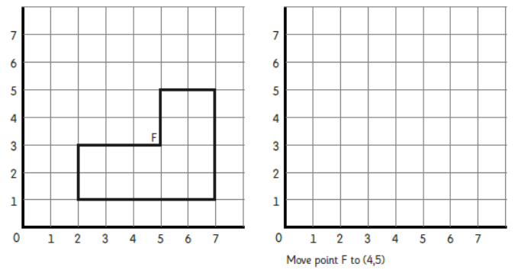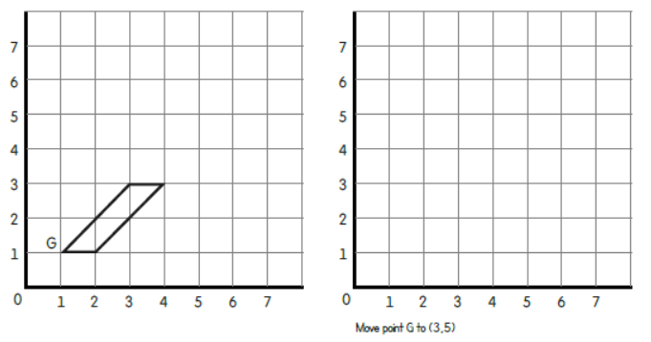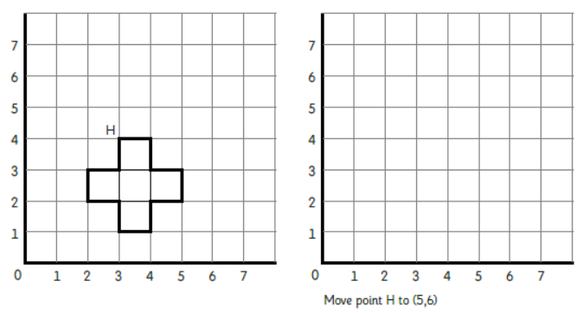
Point A
has been translated
1 across and 2 down
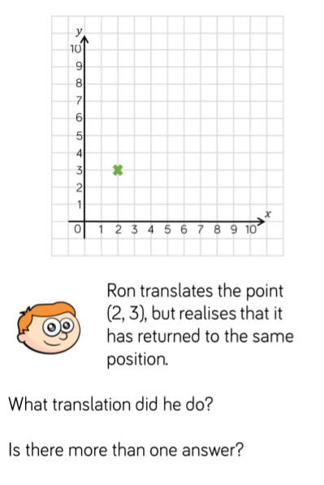
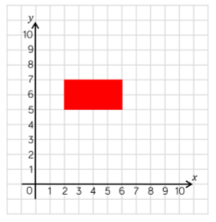
Translate the rectangle 2 left and 3 up.
Write down the coordinate of each vertex of the rectangle before and after the translation.
Translation game:

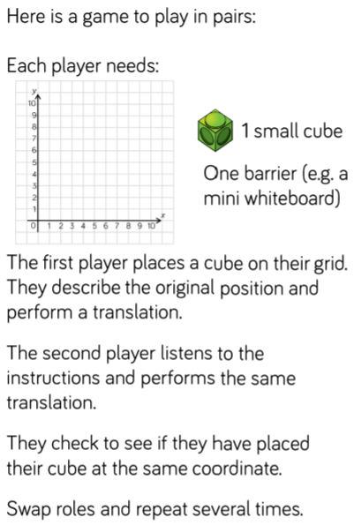

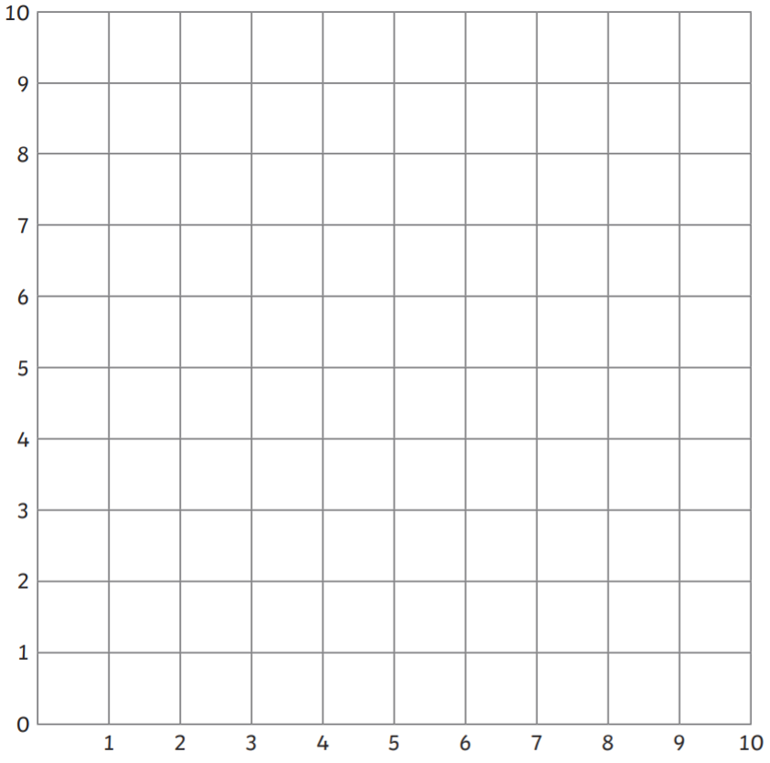

Maths Activity 3: Describing Translations
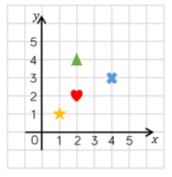
1) Describe the translation from:
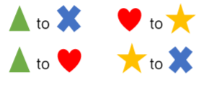

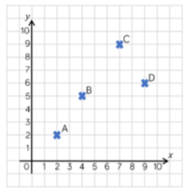
2a) Describe the translation from:
A to B

B to C

C to D

D to A

2b) Plot two new points and describe the translation from A to your new points.

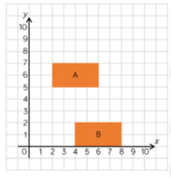
3a) Describe the translation of shape A to Shape B.

3b) Describe the translation of shape B to shape A.

3c) What do you notice?

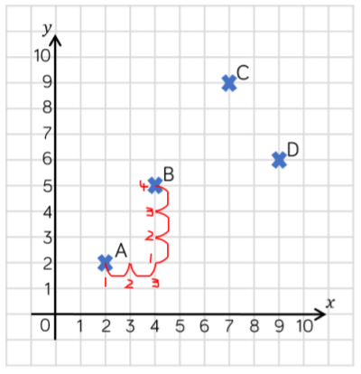
4) Tommy has described the translation from A to B as 3 right and 4 up. Can you Explain his mistake?

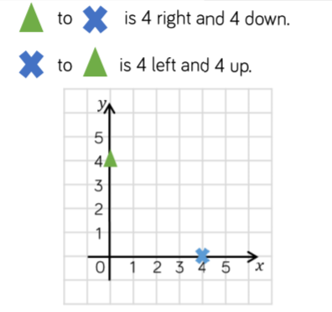
5a) Can you plot other pairs of points where to move between the you travel the same to left or right as you travel up or down?

5b) What do you notice about the coordinates of these points?

