Punctuation Checklist

Form of punctuation | What it looks like | How to use your punctuation | Check
Full Stop | . | Used to show the end of a sentence
Question mark | ? | Are used after a question
Exclamation mark | ! | Used to show surprise, strong emotion or louder speech
Comma | , | Show pause in a sentence and can be used to separate items in a list.
Colon | : | Are used to introduce a list or at the end of a clause to show an elaboration or explanation.  Example:  Exercise has a huge impact on our health: reduces stress levels, helps maintain a healthy body weight and strengthens your muscles and bones.
Semi Colon | ; | Used in a longer list, often containing commas or two closely related main clauses that could make sense on their own.  Example:  There are many important factors you must consider to lead a healthy lifestyle: regular exercise, which helps strengthen your heart; adequate sleep, to improve concentration and productivity; and a healthy diet, which fuels your body and provides sufficient nutrients.
Apostrophe | ‘ | Used to show possession or when letters are missing
Inverted commas | “ “ | Used around the use of direct speech
Dash |  | Creates a break in a sentence, normally in informal writing.
Parenthesis | ( ) | Used to separate information that is not essential to the meaning of the rest of the sentence
Ellipsis | … | Is used to show missing words or long pause in a sentence.

Writing task 1:

LO: We are learning to accurately use a range of punctuation in our writing.

Task: This week the theme of your project learning is sport and a healthy lifestyle. For this piece of writing, we would like you to research and write about the importance of a healthy diet. You may use some of the information provided in the guided reading activity to support you with this task. To display your writing, try creating a poster or presentation.

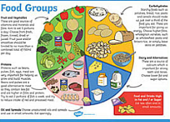
Questions you could answer in your learning:
What is a healthy diet?
Which food groups make up a healthy diet?
Why is it important to eat vegetables?
Are sweets and chocolate really that bad for our health?
Which food groups should I try to eat less of?
What impact does my diet have on my body?

*Remember to use the punctuation checklist to help you include a range of punctuation in your writing

LO: We are learning to accurately use a range of punctuation in our writing.

Task 2: Create your own fitness/physical activity diary to track your progress over the course of Sports Week. In this diary you could include an explanation of the activities you completed each day, detailing the challenges you have faced or the difficulty of each task. You could also comment on the healthy food you have prepared or eaten.
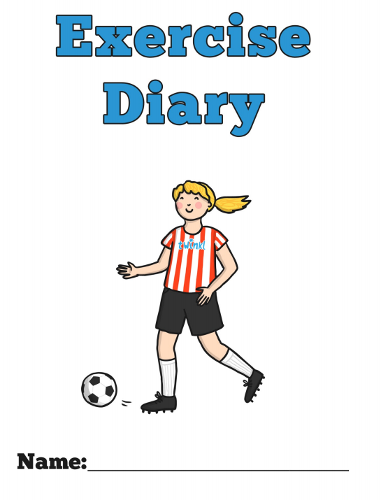


The diary has no set format; it could be a page for each day, or half a page including a picture of the activity you have completed. If you are unsure of how to lay yours out, please see the template provided.

*Remember to use the punctuation checklist to help you include a range of punctuation in your writing


LO: We are learning to accurately use a range of punctuation in our writing.

Task 3: Create a short story about how an athlete became successful. This story can be based on your own sporting icon, or it can be a fictional character in a sport of your choice. To support you with creating this story, you can base the moral of your narrative on a famous sporting quote below.



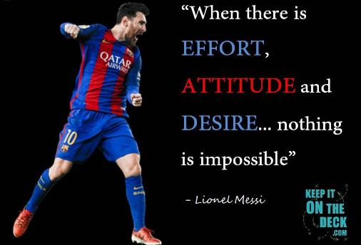
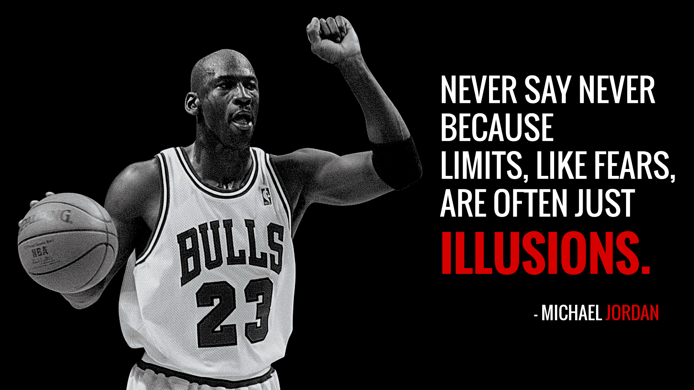
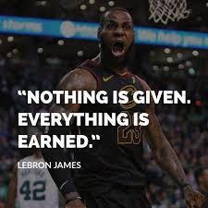


*Remember to use the punctuation checklist to help you include a range of punctuation in your writing

