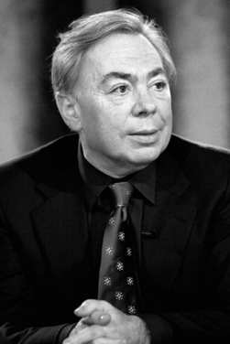
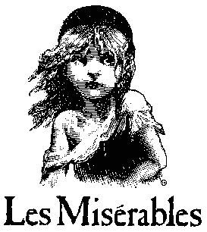

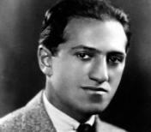
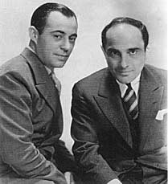
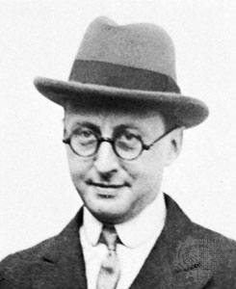
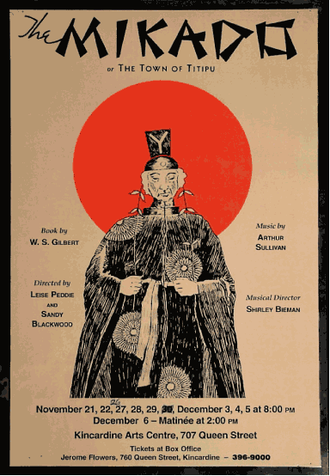
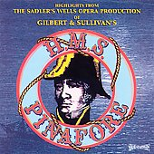
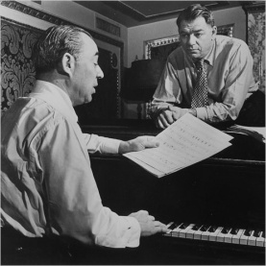
Timeline of Musical Theatre
‘Serious’ Musicals: These are musicals which address serious issues and historical events. They became popular from the 1980s onwards. Claude-Michel Schoenberg and Alain Boublil have written musicals in this style, such as Les Miserables (1980) and Miss Saigon (1989).
Adaptations and Inspiration: In more recent years, films have been adapted into musicals, such as The Lion King (1997) based on the Disney film of the same name. Also, musicals have been made out of the careers of famous musicians, such as We Will Rock You (2002) based on the songs of Queen, and Mamma Mia (1999) based on the songs of Abba.
Andrew Lloyd Webber has had huge success in musical theatre. He has written Joseph (1968), Phantom of the Opera (1986) and many others, and he has produced many shows.
Many Disney films are done in the style of musicals (1937-present day).
Rock Musicals: These are musicals with rock music in them, such as Hair (1967) and Grease (1971). These were very influenced by popular culture.
The 1970s to the Present Day:
Over this period, audiences have seen musicals split into genres and subcategories. Musicals now often address very serious issues and are not just for entertainment. We have also seen many adaptations of films into musicals, and musicals based on the career of a group or artist. A strong musical tradition still exists in Britain and America, and not just on Broadway or in London but everywhere. Film has been greatly influenced by musicals.
George Gershwin was a composer of classical and popular music as well as musical theatre. He was heavily influenced by Jazz, and wrote Porgy and Bess in 1935.
Richard Rodgers (who became one of the most important musical composers) began his career working with Lorenz Hart and together they wrote many musicals.
Jerome Kern was one of the first composers of musicals as we know them today. He had big success with Oscar Hammerstein II with a musical called Show Boat in 1927.
H.M.S Pinafore (1878)

The Mikado (1885)

The Beginning:
The origins of Musical Theatre lie in Opera. Opera was very fashionable with the upper classes in Europe in the 1700s and 1800s. In the late 1800s, a duo called Gilbert and Sullivan began writing short, comical operas designed for everyone, not just the upper classes. This still continued to develop throughout the early 1900s.
Richard Rodgers and Oscar Hammerstein II wrote Oklahoma! in 1943, and this was the first musical to combine a plot with music and dance which moved the story forward. They had a long, successful careers working together and some of their more famous works include The King and I (1951) and The Sound of Music (1959).
Cole Porter – Kiss Me Kate (1948)
Irving Berlin – Annie get Your Gun (1946)
The Golden Age 1943-1968:
This period is when the tradition of musicals was truly established in Britain and America. Some of the greatest musicals were written during this time and the world saw the development of many great composers. Many musicals written and premiered in this time are still loved and performed today.
The ‘Roaring Twenties’ and 1930s:
The 1920s and 30s saw a huge boom in musicals and theatre productions. Theatre at this time was one of the main forms of entertainment. This pre-war era was when musicals were beginning to look and sound like the musicals we still have today, but the songs and dance weren’t usually related to the plot (if there was one!)

