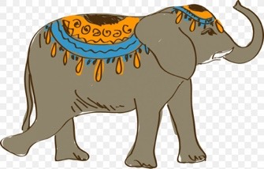

Phonics Activities Week 4

L.O. We are learning to segment the sounds in simple words and blend them together again.

Warm up: Log onto Phonicsplay.co.uk and practise segmenting and blending Phase 2 and 3 words.

Activity 1: Play snakes and ladders with your adult or sibling at home. All you will need is some counters and a dice. Can you remember all your Phase 3 tricky words?

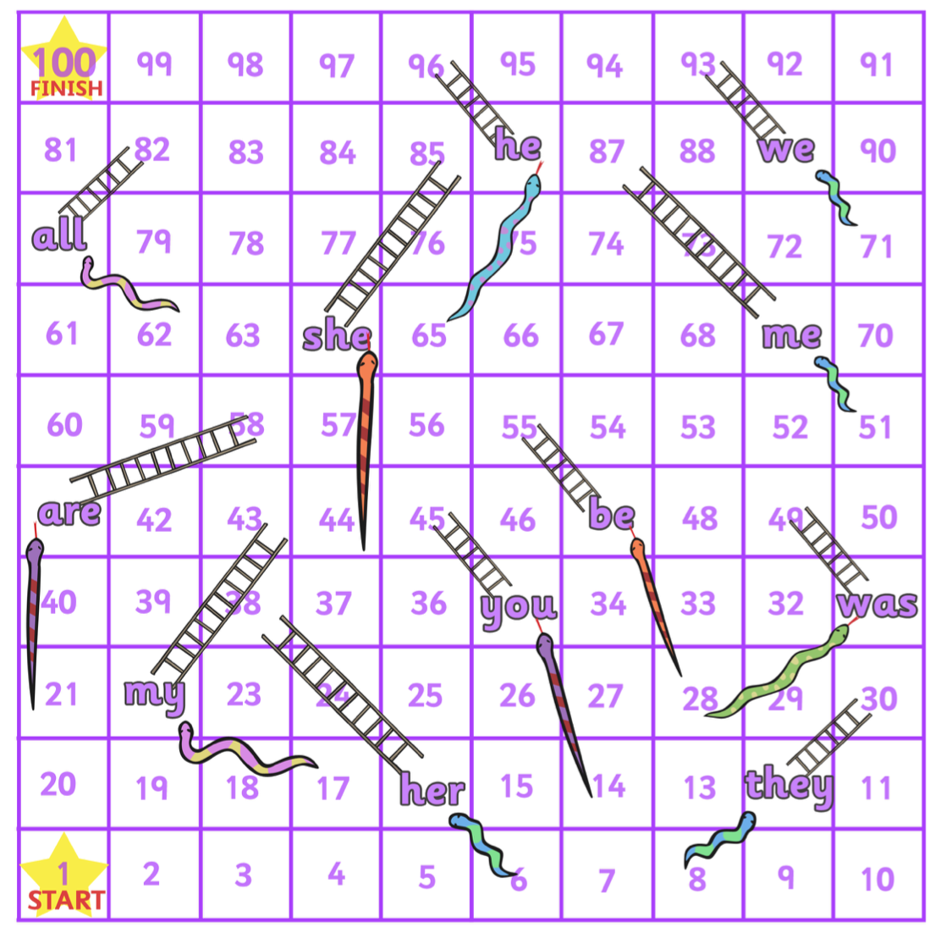

Activity 2: Can you work out which of these CVC words are real and which ones are alien words? Write the alien words inside the box.

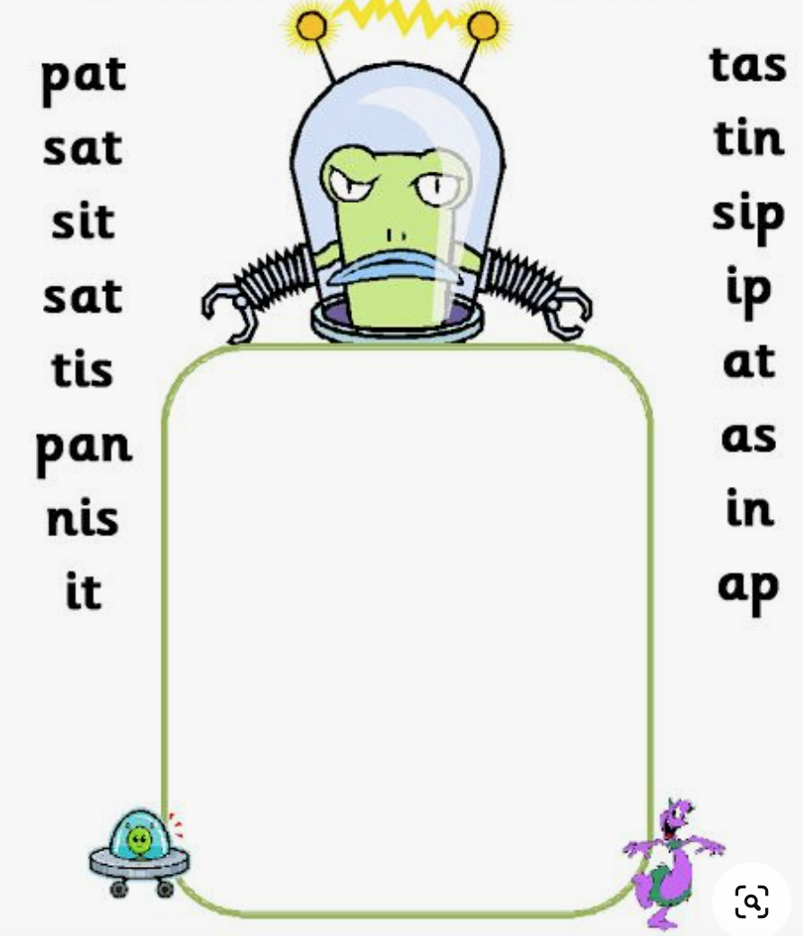

Activity 3: For our final activity this week we are going to practise sounding out Phase 4 words. These words will most often have 4 sounds in them, either CVCC or CCVC (consonant/vowel). For this next game you will need a dice again and if you would like a challenge why don’t you grab a pencil and piece of paper and have a go at spelling some of these words as well as sounding them out.

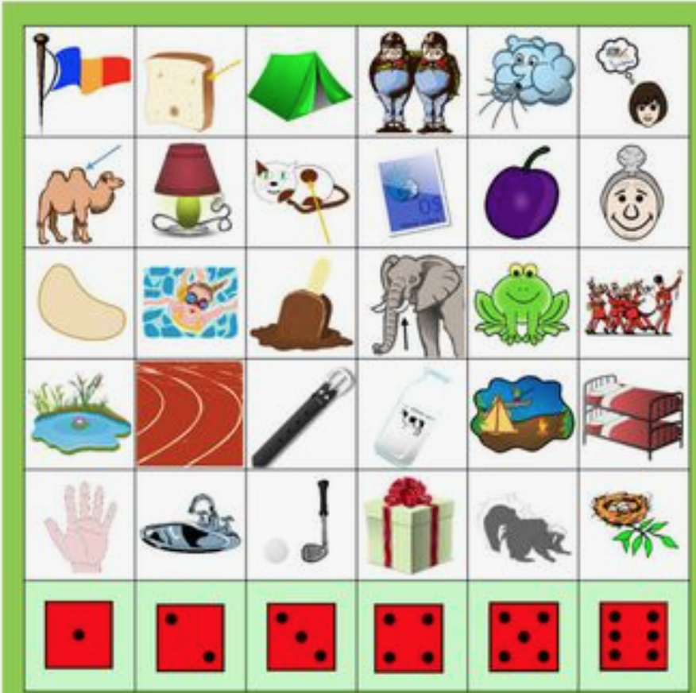

Reading Activities Week 4

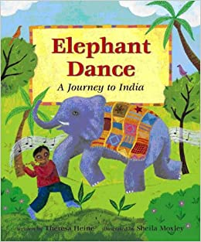
L.O. We are learning to talk confidently about picture books using prediction, asking questions, expressing opinions.

Warm up: Take a look at the front cover of our story. What do you think it is going to be about? Who do you think the little boy is? Do you know what instrument he is playing? Looking at the picture, what do you think India would be like? Do you think it’ll be similar or different to the UK, where we live?

Activity 1: Read or listen to the story https://www.youtube.com/watch?v=4xsDWEvQawA with your adult. When Grandfather comes to visit Anjali and Ravi he tells them about the sun in India and how it turns into a ferocious tiger. Why do you think Grandfather told the children the sun was a tiger? Do you know why the tiger might eat red chillies for his dinner? Finally, how do you think the tiger changes after he drinks a cool bowl of coconut milk? Take a look in the sky on the second page for a clue.

Activity 2: Listen again to the story when Grandfather brings his family presents from India. All of those objects are special to India, why don’t you have a look at what some of those objects are by researching them with your adult. Which gift would you like the most and why? If you were going to give a gift that represented where you came from, what might it be? I might take them a box of scones and jam!

Activity 3: Take a look back to where Grandfather describes the rainbow. Why do you think the word ‘stretching’ has been written like that? Grandfather describes each colour of the rainbow in India, do you think you could describe each colour of the rainbow that you have seen here in England?

Please keep up the daily reading as much as possible, there are many great books on the Oxford Owl website that are sutiable for a range of levels, check the Saxon website for the username and password.
Username: saxonreception Password: reception
Writing Activities Week 4

L.O. We are learning to write simple sentences using fingers spaces and full stops.

Warm up: Watch some of these videos about Diwlai https://www.bbc.co.uk/cbeebies/watch/lets-celebrate-diwali
Activity 1: Using the information you have learnt about the celebration of Diwali, write a letter to a friend or a family member about Diwali. You could describe all the things they do to get ready for Diwali and then what happens during the celebration.

On the next page is a template you could use for this:

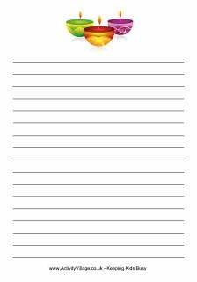

Activity 2 : India has some wonderful wildlife. Could you research one in detail and write some sentences about them alongside a drawing of it?
You might like to learn and write about their national bird the Peacock or an Indian Elephant or Tiger?

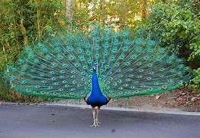

Activity 3: Can you find out some interesting facts about India? What is the weather like? Are there any beaches? What are some of the special places you can visit there? What food do they like to eat in India? What is a Rangoli pattern? What are they traditionally drawn with?


Once you find out some facts, can you pretend that you are in India? Could you write a postcard to one of your Reception teachers or a friend about what you have been up to there?

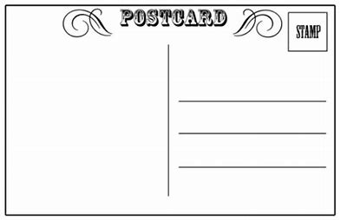

Maths Activities Week 4

L.O. We are learning to use everyday language to talk about time

Warm up: For the warmup activity you can count actions and see if you can do things more quickly. An adult can help you time your activity for a minute and suggest things to do.
The activity: set a timer for a minute (or half a minute) and count how many actions you can do in that time, such as star jumps, hops, or writing your name.
Questions that encourage mathematical thinking and reasoning:
How many jumps did you do? How many hops? Which did you do more of? Did you do more or fewer than last time? You did more jumps – does that mean you are getting faster or slower? What do you think you can do more of in a minute - star jumps or twirls? Why do you think that is? How many times do you think you can do ‘heads, shoulders, knees and toes’? How many claps or stamps do you think you can do in half a minute?

Activity 1: For this activity you need similar items (such as marbles, shells, buttons etc) and some containers. You also need a device, such as a sand timer or digital timer that you can use by yourself as you fill up the container.
The activity: Place the timer near to a collection of small, easy-to-hold items and some containers. Predict how many marbles/shells/buttons you think you might be able to put in one of the containers before the sand runs out.
Questions to encourage mathematical thinking and reasoning: Tell me about what you are doing? How many marbles did you get in that time? What could you do to make sure you get more marbles in your pot this time? What would happen if you used a different timer? What would happen if you only used one hand/used both hands? What would happen if you used a different pot?

Activity 2: For this activity you can make a Clock Playdough Mat. Make the hour and minute hands with playdough or different coloured thread, something that moves to show the time. Look at your real clocks and identify the hour hand and minute hand, and then decide what colour playdough each should be.
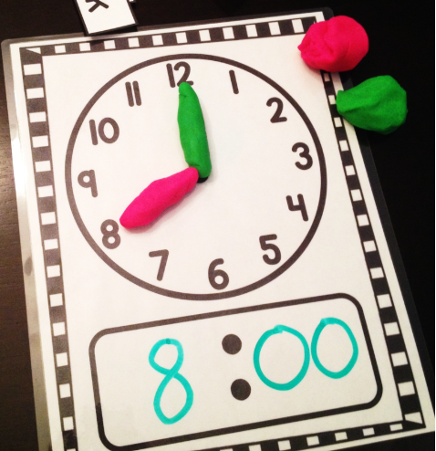
This activity will give you the opportunity to talk about the numbers on the clock and you can practise telling the time. Have a look at a few real clocks and count out the numbers around the circle. Notice that the numbers always go the same way - clock-wise – around the face of the clock. Talk with your adult about how the numbers go from 1 to 12, but there are 24 hours in the day. So, for each day we work our way around the clock twice. Look at your real clocks again and identify which hand is for hours, which for minutes, are they the same size? Are they moving at the same speed?
Talk about what time you get up, what time you go to bed, and see if you can place the hands in the right place on the clock mat to match.

Activity 3: For this activity you can have a go and learn the days of the week and months of the year. Practise them and sing along by watching
https://www.youtube.com/watch?v=3tx0rvuXIRg
https://www.youtube.com/watch?v=lPeAo1hz8GA
After practising, try and sing them independently. You can then make them into paper chains sorting them out in order. And hang them in your room.
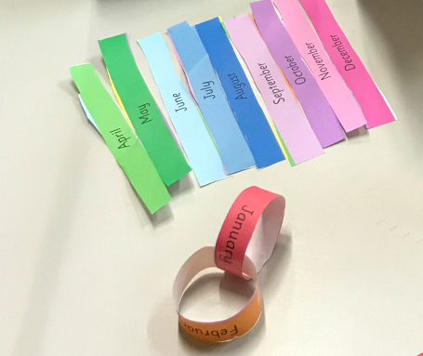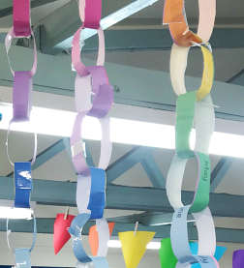

Project Week 4

Flower Garland
In certain parts of India, it is customary to wear a necklace of fresh flowers at Diwali, the festival of lights. This week we would like you to make a paper flower garland instead.

You will need:
Thread
Paper flowers (in bright colours with a hole punched in them)
Coloured plastic drinking straws that are cut into pieces (or use pasta instead)

Instructions:
Cut out a collection of flowers from the crepe paper. Snip the straws into small pieces.
Cut a piece of thread to the length that you want your necklace (remember to leave extra for tying). Fasten a piece of sticky tape to the end of the thread to secure. Thread through a flower, and then a piece of straw, and so on. When the thread is nearly full, take off the sticky tape and tie the ends together tightly.


