Reading task 1: We are learning to interpret themes in the text.


Lily is a little girl, who is shy and reserved. But she enjoys playing soccer. Her friends and classmates ridicule Lily for her interest in soccer. Nonetheless, she is determined to pursue her passion and become a successful soccer player.
Every day, after returning from school, Lily quickly finishes her homework and practises soccer. Her mother understands the love Lily has for the sport and supports her in every way.
When the interschool competitions are announced at the school, Lily decides to participate. She takes part in the selection trials, and her classmates mock her once again. But they are shocked when Lily performs well and the judges select her to represent the school. Lily’s commitment and hard work mute every person who mocked her.
Questions:
- What do you think an appropriate title for this story would be?

- What is Lily’s personality like? Explain how you know.

- What do you think the moral of this story is?

Reading task 2: Beautiful Ambition
LO: We are learning to interpret themes in the text.
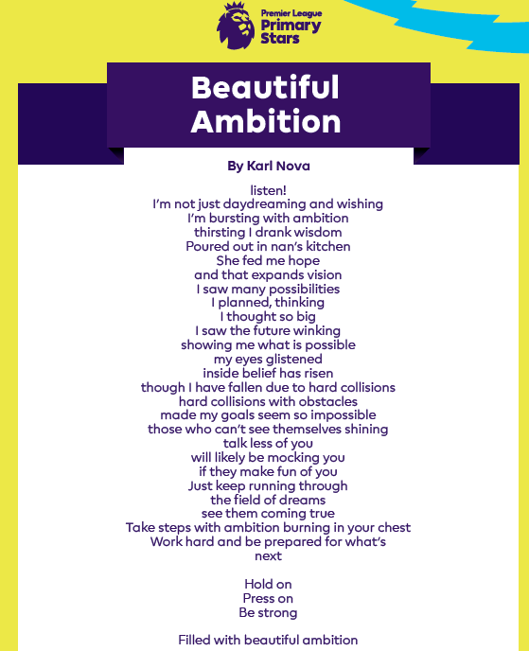

Questions:
- What do you think the word obstacle means in the sentence, ‘although I have fallen due to hard obstacles.’

- Think of three synonyms for the word ambition.

- What do you think are the key messages from the poem?

