LO: We are learning to use a range of conjunctions to create cohesion in our writing.

A conjunction is a word, or words, used to connect two clauses together. Words such as: 'although', 'because' or 'when' . A subordinating clause is a part of a sentence that adds additional information to the main clause.

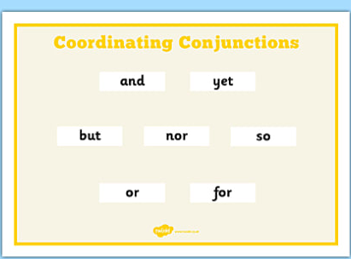

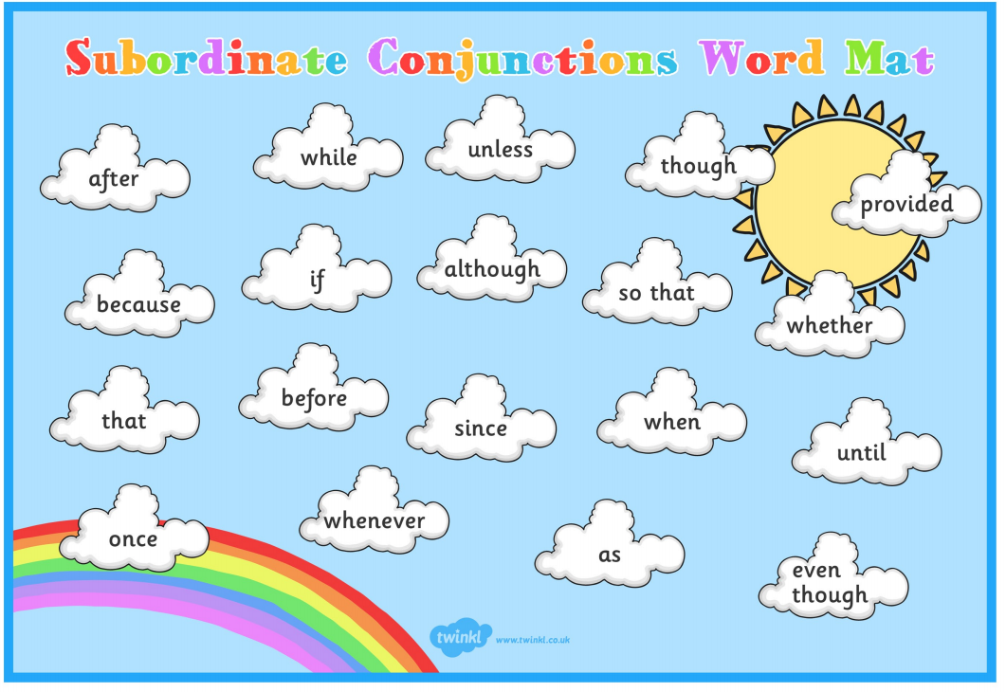

Writing task 1: My Career.

LO: We are learning to use a range of conjunctions to create cohesion in our writing.

Task: This week is careers week. As you get older, you will start to think about what job you would like to do. This may change several times between now and when you start working and that is fine. Some people, however, do know what they want to do and will end up doing that job as an adult. For now, think about a career that you might want to pursue as an adult and try to answer these questions.
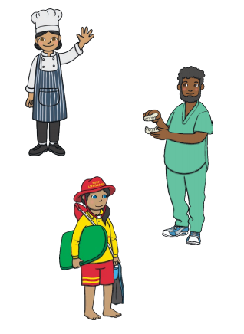

1. What job would you like when you are older?

2. What does this job involve?

3. What do you think you need to be good at to do that job well?

4. What can you do over the next few years to learn these skills and qualities?

5. What will be your number one goal to work on and why?

Writing task 2:

LO: We are learning to use a range of conjunctions to create cohesion in our writing.

Task: For this piece of writing, we would like you to write a story based on a character who achieves their dream job. The story could be based on your own personal goals, a role model’s journey to success, or you could create a moral story using a fictional character.




Questions to answer in your story:
Why has the character chosen this as a career?
What are your characters qualities?
What obstacles did they face along the way?
How did they overcome these obstacles?
What steps did they take in order to achieve their target?
What mistakes did they make?

*Remember to use the co-ordinating and subordinating word mats to ensure you include a range of conjunctions in your writing.

Writing task 3:

LO: We are learning to use a range of conjunctions to create cohesion in our writing.

Task: For this piece of writing, we would like to write a diary entry from the perspective of the young fisherman in the story: The Catch. To watch the video, please click on the link below. If you are unable to access the clip, please use the pictures and the story starter to support you.

Video Link: https://www.literacyshed.com/the-other-cultures-shed.html

Questions to answer in your story:
How did the you feel when catching the fish?
What was it like to see the fox in distress?
What did you think was going to happen when you released the fox?
What were your emotions when following the fox?
What did you see, feel, hear, touch, and smell on your journey?
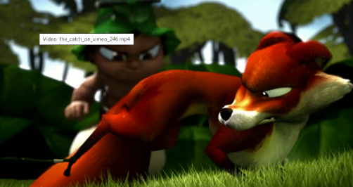
What was it like to see the giant fish?
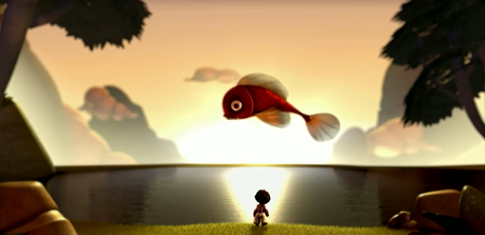
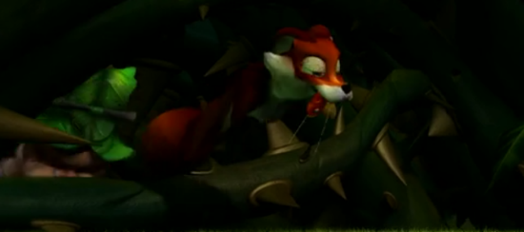
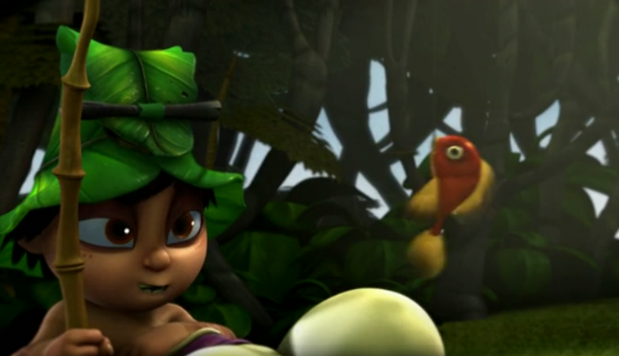
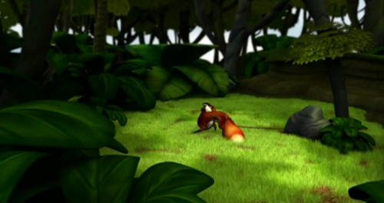

Story starter:
Today was the most thrilling, adventurous day of my life.
The day started normally; after eating breakfast with my family, I scooped up my fishing rod and ran to the lake. I hoped that today, I would finally catch my very first fish.

*Remember to write in first person for your diary entry and use the co-ordinating and subordinating word mats to ensure you include a range of conjunctions in your writing.

