Introduction to Coordinates

What are Coordinates?
Coordinates are numbers which determine the position of a point or a shape in a particular space (a map or a graph).
In primary school children are taught Cartesian coordinates, which they are introduced to in Year 4. Points are marked by how far along they are on the x axis (the horizontal axis) and how far up they are on the y axis (the vertical axis).
Children will be shown a grid like the following, with numbers along the x axis and the y axis:
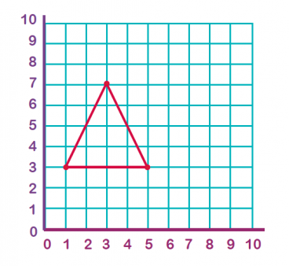
The coordinates of the left-hand corner of this triangle are (1, 3).
How to read and plot coordinates
Coordinates are always written in brackets, with the two numbers separated by a comma. Coordinates are ordered pairs of numbers; the first number indicates the point on the x axis and the second the point on the y axis.

When reading or plotting coordinates you always go across first and then up (a good way to remember this is: 'across the landing and up the stairs' or ‘a baby learns to crawl before it walks’).

Children start to learn about co-ordinates in Year 4. For example: they may be shown the above triangle and asked to write the three coordinates for the three points of the triangle. This would constitute reading coordinates. They may then be given a blank grid and asked to plot the following coordinates: (1, 1) (4, 1) (1, 3) and (4, 3) then join up the points to make a shape (which in this case would be a rectangle).

Maths Activity 1:

Plot these points on your 10 x 10 grid to tell me what shape they will make. Write your answer on the line.
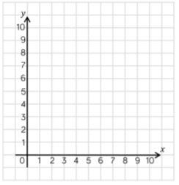
- (2,2) (2,4) (4,2) (4,4)

- (1,1) (2,3) (3,1)

- (1,1) (1,3) (6,1) (6,3)

- (2,1) (5,1) (5,4)

- (3,1) (5,1) (6,3) (4,4) (2,3)

- (3,4) (2,3) (3,2) (4,2) (5,3) (4,4)

- (2,2) (3,3) (6,1)

- (0,0) (2,0) (0,3) (2,3)

Without plotting these co-ordinates, can you predict what shapes these co-ordinates will make?

1. (1,2) (3,2) (3,4) (1,4)

2. (1,1) (5,1) (5,2) (1,2)

3. (2,1) (4,1) (3,4)

4. (3,3) (3,6) (6,3) (6,6)

What extra co-ordinate will I need to make a square?

5. (1,1) (4,1) (1,4) (4,__)

6. (2,2) (2,4) (4,2) (4,__)

7. (3,1) (3,2) (4,1) (4,__)

8. (5,1) (5,4) (2,1) (2,__)

Maths Activity 2:
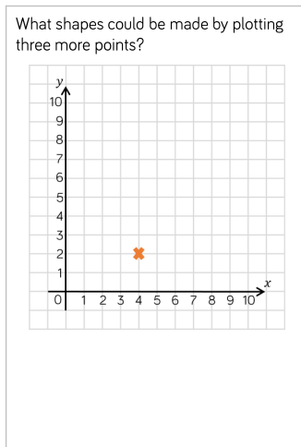
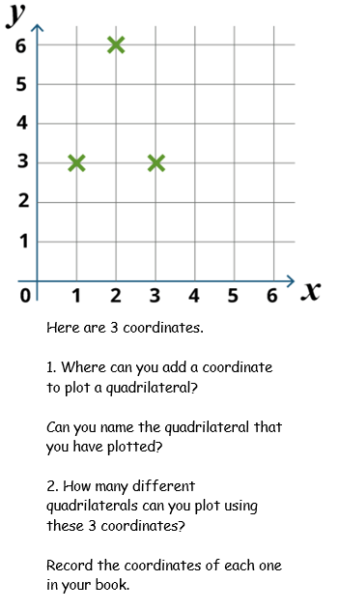

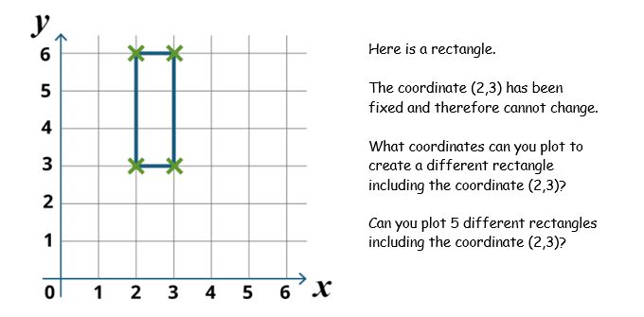

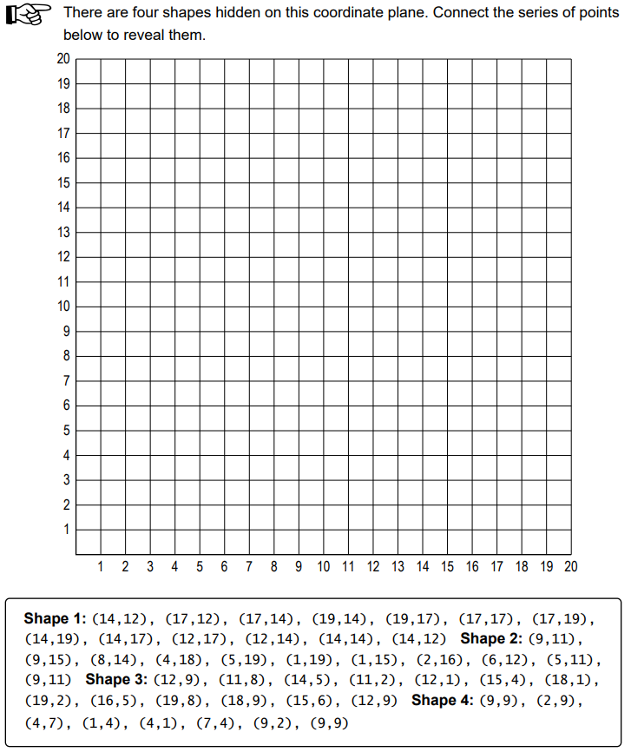
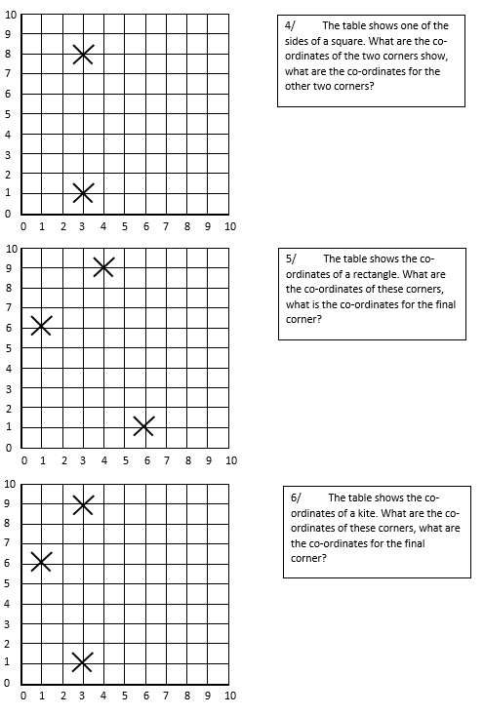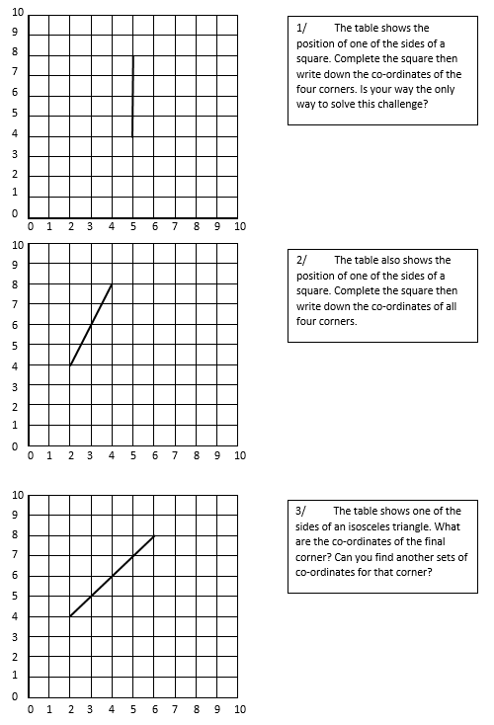

Maths Activity 3:



