History Project: Anglo-Saxons

Introduction
What was England like?
England looked very different 1,600 years ago when the Anglo-Saxons came to our shores.
- Much of the country was covered in thick oak forests.
Most of England's one million people lived in the countryside where they made a living from farming.
There were many kings, each one ruling over a different area of England.
Why did the Romans abandon England?
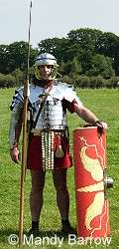
The Romans had invaded England and ruled over England for 400 years. In 410, the Romans left England because their homes in Italy were being attacked by fierce tribes and every soldier was needed.
The people of England were sad when the Romans left because they had no professional soldiers of their own to protect them from the sea-raiders, who were growing bolder in their attacks upon the coast.
The Dark Ages
The Dark Ages describe the centuries after the end of the Roman rule. It is a time in history we have less evidence from. It is the time in history when the Saxons and Vikings came to Britain.
England is invaded again!
With the breakdown of Rome's control of Britain it became possible for the Angles, Saxons and Jutes from across the North Sea who had been raiding the coast of Britain for a hundred years to increase their pressure. Instead of raiding and then withdrawing, by about 450 A.D they were beginning to settle here. The invasion consisted of a series of attacks on different parts of the country over a period of years and under a number of leaders.
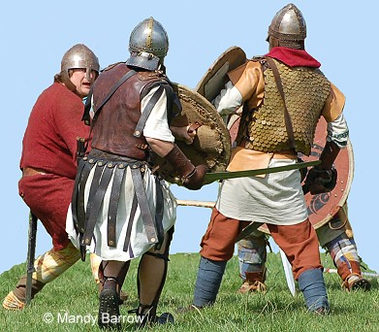
The Saxon chieftains Hengist and Horsa led a massive attack on Kent in about the year 455. They marched from Thanet through Faversham to Canterbury and eventually arrived at Aylesford, near Maidstone, where a fierce battle took place.
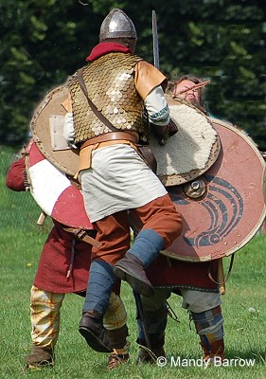

Who were the Anglo-Saxons?
The Angle, Saxon, and Jute are known as the Anglo-Saxons. The Angles and the Saxon tribes were the largest of the three attacking tribes and so we often know them as Anglo-Saxons. They shared the same language but were each ruled by different strong warriors.
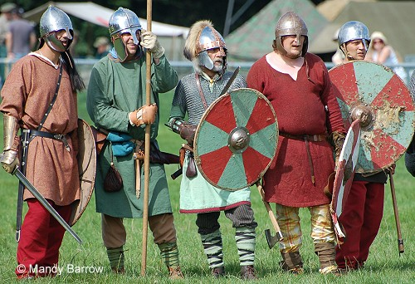
Anglo-Saxons
The Anglo-Saxons were warrior-farmers and came from north-western Europe. They began to invade Britain while the Romans were still in control.
The Anglo-Saxons were tall, fair-haired men, armed with swords and spears and round shields.
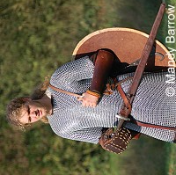
They loved fighting and were very fierce.
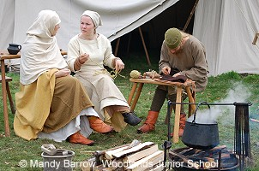
Their skills included hunting, farming, textile (cloth) production and leather working.

How do we know about skills and occupations of the Anglo-Saxons?
We know about the Anglo-Saxons because of things we have found giving us quite detailed information about their lives. Anglo-Saxons were often buried with their possessions. The objects we have found in graves have provided us with evidence of the different jobs done by men and women and the skills they had.
Knives and spears are often found in Anglo-Saxon men's graves. This suggests they were involved in hunting, fighting and farming. Women's graves often include tools used for sewing and weaving, which suggests they were involved in making clothes (textile production).
What did the Anglo-Saxons do for entertainment (leisure)?
The Anglo-Saxons enjoyed horse racing, hunting, feasting and music-making. They played dice and board games such as draughts and chess. Entertainment during feasts included listening to a harp being played and juggling balls and knives.
Children played with balls, hoops and whipping tops (spinning tops). They also played with carved wooden toys such as horses and small wooden boats.

Activity 1: Runes

Anglo Saxon Runes
When the Anglo-Saxons became Christians, they began to use the Roman alphabet for writing (as we still do today). Before that time, they wrote in runes like these:
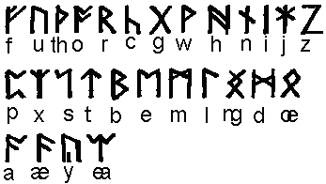
Each rune had a name, such as 'joy' or 'ash tree' 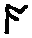. The runes were all made of straight lines, which made them easier to carve. Runes were often carved on precious objects - like an ivory box - or on stone monuments. Sometimes runes told the maker's name.
You can see that some of the runes are quite like our capital letters:
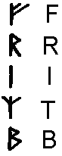
Some are easier to guess if you turn them upside down,

although some are not at all what you might expect:
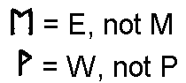
The word RUNE means secret or mystery. Runes had a religious meaning and were used in religious ceremonies. They were a charm or a spell as well as a way of writing messages.
This is why TO SPELL (meaning to put down the right letters in the right order) and A SPELL (as in a magic spell) are the same word in English. The Anglo-Saxons believed that if you used the right runes in the right order, they could have magical powers. For example, a prisoner could magically release himself by carving certain runes.
Even our words READ and WRITE are connected with runes. The Anglo-Saxon words
writan (= to carve runes) and ridan (= to interpret runes) became our words write and read.
Why not try using runes like a code to write secret messages to your friends? Look at the alphabet of runes again. As you can see, Anglo-Saxon had some sounds (like æ - ) that we don't use any more, but some letters you might need (q for example) are missing. You can make up your own runes for these. Remember to make them out of straight lines.

Make Salt Dough Runes
Carve the runes into salt dough stones to create your name or even the whole alphabet.

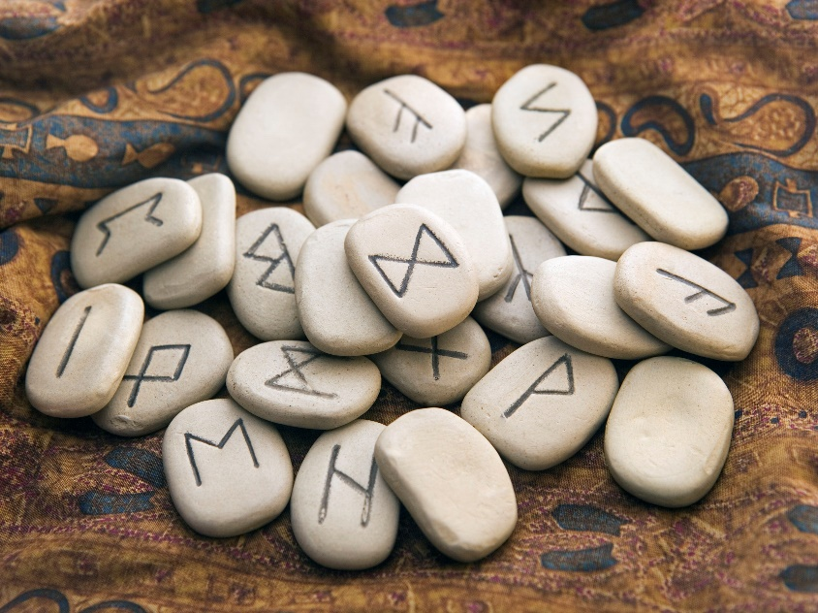

Salt Dough Recipe

Ingredients

- 2 cups all-purpose flour
- 1 cup salt
- 1 cup cold water

Directions

- Mix flour and salt together in a bowl. Slowly mix water, a few tablespoons at a time, into flour mixture until dough is smooth and easy to handle. Knead dough for 10 minutes and let rest for 20 minutes.
- Preheat oven to 120 degrees C (250 degrees F)
- Form dough into desired shapes and arrange on a baking sheet.
- Bake in the preheated oven until dry and hard, about 2 hours. Allow to cool completely.

Write your own secret message using runes.

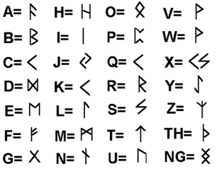

__________________________________________________________________________________________________________________________________________________________________________________________________________________________________________________________________________________________________________________________________________________________________________________________________________________________________________________________________________________________________________________________________________________________________________________________________________________________________________________________________________
_____________________________________________________________________________________________________________________________________________________________________________________________________________________________________________________________________________________________________________________________________
_____________________________________________________________________________________________________________________________________________________________________________________________________________________________________________________________________________________________________________________________________

Activity 2: Weapons and Armour

What did Anglo-Saxon armour and weapons look like?
SUTTON HOO HELMET: This helmet was found in the ship-grave at Sutton Hoo. Can you see the two dragon's heads nose-to-nose at the front?
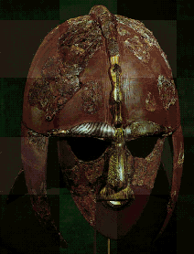
From the little pieces, it is possible to see what the whole helmet might have looked like:
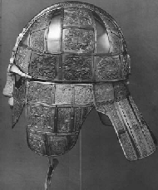
Reconstructed helmet.

Here is what a shield probably looked like:
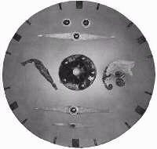
Only the 'boss' (the middle part) and some of the metal decorations have survived.
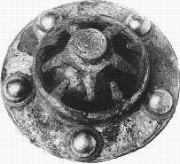
This is the dragon from the left-hand side of the shield:
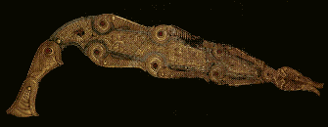
This is a bird of prey. You can see it on the right-hand side of the shield.
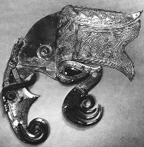
The wooden part of the shield has rotted away. The shields described in Beowulf are made from the wood of the linden tree (or lime tree, as it is often called).
This sword was found in Germany: The blade is covered by a sheath decorated with with gold.
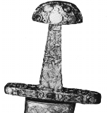
Anglo-Saxon swords were often decorated with complicated patterns like these:
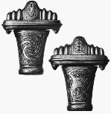
A mailcoat or mail-shirt:
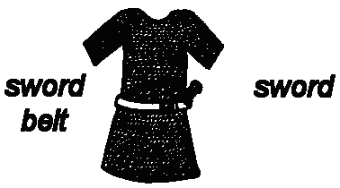
A mailcoat or mail-shirt was to protect the warrior's body. It was made out of tiny metal rings linked together very tightly so the point of the sword or spear could not easily go through it. The spearheads looked like this:

A mailcoat was not stiff and heavy like the suits of armour knights wore later in history. So the warrior could move easily when fighting on foot.

Design a Saxon Shield
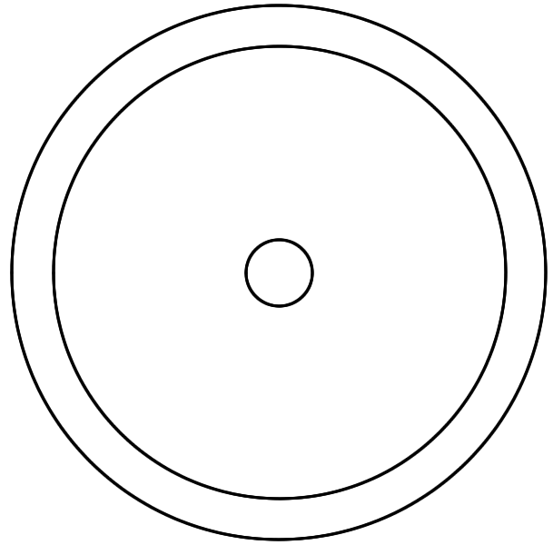

Make your own Saxon Armour and Weapons using things you can find at home.
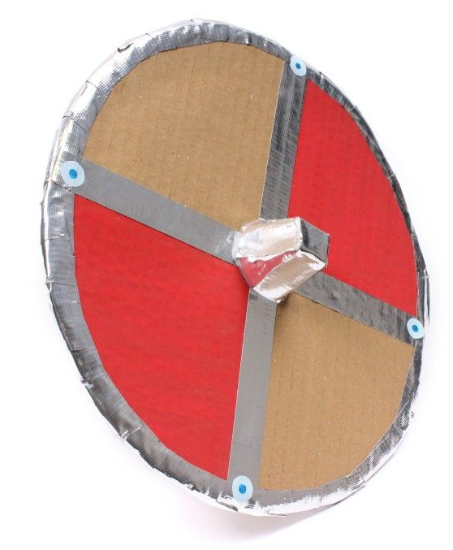
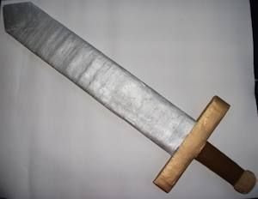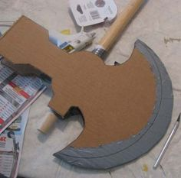

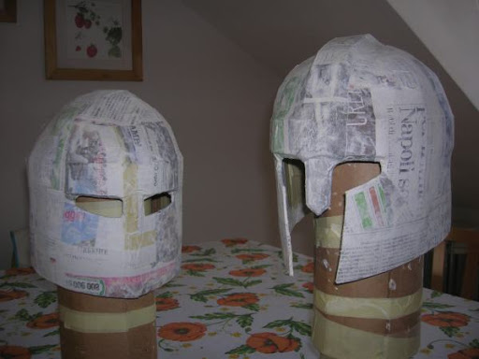
Activity 3: Cooking
Try this Anglo Saxon recipe

Honey and Oat Bread

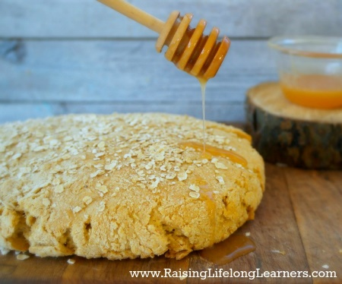

Ingredients
- 384g or 13.5oz whole wheat flour
- 256g or 9oz all-purpose flour
- 1 tsp. baking soda
- 1 tsp. salt
- 250ml water
- 96g or 3.4oz rolled oats
- 43g or 1.5oz rolled oats {for sprinkling on top}

Instructions
- Mix all dry ingredients and then add the water.
- Stir all of the ingredients with a wooden spoon until you can’t stir any more.
- Then, knead the dough with damp hands until flour is completely incorporated.
- Finally, form the dough into a round, place it on a baking stone sprinkle with reserved oats, and place it in a cold oven.
- Turn the oven to190 degrees C (375 F) and leave it alone for an hour.
- After an hour, pull the bread out of the oven, let it cool slightly, then rip it apart in chunks like a Saxon (or cut it in nice wedges) and drizzle honey on it.

Activity 4: Research
Find the correct answers to each question. Tick or circle the correct answer.

Who was Offa?
King of Mercia
King of Northumbria
King of Wessex
King of East Anglia

Which king was killed at the Battle of Hastings?
Canute
Edward
Harold
William

Who became King of England in 1016?
Canute
Alfred
Harold
Ethelred

What happened to the Anglo Saxon leaders?
They went back to Germany
They became kings
They were killed by the Romans
They became farmers

Who began to raid England in the 8th Century?
Vikings
Romans
Greeks
Normans

Who invaded England in 1066?
Vikings
Romans
Greeks
Normans

What did Offa build to separate England and Wales?
Offa's Wall
Offa's Canal
Offa's Fence
Offa's Dyke

What did missionaries do?
Made weapons
Introduced Christianity to the Anglo Saxons
Spied for the kings
Told stories

Who defeated the Vikings and became the King of England?
William the Conqueror
Alfred the Great
Ethelred the Unready
Edward the Confessor

Which kingdom defeated Northumbria in the 8th Century?
Wessex
Sussex
Mercia
Kent

