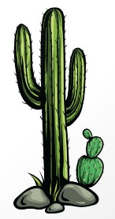

Phonics Activities Week 5

L.O. We are learning to segment the sounds in simple words and blend them together again.

Warm up: Log onto Phonicsplay.co.uk and practise segmenting and blending Phase 2, 3 and 4 words.

Activity 1: Blending phonics into words can sometimes be challenging. For this activity, we would like you to make ‘slide cards’. The rule is to look at one letter at a time, which will help you blend the sounds gradually.
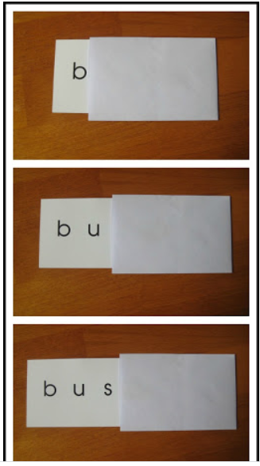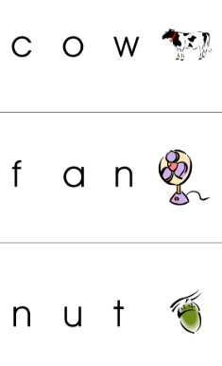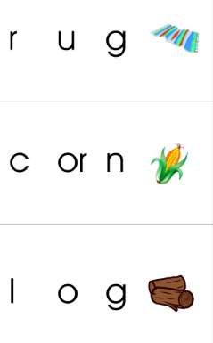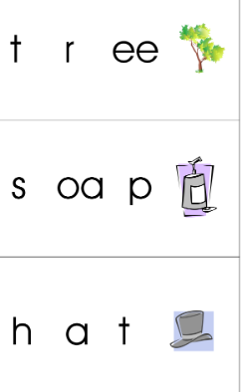

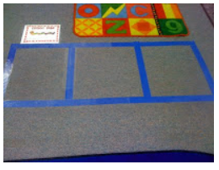
Activity 2: For this activity, you can make sound boxes on the floor to help you s-t-r-e-t-ch out the sounds and then blend them back together. On a piece of card, write sounds from phase two and three. Put one sound in one box, then hop along the boxes as you say each, then hop "out" of the boxes and say the word. If the word makes sense, it’s a real word and if it doesn’t, that’s a pseudo word. Have fun hopping.

Reading Activities Week 5

L.O. We are learning to talk confidently about picture books using prediction, asking questions, expressing opinions.

Warm up: The book for this week is ‘Off we go to Mexico’ before you listen to the story, pause it and look at the cover https://www.youtube.com/watch?v=cPJV0QVAfBY
Think back to the book we read last week. How do you think this book will be different? What do you think we might see in this book? Do you know anything about Mexico already?

Activity 1: Listen to the story and talk with your adult about the things that you have learnt about Mexico.
What are some things you might see at a beach in Mexico?
Does the festival in the story remind you of any celebration you have at home?
How do you think Ancient Mexico is different to the Mexico we see today?

Activity 2: For this activity you should visit the National Geographic Kids Mexico site to learn a little more about Mexico http://kids.nationalgeographic.com/kids/places/find/mexico/
You can always draw a picture of something you like or have learnt.

Activity 3: Listen to the story again and find out why they wave their flags, and what the flag look like. Can you colour the flag attached to this activity?
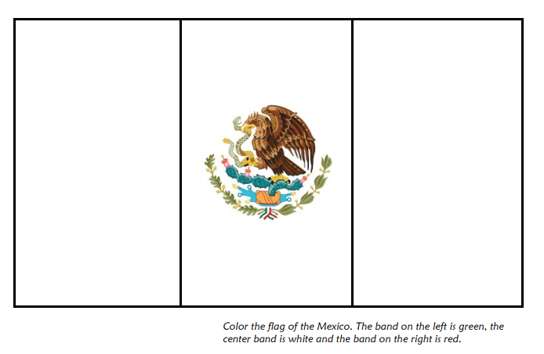

Please keep up the daily reading as much as possible, there are many great books on the Oxford Owl website that are sutiable for a range of levels, check the Saxon website for the username and password.
Username: saxonreception Password: reception

Writing Activities Week 5

This week we would have had, ‘move-up morning’. This is where you would meet your new teacher, visit your new classroom and enjoy some fun activities that would help you to get ready for Year 1. As we are not in school as normal, we would like you to have a go at some of these activities at home. You will also have received a video from your new class teacher (who might be quite familiar) from inside your new classroom. We hope you are as excited as we are!
(The links to these videos will be emailed out on Tuesday 30th June, which would have been our
‘Move-Up morning’)

L.O. We are learning to write simple sentences using fingers spaces and full stops.

Warm up: Although your teacher is not changing next year, we know that all of you have grown up so much throughout your time in Reception and you are all ready for Year 1. As you have been at school now for a whole year we would like you to fill out a new profile page so your teacher knows all about what makes you, you. Working with an adult, fill out your one page profile to give back to your teacher (see attachment on school website).

Activity 1: Think back to your time in Reception - what has been your favourite moment? Maybe it was taking part in the nativity show, or meeting the firefighters, going to Bocketts Farm, or even just enjoying the mud kitchen during choosing time! Draw a picture of your favourite moment in Reception and underneath, write a sentence telling your teacher a little bit about your favourite moment in school.

Activity 2: Do you have any questions about Year 1? Is there anything you would like to know or are unsure about? Why don’t you write an email to your teacher (you might need a little help from an adult) with any questions you have about life in Year 1? It might be about your new classroom, the learning or the school day.
Use the lines below to write out your questions before creating the email.

Activity 3: In Year 1 we have many exciting topics, including Space! For your final activity, we would like you to learn a little bit about space in order to get ready for Year 1. Can you research what rockets are and then design your own rocket, telling us what materials you would use and what makes your rocket unique? You could have a go at creating your rocket afterwards. (See template on next page)

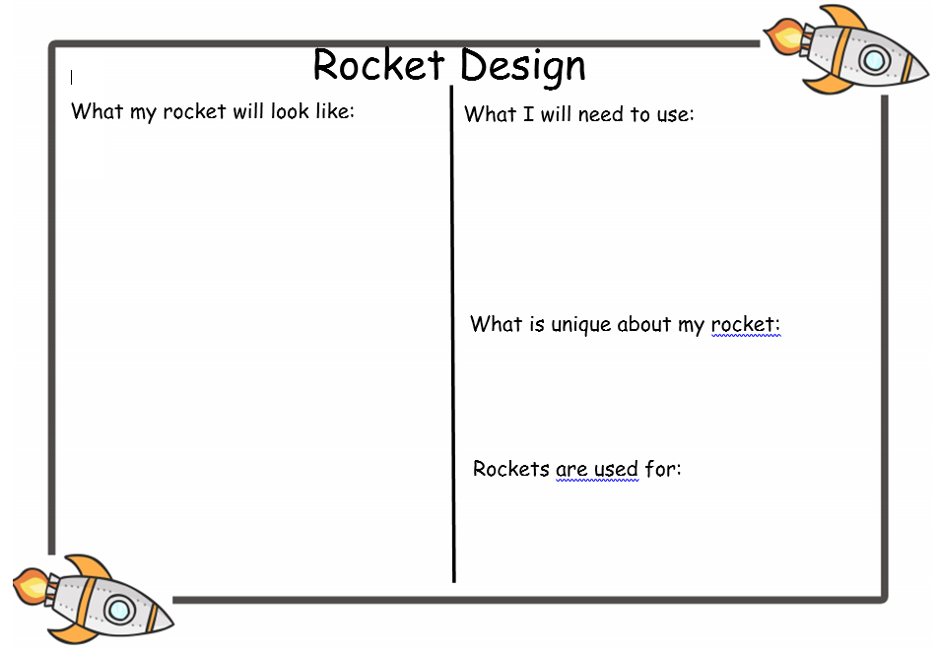

Maths Activities Week 5

L.O. We are learning to re-call, order and add numbers to 20.

Warm up: https://saxonmaths.weebly.com/reception.html visit the Saxon maths website and practise counting to 20 with Jack Hartman in his song ‘Count to 20 and workout’.
Whilst you’re on the website you could also have a go on some of the counting games.

Activity 1: Cut out these numicon, 1 to 10 (see next page).
How quickly can you place them in the correct order? Ask an adult to time you and then see if you can do it even quicker. What do you notice about the numicon as the number gets bigger? Can you make any teen numbers using 2 numicon together?

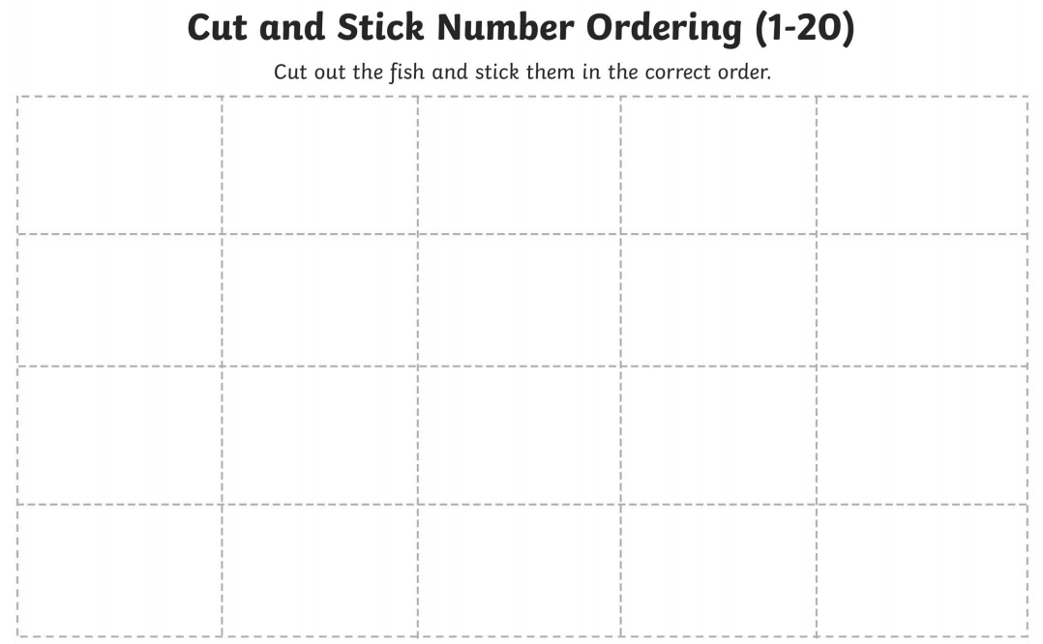
Activity 2: For this next activity, you are going to be ordering numbers to 20. Can you cut and stick the fish into the correct place. Beginning with 1, in the top left corner.

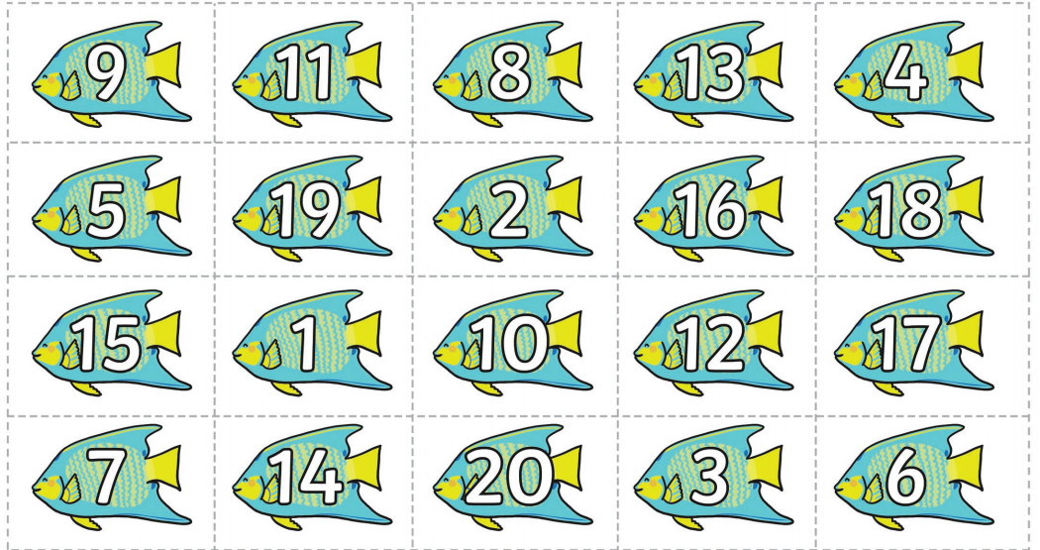

Activity 3: For the final activity you will need 20 pegs and a clothes hanger like the one in the picture. Place some card over the hanger with a large add sign on it in order to divide the hanger in half. Place some of the pegs on one side of the hanger and the rest on the other side. Can you record and answer the number sentence you have made?

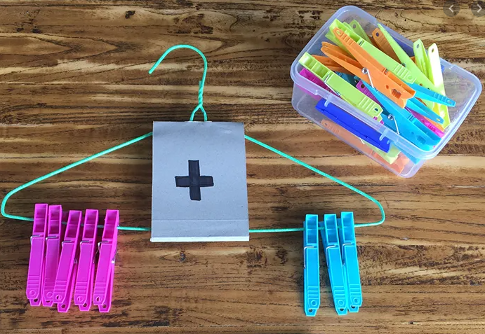

Record your number sentences on a piece of paper like this.

20

Project Week 5

“We are a box of crayons, each of us unique, but when we get together, the
picture is complete.”

We think this quote from the story ‘The Crayon Box that Talked’ https://www.youtube.com/watch?v=hrTHdi8wmCo describes perfectly how we feel about all of you. We would like you to design your own crayon with a big picture of yourself on it, to be put up on display in your new classroom. You may also like to draw some pictures of the things you enjoy on your crayon such as your favourite subject at school, your favourite sport or maybe your favourite book!
Use the template below then bring your crayon into school over the new few weeks. You can always drop it through the letterbox on your daily walk!

This is an example of some crayons completed by other children.
See the template for your crayon on the next page.



