Year 1 Phonics Activity 2.
Look at the pictures and use the ‘a’ sounds at the top to write the word in the box next to it. Eg. The first one is ‘rain.’
Some are quite tricky but for parents, we have included the answers at the end of the phonics activities. Good luck!
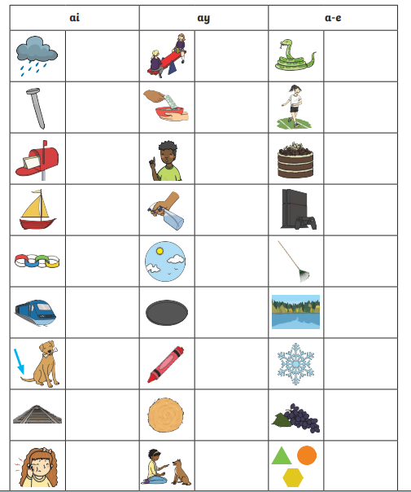

Challenge: Now choose 3 pictures and write a sentence including all three of them below!

Year 1 Phonics Activity 3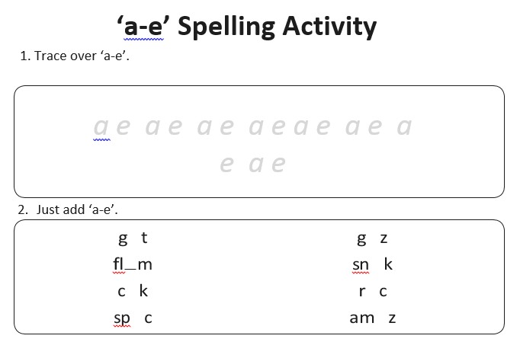

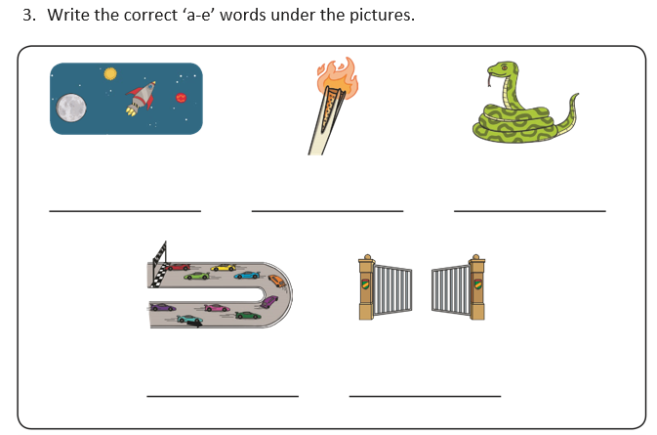
Challenge:
Can you write a sentence using each picture in the boxes. You could try and add in some other ‘a’ sounding words too.

Well done! You have completed your phonics activities.


