Here is the link to listen to the story The Bears Picnic. https://soundcloud.com/talkforwriting/brian/s-Tdy7BXbHz4i

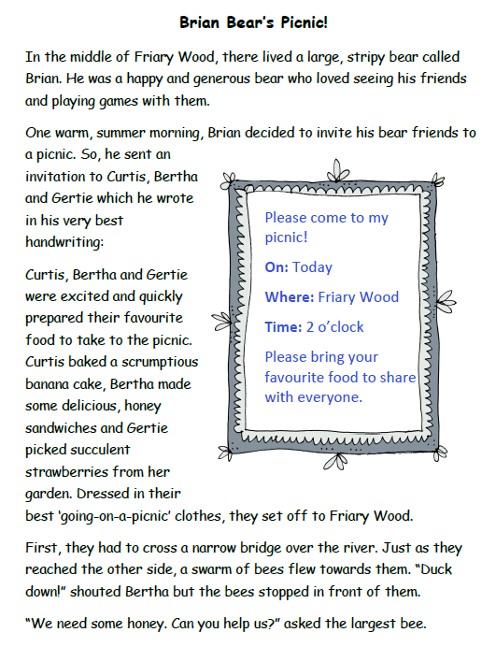

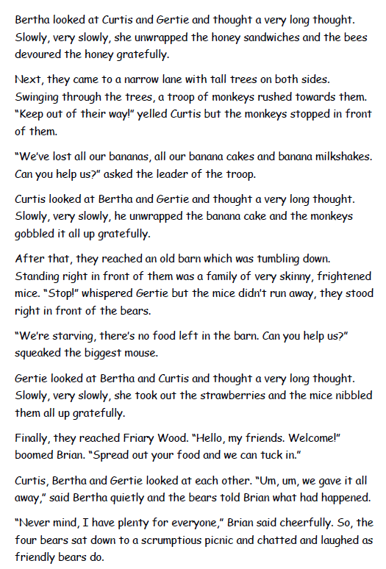
Activity 1:
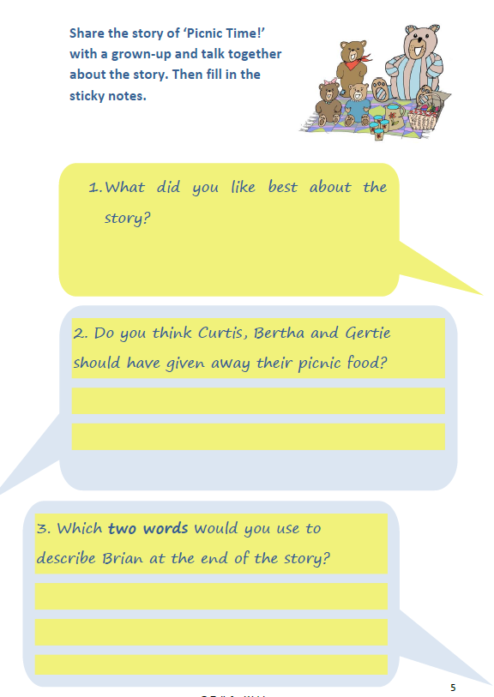
Activity 2: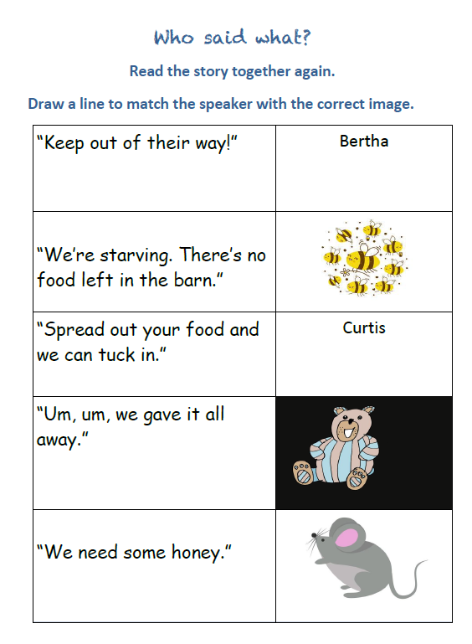
Activity 3:


