Maths Week Five

This week your Maths learning videos are on the BBC Bitesize website and White Rose Website 16th and 17th June, and the learning sheets are below. Remember you do not have to do it all each day - just have a go at some of the activities.
Session 1.
Warm up | Making doubles. What is a double?  https://www.youtube.com/watch?v=4U2QLjqripY
Main activity | Watch the White Rose video Summer Term Week 8 ‘Doubles’ and complete the learning sheets below.  https://whiterosemaths.com/homelearning/year-1/  Or you can go to BBC Bitesize and do their warm up activities instead if you like.
Game | https://www.topmarks.co.uk/maths-games/hit-the-button  Hit the button! Choose doubles or halves to practice.
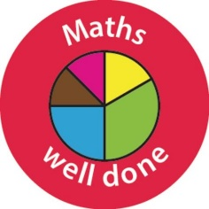 Well done Year One!

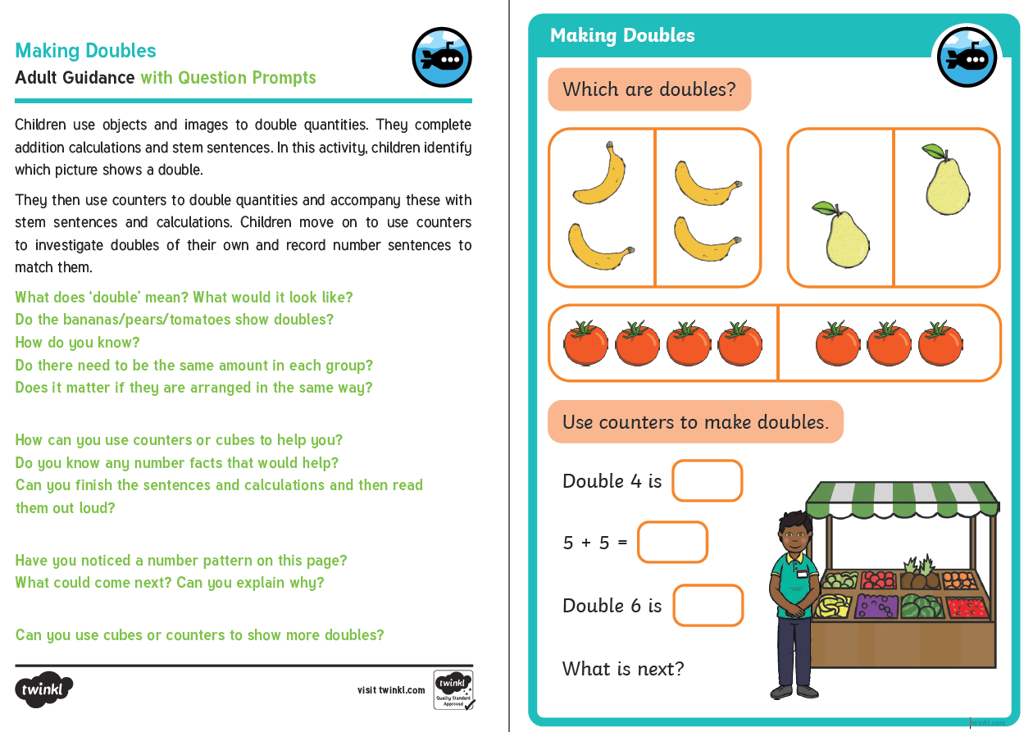
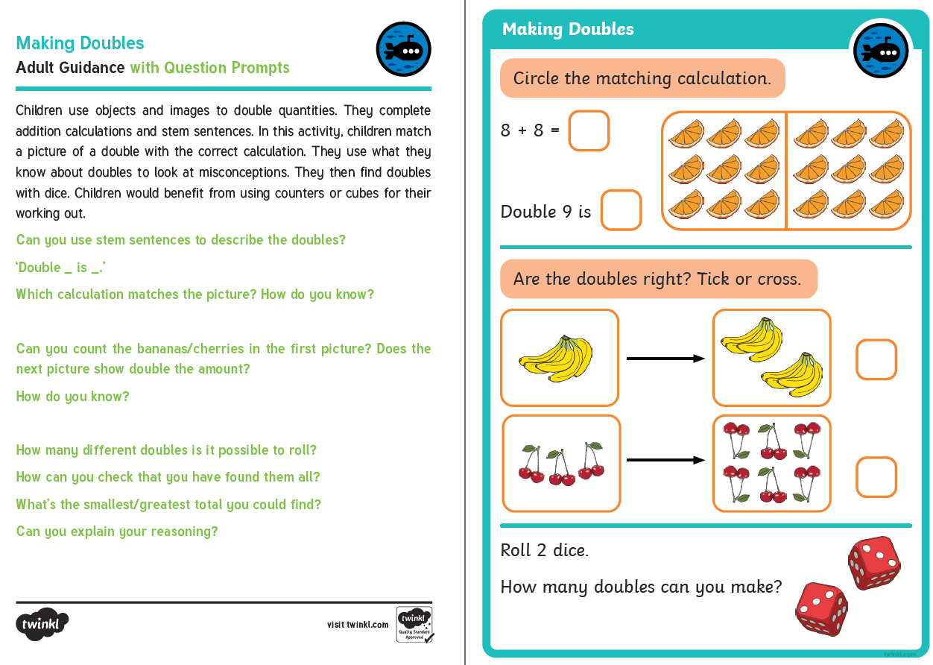
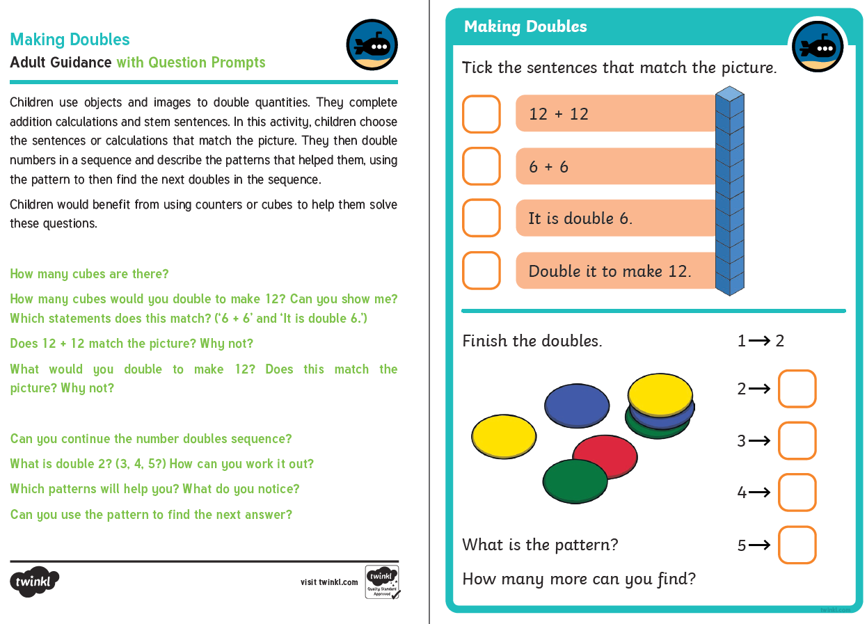

Session 2.
Warm up | https://www.youtube.com/watch?v=e0dJWfQHF8Y  Practice your counting to 100, saying your  -teen and -ty numbers accurately.
Main activity | Watch the Maths video from your class teacher then complete the learning sheets below. The focus for this session and session 3 is sharing equally.
Game | https://www.topmarks.co.uk/Flash.aspx?f=sharingv2

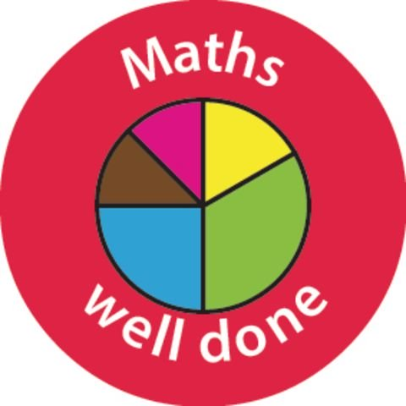

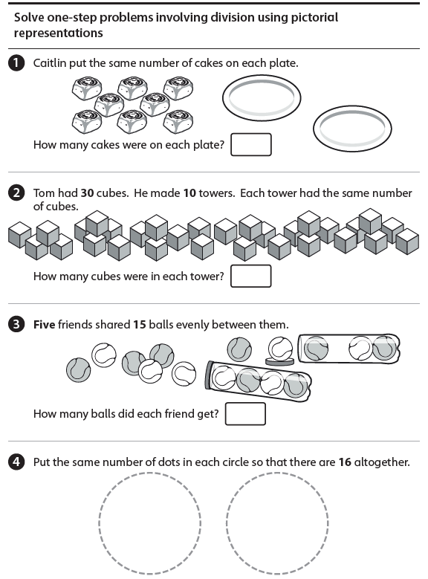
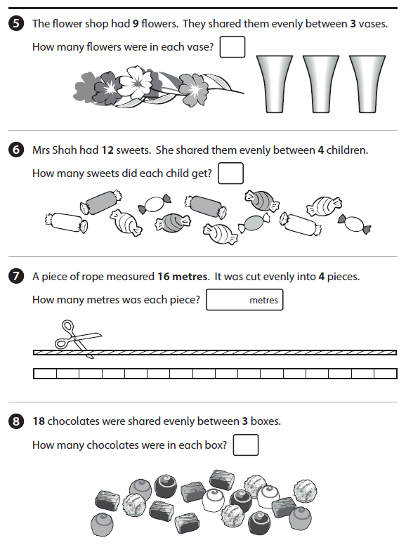

Session 3.
Warm up | Warm up by counting in 5s today.  https://www.youtube.com/watch?v=EemjeA2Djjw
Main activity | Today we will continue with sharing. If you would like a reminder then watch the White Rose video from Summer Term, week 8, lesson 3 (make equal groups) 17th June. Or you could re-watch the teacher video from yesterday. There are also activities on BBC Bitesize if you would like to follow those.  Main task: complete the learning activities below.  Remember that each group should have an equal amount in.
Game | https://www.topmarks.co.uk/Flash.aspx?f=sharingv2

Well done Year One! You have done so well this week.



