Modelled writing from the video

It was the first day of the new school year and my time in year five had so far been rather strange. I wasn’t sure if it was year five itself or just that my new teacher could at best be described as a little bit odd. It all began in the morning, when I met her for the first time. Her hair (while long) was split into five unequal parts; some parts braided like Pippi Longstockings and other held in a range of butterfly clasps and ponytail ties. She wore a large, thick, velvet ribbon around her neck like a choker with a knot tied to hold it in the back. The long tails of the ribbon floated almost to the floor.
During class time, while she was explaining our task, she often missed words or said them out of order. This resulted in an almost Yodalike speech pattern. When she wrote on the board it was with not a single trace of punctuation, nor was a capital letter in sight.
I finally discovered what was so strange about her when I popped into the classroom at lunch on a hunt for my elusive water bottle.

Punctuation Checklist
Form of punctuation | What it looks like | How to use your punctuation | Check
Full Stop | . | Used to show the end of a sentence
Question mark | ? | Are used after a question
Exclamation mark | ! | Used to show surprise, strong emotion or louder speech
Comma | , | Show pause in a sentence and can be used to separate items in a list.
Colon | : | Are used to introduce a list or at the end of a clause to show an elaboration or explanation.  Example:  Exercise has a huge impact on our health: reduces stress levels, helps maintain a healthy body weight and strengthens your muscles and bones.
Semi Colon | ; | Used in a longer list, often containing commas or two closely related main clauses that could make sense on their own.  Example:  There are many important factors you must consider to lead a healthy lifestyle: regular exercise, which helps strengthen your heart; adequate sleep, to improve concentration and productivity; and a healthy diet, which fuels your body and provides sufficient nutrients.
Apostrophe | ‘ | Used to show possession or when letters are missing
Inverted commas | “ “ | Used around the use of direct speech
Dash |  | Creates a break in a sentence, normally in informal writing.
Parenthesis | ( ) | Used to separate information that is not essential to the meaning of the rest of the sentence
Ellipsis | … | Is used to show missing words or long pause in a sentence.

LO: We are learning to accurately use a range of punctuation in our writing.

Writing task 1: This week the theme of your project learning is Transition to Y5. For this piece of writing, we would like you write a letter to your new teacher introducing yourself. Complete the one Page Profile in your Project first and use this as a planning sheet to help guide your writing.

Questions you could answer in your learning:
What is your personality like?
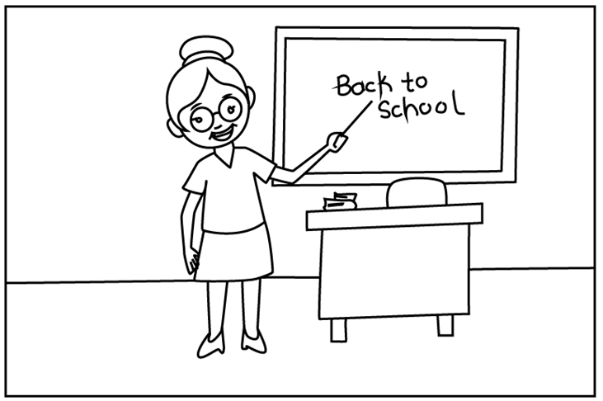
What is important to you?
Who is in your family?
How do you learn best?
What are you good at in school?
What do you find challenging in school?
What is your goal for year 5?

*Remember to use the punctuation checklist to help you include a range of punctuation in your writing

LO: We are learning to accurately use a range of punctuation in our writing.
Writing Task 2: Write a diary entry summarising your year. Fill in the My School Year Memory Page to use as your planning. Each box on the page can correspond to a paragraph in your summary.
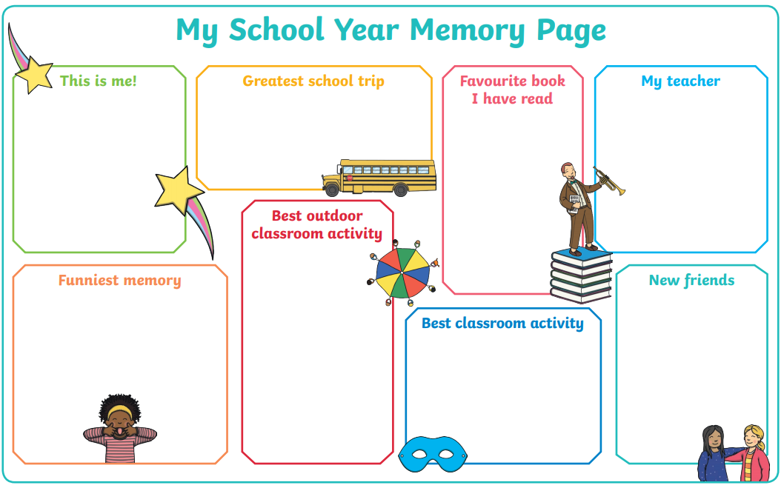
*Remember to use the punctuation checklist to help you include a range of punctuation in your writing
LO: We are learning to accurately use a range of punctuation in our writing.

Writing Task 3: Create a short story about how on the first day of the new school year you pop your head into the classroom and spot something strange about your teacher. This story can be based on your own imagination, or any of the following examples:
- Saw your new teacher was a robot
- Saw your new teacher was a genie who can grant three wishes to their favourite student
- Saw your new teacher was an alien in disguise (who was making a call back to the mothership)
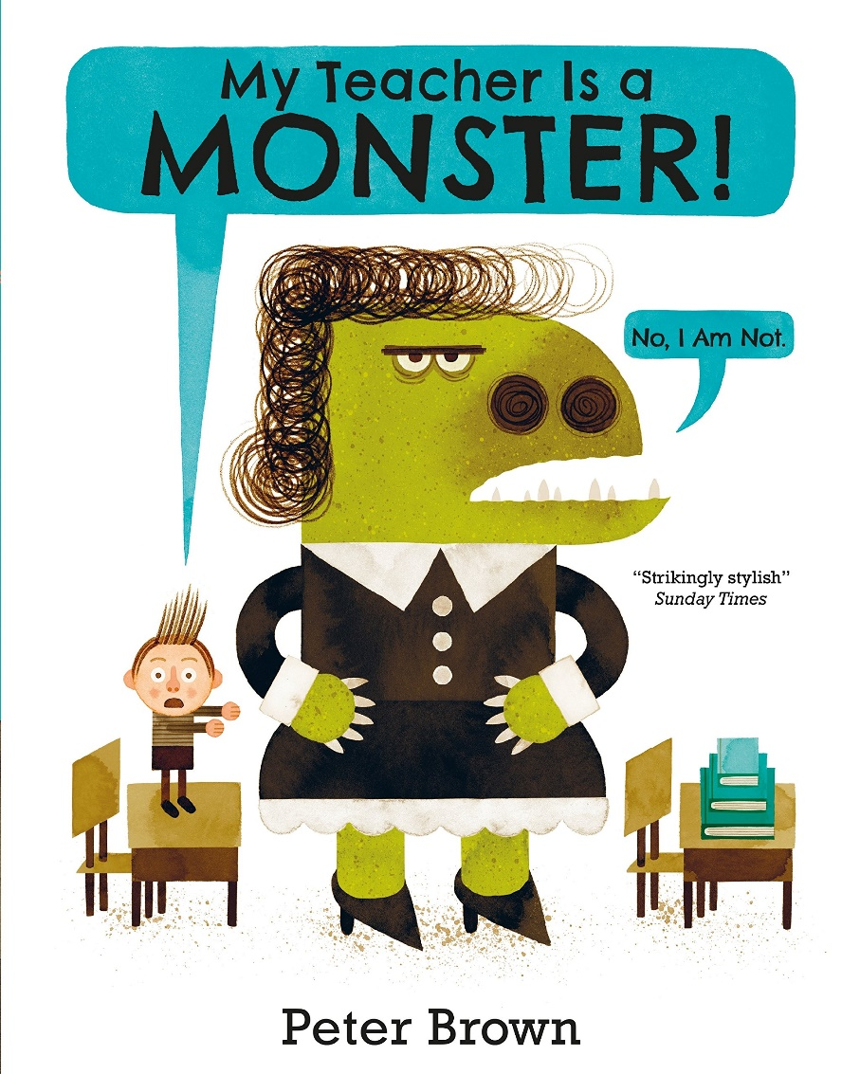

*Remember to use the punctuation checklist to help you include a range of punctuation in your writing

