Maths problem from the video
Day | Number of tickets sold
Monday | 45
Tuesday | 60
Wednesday | 35
Thursday | 70
Friday | 55
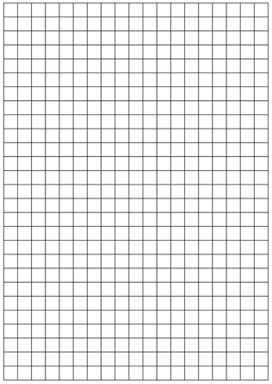

Introduction to Statistics

What is a bar chart?
A Bar Graph (also called Bar Chart) is a graphical display of data using bars of different heights
Imagine you just did a survey of your friends to find which kind of movie they liked best:
Table: Favorite Type of Movie
Comedy | Action | Romance | Drama | SciFi
4 | 5 | 6 | 1 | 4
We can show that on a bar graph like this:
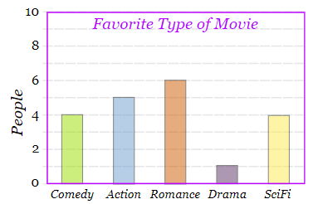
It is a really good way to show relative sizes: we can see which types of movie are most liked, and which are least liked, at a glance.
We can use bar graphs to show the relative sizes of many things, such as what type of car people have, how many customers a shop has on different days and so on.
What is a Pictograph?
Pictograph is a way of showing data using images.
Each image stands for a certain number of things.
Here is a pictograph of how many apples were sold at the local shop over 4 months:
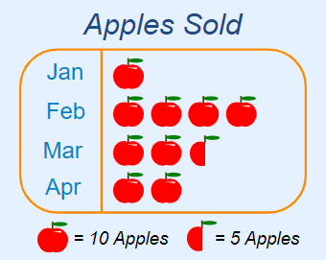
Note that each picture of an apple means 10 apples (and the half-apple picture means 5 apples).
So the pictograph is showing:
- In January 10 apples were sold
- In February 40 apples were sold
- In March 25 apples were sold
- In April 20 apples were sold
It is a fun and interesting way to show data.
But it is not very accurate: in the example above we can't show just 1 apple sold, or 2 apples sold etc.
Pictographs can also be vertical, like this:
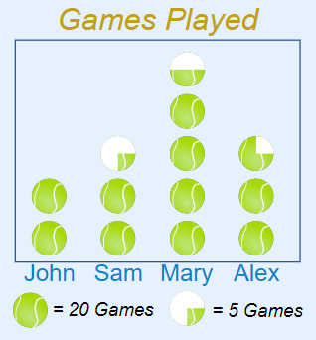

What is Discrete Data
Discrete Data can only take certain values.

Example: the number of students in a class
We can't have half a student!

Example: the results of rolling 2 dice
Only has the values 2, 3, 4, 5, 6, 7, 8, 9, 10, 11 and 12

What is Continuous Data
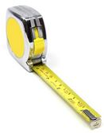
Continuous Data can take any value (within a range)
Examples:
- A person's height: could be any value (within the range of human heights), not just certain fixed heights,
- Time in a race: you could even measure it to fractions of a second,
- A dog's weight,
- The length of a leaf,
- Lots more!

Maths Activity 1: Fluency

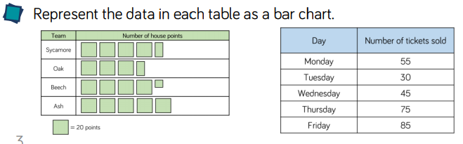
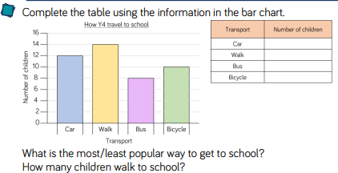
Maths Activity 2: Reasoning and Problem Solving
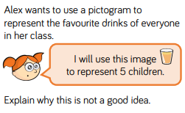
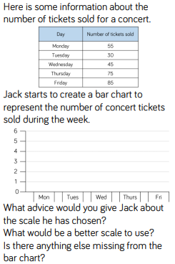
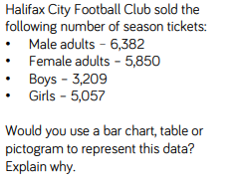

Maths Activity 3: Representing data in a bar graph

Complete the table and draw a bar graph using the following information and the squared paper provided.

- 24 children were asked to choose their favourite colour.
- A quarter of the children chose red.
- Two children chose green.
- The number of children who like pink is double the number of children who like green.
- Orange is as popular as green.
- The number of children who like blue is half the number of children who like red.
- No children like brown.
- An eighth of the children like purple.
- The rest of the children like yellow.
RED | GREEN | PINK | ORANGE | BLUE | BROWN | PURPLE | YELLOW



