

Phonics Activities Week 6

L.O. We are learning to segment the sounds in simple words and blend them together again.

Warm up: watch alphablock and practise reading with them
https://www.youtube.com/watch?v=nQPsHfx4Urw

Activity 1: For this activity we would like you to play the missing sound game.
In this activity, you will have the beginning and ending sounds in a word but need to find the missing middle sound.
To make the missing sound poster use any sized paper and write the words with a missing sound in the middle.
Then write out six of each vowel onto a Post-it and try to find a place where the vowel could fit. Not every vowel works in every word
Most words have multiple vowel options (like hat, hit, hut, hot)

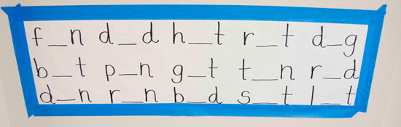

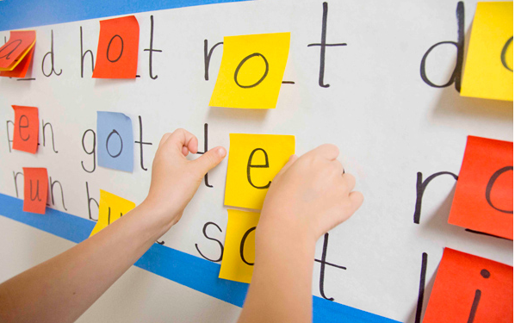

Activity 2: For this activity, we would like you to practise reading with these sentence strips.
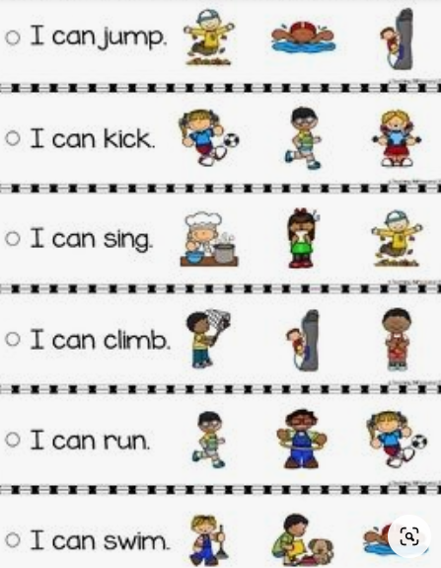
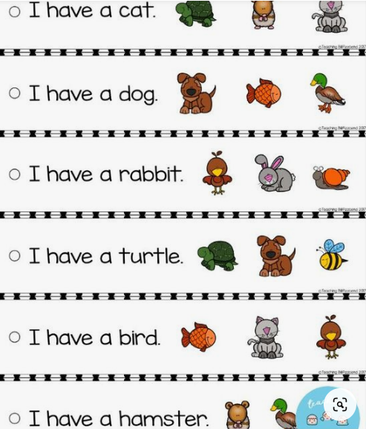

Activity 3: This activity is called ‘Sentence Scrambles’. If the sheet is printed, cut each strip. Then one at the time, cut out the words on each strip and paste them in the boxes and make a sentence, then write your sentence. If you cannot print the sheet write the sentence first, draw the boxes then write the words and paste them in the boxes to make the sentence. Remember to use a capital letter at the beginning, finger space between each word, and punctuation at the end.

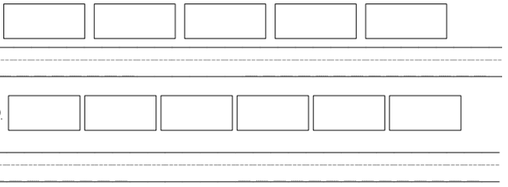

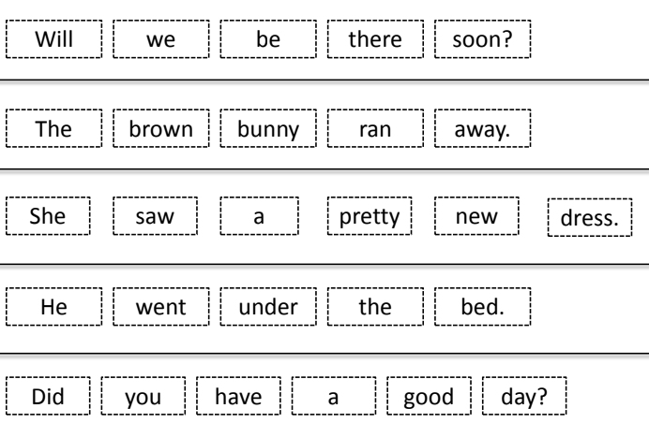

Reading Activities Week 6

L.O. We are learning to talk confidently about picture books using prediction, asking questions, expressing opinions.
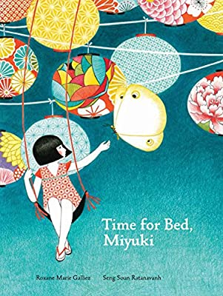

Warm up: Take a look at the front cover of our story this week. The title of the story is ‘Time for Bed, Miyuki’. Look closely at the illustrations; discuss with your adult what you think the story might be about. Where do you think the story might be set? Do you think it will be set in England or another country? Why do you think that?

Activity 1: Listen to the first page of the story https://www.youtube.com/watch?v=T9QOwnZVP5M, up to where it says, ‘But where is Miyuki?’ Why do you think the nightingale is preparing her nest? Why is the toad jumping in the bucket? What are the ants carrying? Who do you think Miyuki is and where do you think she is?

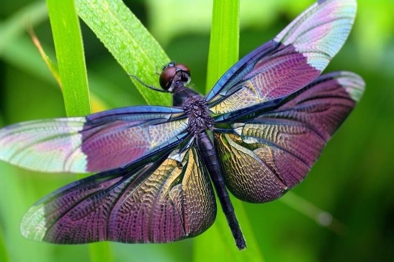
Activity 2: Read up to, ‘So grandfather helped Miyuki make a canopy…’ how would you prepare for the arrival of the dragonfly queen? Can you imagine what you would include in your garden to make it special for the dragonfly queen? Miyuki wants to have a canopy under the cherry tree, what flowers would you include?
Draw a picture of the garden you are imagining for the dragonfly queen to visit.

Activity 3: Read or listen to the end of the story. Can you re-tell the story to an adult? What different activities did Miyuki want to do before going to bed? This story is set in Japan, do you think you can go back through the story, looking at the different pictures and see which ones tell us this story is from Japan? Maybe you don’t recognise some of the things you have seen in the story? Maybe the clothes are different to what we might wear or the food is different to what we usually eat! Can you also see any similarities between Japan and England?

Please keep up the daily reading as much as possible, there are many great books on the Oxford Owl website that are sutiable for a range of levels, check the Saxon website for the username and password.
Username: saxonreception Password: reception
Writing Activities Week 6

L.O. We are learning to write simple sentences using fingers spaces and full stops.

Warm up: Listen to the story again, paying close attention to both the words and the pictures! https://www.youtube.com/watch?v=T9QOwnZVP5M

Activity 1: During the story, Miyuki explains to her grandfather that there are many jobs she needs to complete before she can go to bed. Can you write a recount of your evening? What do you like to do after eating dinner but before you go to bed? Are there particular jobs you need to complete like Miyuki?
You could use the sentence starter, ‘Before I go to bed I must…’ to help you write your sentences.
Remember to use the writing guide to help you form your sentences!
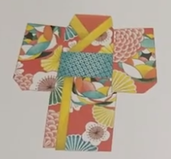
Activity 2: As you can see throughout the story of Miyuki, both Miyuki and her grandfather wear very special clothing. These clothes are called Kimonos and are traditional items of clothing in Japan. We would like you to design your own kimono below and then write a sentence or two describing your kimono. Think about the colours you will use, the shapes and patterns you will include and whether it will have a belt as well!

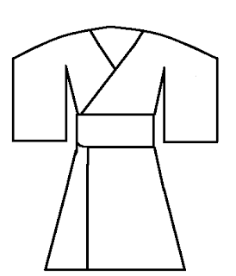

___________________________________________________________________________________________________________________________________________________________________________________________________________________________________________________________________________________________________________________________________________________________
Activity 3: Using the story and your tablet or computer, research what life is like in Japan and write a postcard to a friend or family member telling them all about Japan! There are some great ‘Go Jetters’ episodes where they visit Japan including https://www.bbc.co.uk/iplayer/episode/b08g56lb/go-jetters-series-1-50-the-jigokudani-monkey-park-japan

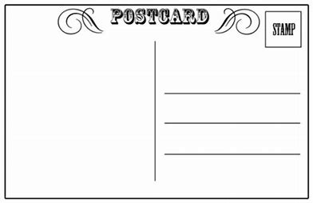
Maths Activities Week 6

L.O. We are learning to answer and record subtraction calculations.

Warm up: Can you help the Numberblocks add and subtract? Play the game and see if you can find the correct answer.
https://www.bbc.co.uk/cbeebies/puzzles/numberblocks-number-magic-adding-and-subtracting

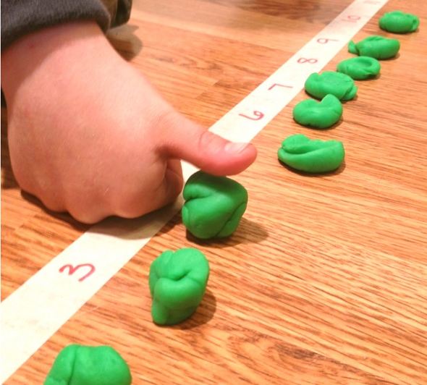
Activity 1: For the subtraction squish activity you need playdough and masking tape and it’s very simple to play. First, use a piece of masking tape to create a number line on the floor. We are working on subtraction facts up to 20, so the number line needs to go from 1-20. Next, you have to make a few balls from playdough.
Then it’s time to play!
Ask an adult to make a variety of subtraction problems. This can be like 12-4 or 18-7 etc. Once you have the subtraction problem, you can line up the correct number of play dough balls and then squish them to find the answer. (For instance, if the problem was 10-6, you would put a ball on each number up to 10, and then squish 6 of the balls. Afterwards, you have to check how many of the balls are un-squished, to help you find the answer. Have fun!

Activity 2: For this activity, you can play with your adult or sibling. You will need a dice/cube and write numbers on a sticky note ‘1’, ‘2’, and ‘3’ - each number on two sides. You can use anything instead of counters to move along the game board - one item per player. You also need a number line and you can make this together with your adult. You have to put your counter at the end of the number line. Take turns to roll the dice/object and move the counter along the number line by moving backwards by the number rolled on the die/cube.
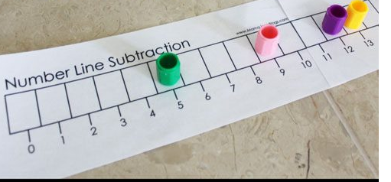
Take a look at the videos your teacher sent you to see how the game works in action!

Activity 3: Practise your number facts! How quickly can you complete these number sentences (you could do one column at a time)? Have a go at timing yourself at the beginning of the week and then again at the end to see if you can answer them even quicker! For this activity you can use any objects you like to find the answer. And you can also make up your own number stories.
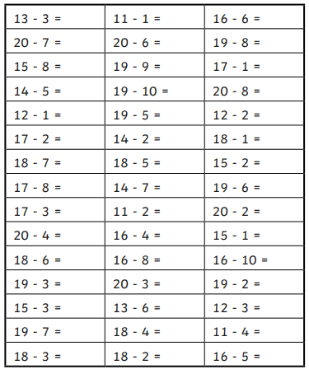
Example: I have 13 bananas. I eat 3. How many bananas are left?



Project Week 6

This week in school it is STEM week so there will be many exciting and interesting science experiments taking place. We would like you to join in too so below is a fun experiment you can complete at home.


