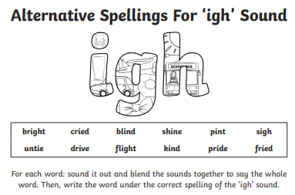
Year 1 Week 6 Phonics Activity 2
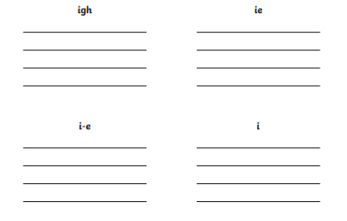
Challenge: Try and write a sentence using a word from each group if you can.

Phonics Activity 3 – Complete the table by writing the word next to each picture using the igh sound at the top.
(Answers below if you are stuck!)
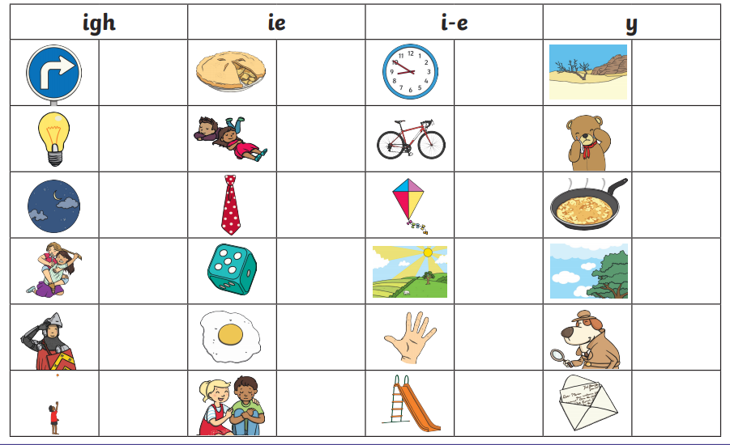
Answers to Phonics Activity 2.



