Maths Week Six.

This week your Maths learning is on money. If you have real coins to use and explore then fantastic! If not, don’t worry; you can cut out these pictures to help you.
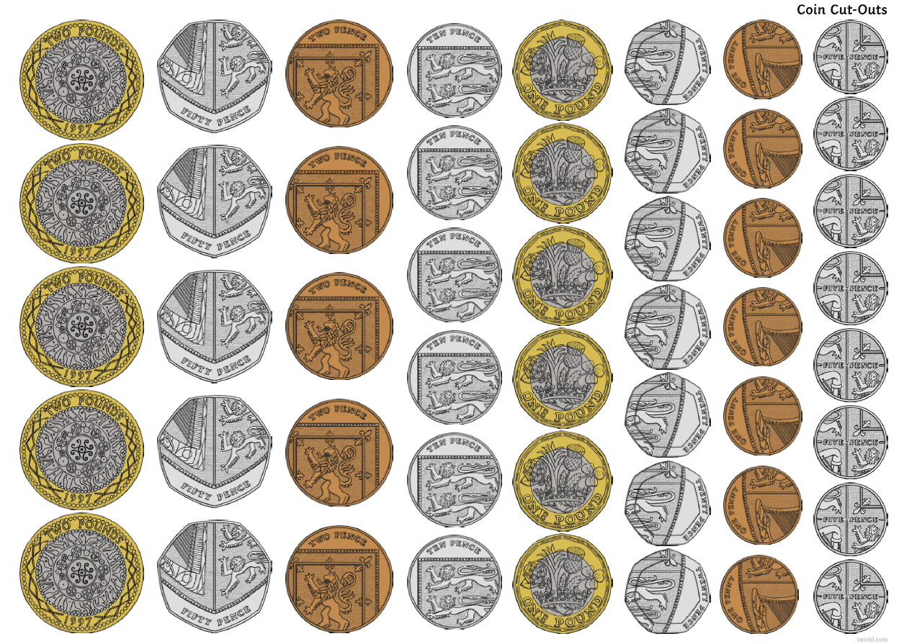

Session 1.
Warm up | Count to 100 – number counting practice.  As always, make sure you pronounce your teen and ty numbers correctly. Can you count backwards?  https://www.youtube.com/watch?v=cVwjmC-gpBU
Main activity | Go to BBC Bitesize Maths lesson 30th June.  https://www.bbc.co.uk/bitesize/articles/zhwy6g8  Follow the activities and coin practice. Then complete the learning sheets below.  You can watch the video on White Rose 30th June if you would like as well.  https://whiterosemaths.com/homelearning/year-1/
Game | https://www.oxfordowl.co.uk/api/interactives/24483.html  Complete the Oxford Owl money questions.
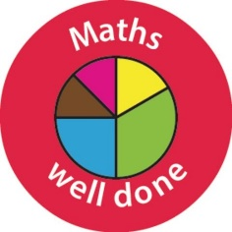 Well done Year One!

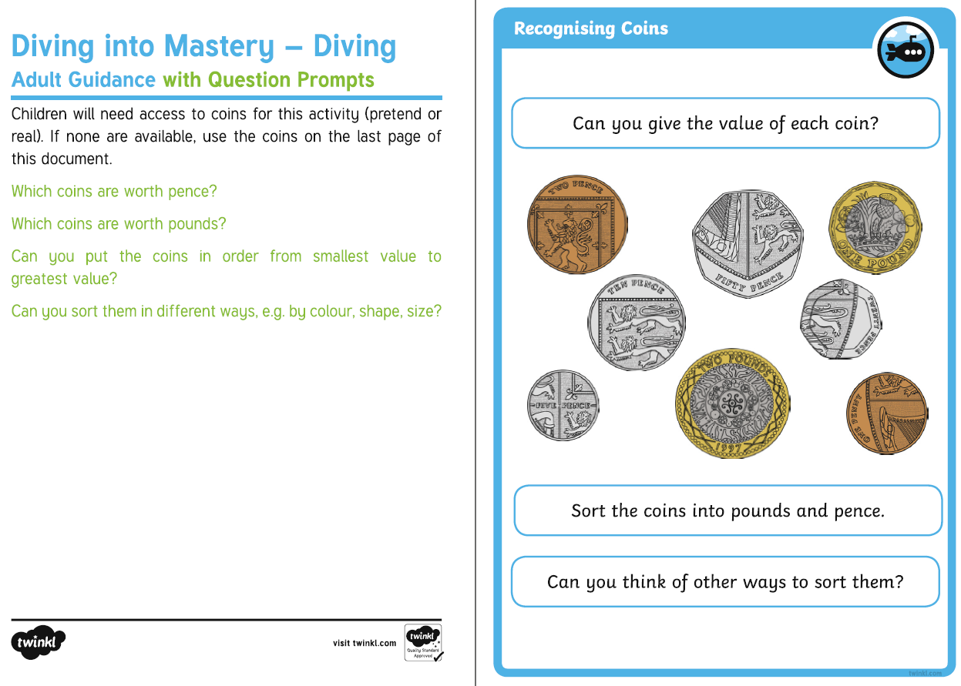
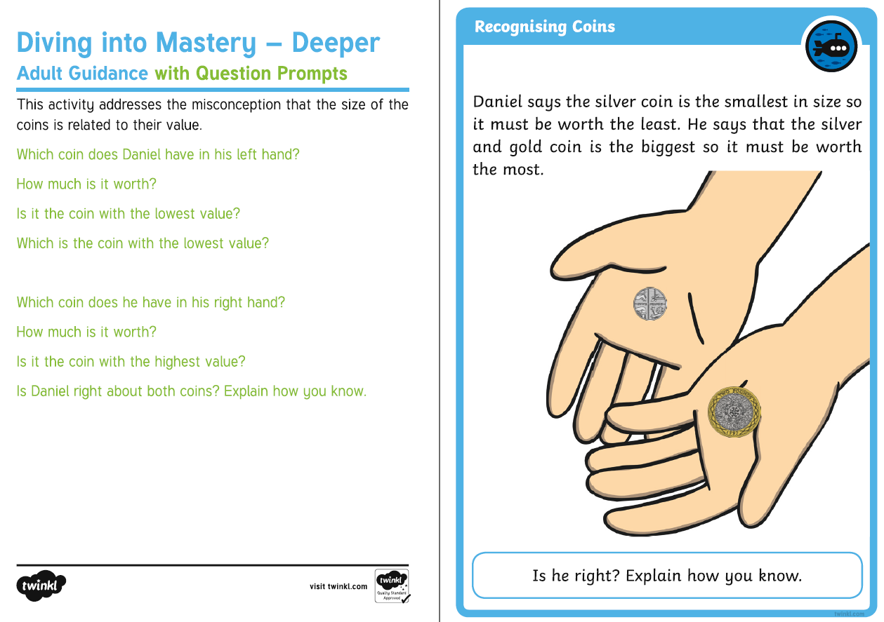
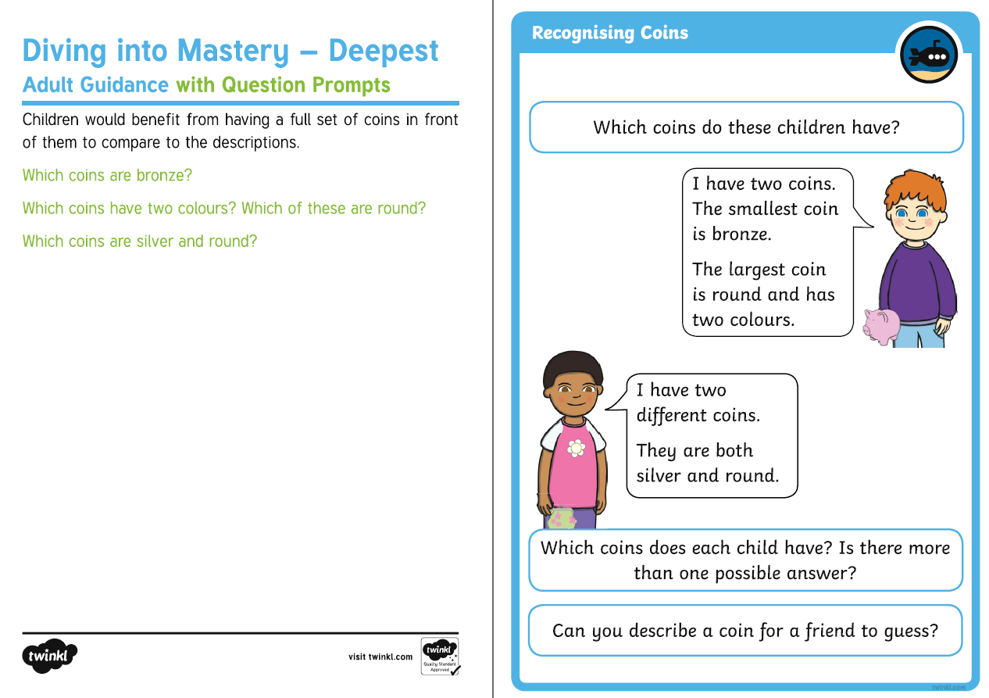

Session 2.
Warm up | https://www.youtube.com/watch?v=OCxvNtrcDIs#  Today we would like you to practise counting in 2s. If you don’t practise then you might forget!
Main activity | Watch the video from your teacher in the green box on your overview sheet. They have gone to the shop!  Play shops with someone at home. You can use our price list or make up your own. Complete the learning sheet below.
Game | https://www.topmarks.co.uk/money/toy-shop-money  Go to the online shop!

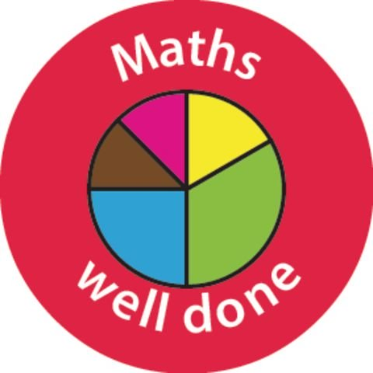
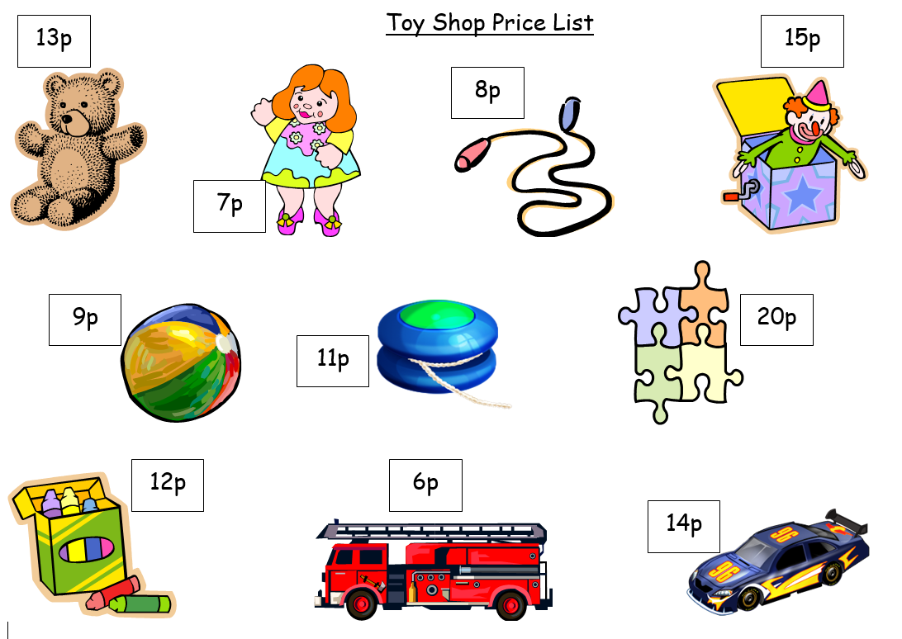
You are at the toyshop. What would you like to buy? Which coins will you need?
Draw the coins you have used.

I spent _____________.

Session 3.
Warm up | Today we would like you to practise counting in 5s. If you don’t practise then you might forget!  https://www.youtube.com/watch?v=EemjeA2Djjw
Main activity | Practise your money and addition knowledge by adding the amounts in each purse.
Game | https://www.topmarks.co.uk/money/coins-game  Can you order the coins?

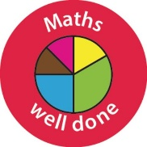
Well done Year One! You have done so well this week.

LO: To recognise coin values and use addition knowledge to find the total amount.
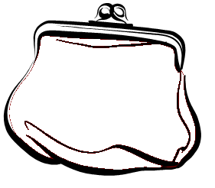
How much money is in my purse?

Which coins can I put in this purse to make 6p?

How much money is in my purse?

