Please watch the video of Mr Howick or Miss Robinson first.
Time of the day | Temperature in London on 25th June 2020
6.00am | 19
8.00am | 24
10.00am | 27
12.00pm | 29
2.00pm | 32

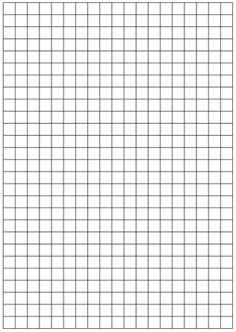

Introduction to Statistics

What is a Line Graph?
A Line Graph is a graph that shows information that is connected in some way (such as change over time).
You are learning facts about dogs, and each day you do a short test to see how good you are. These are the results:
Table: Facts I got Correct
Day 1 | Day 2 | Day 3 | Day 4
3 | 4 | 12 | 15

And here is the same data as a Line Graph:
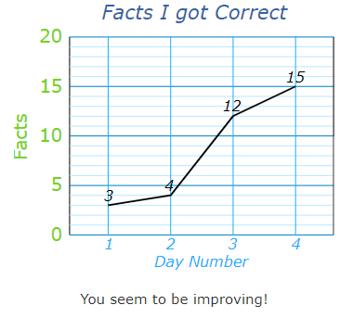

Making Line Graphs

Example: Ice Cream Sales
Table: Ice Cream Sales
Mon | Tue | Wed | Thu | Fri | Sat | Sun
$410 | $440 | $550 | $420 | $610 | $790 | $770
Let's make the vertical scale go from $0 to $800, with tick marks every $200

Draw a vertical scale with tick marks
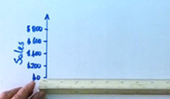
Label the tick marks, and give the scale a label
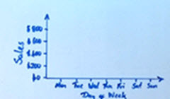
Draw a horizontal scale with tick marks and labels
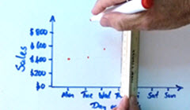
Put a dot for each data value
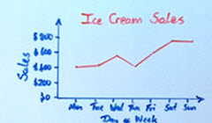
Connect the dots and give the graph a title
Important! Make sure to have:
- A Title
- Vertical scale with tick marks and labels
- Horizontal scale with tick marks and labels
- Data points connected by lines

What is Discrete Data
Discrete Data can only take certain values.

Example: the number of students in a class
We can't have half a student!

Example: the results of rolling 2 dice
Only has the values 2, 3, 4, 5, 6, 7, 8, 9, 10, 11 and 12

What is Continuous Data
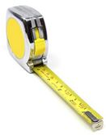
Continuous Data can take any value (within a range)
Examples:
- A person's height: could be any value (within the range of human heights), not just certain fixed heights,
- Time in a race: you could even measure it to fractions of a second,
- A dog's weight,
- The length of a leaf,
- Lots more!

Maths Activity 1:
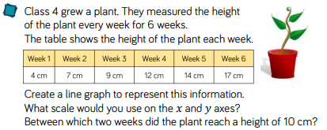

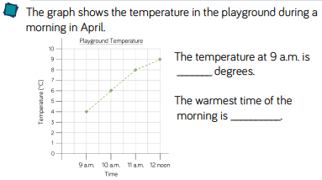


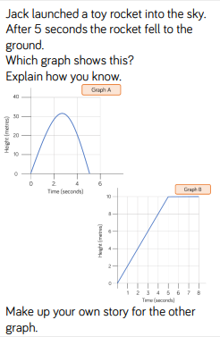
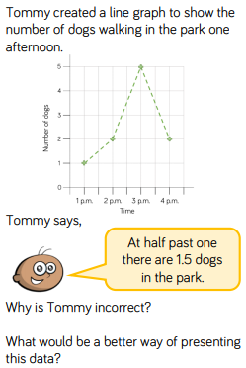
Maths Activity 2:
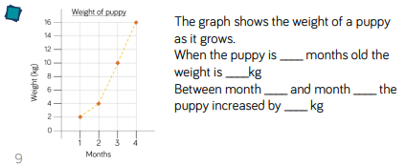
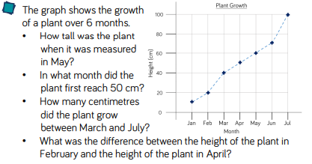

Maths Activity 3:
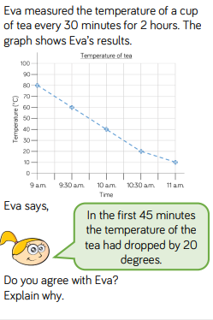

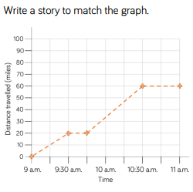

Temp

This graph shows the temperature in a room over twelve hours. Answer the questions below.

1a) What was the lowest temperature recorded on the chart.

1b) What was the temperature at 3 o’clock am?

1c) What was the temperature at 11.00?

1d) Which hour shows the biggest rise in temperature?

1e) For how long was the temperature between 16 and 17 degrees?

1f) Can you estimate the temperature at 07.30?

1g) Can you estimate the temperature at 10.00?

