Which song was it?
Happy Birthday
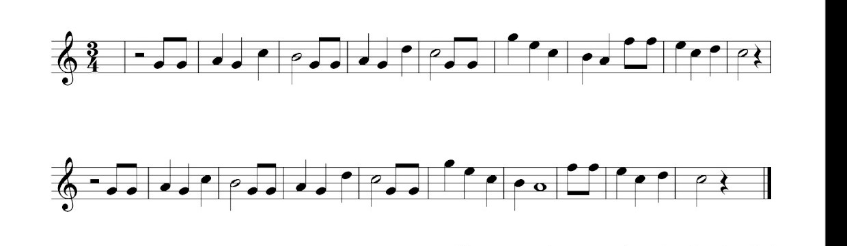

Can you plot some notes on the blank stave?
Can you write your own composition?
Have a go.
Also practice drawing the treble clef.
Use the blank stave to practice plotting notes and naming them. Use the following to help.




