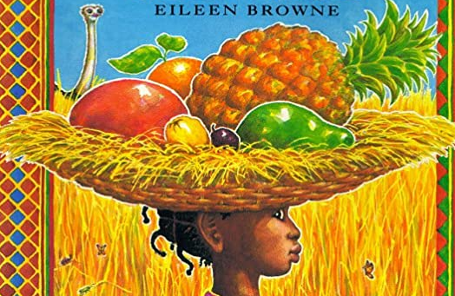

Phonics Activities Week 1

L.O. We are learning to segment the sounds in simple words and blend them together again.

Warm up: Play some Phonics games.

https://new.phonicsplay.co.uk/resources/phase/3/buried-treasure

https://new.phonicsplay.co.uk/resources/phase/3/dragons-den

Listen to the tricky word song
https://www.youtube.com/watch?v=TvMyssfAUx0&list=RDQM6Px4gdBehlY&start_radio=1&safe=active

Activity 1:

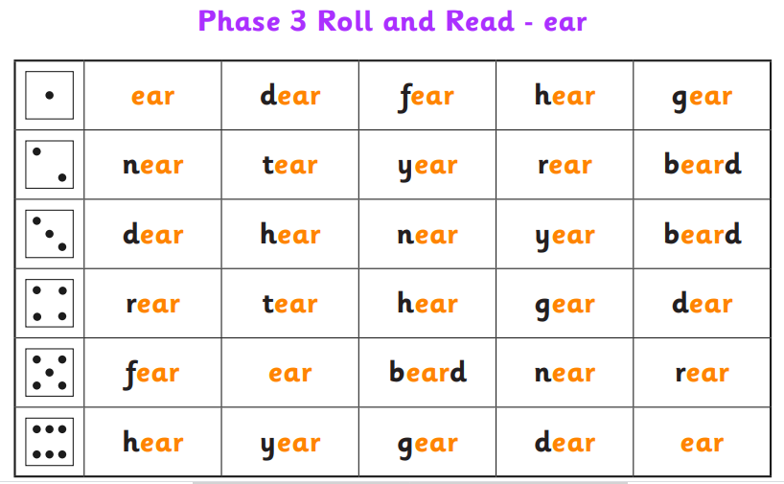

Activity 2:
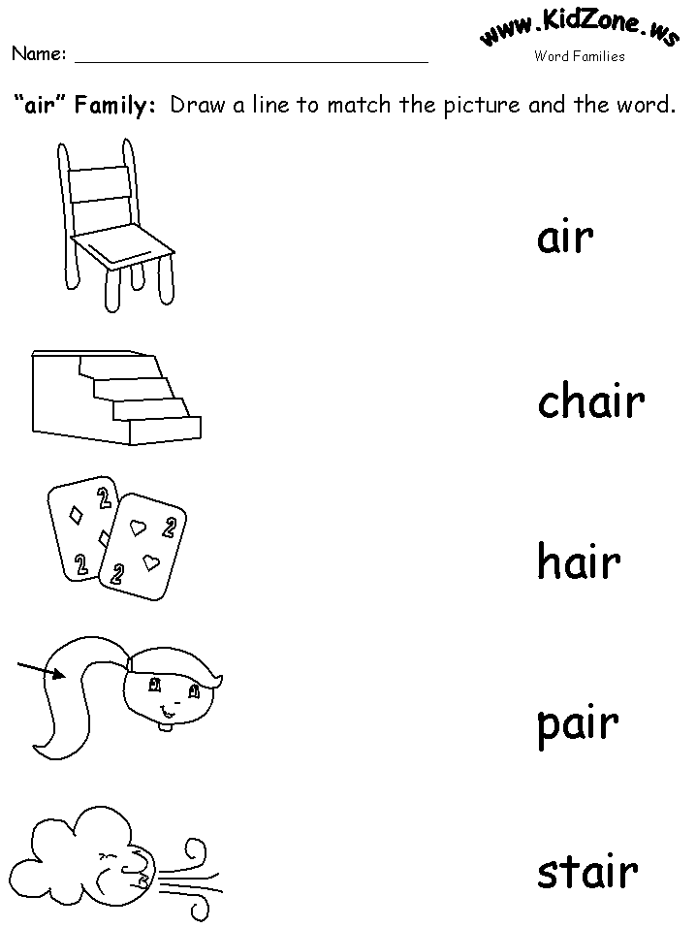

Activity 3:
Tricky words- Have a go at writing some tricky words using chalk on the ground or using paint and water on your fence or pavement. You could make a tricky words lucky dip or hide some on flashcards around the house. You can compete against your adult or sibling to see who can find the most. 1 point for finding the word 2 points if you can read it too!

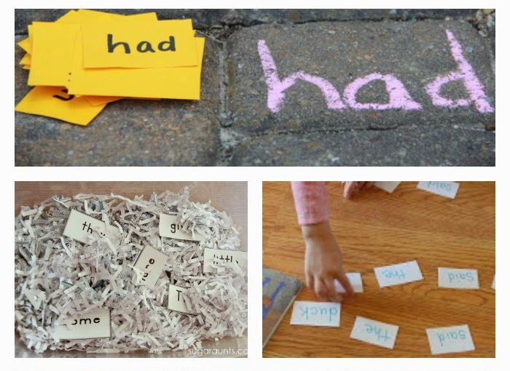

Reading Activities Week 6

L.O. We are learning to talk confidently about picture books using prediction, asking questions, expressing opinions
Warm up: Have a look at the front cover of the book with your adult. What do you think the book is about? What do you think the surprise might be? What makes a surprise? Have you ever had a surprise? Has your adult ever had a surprise? How did this make you feel? Why do you think you felt like that?

Activity 1: Read the first page https://www.youtube.com/watch?v=ocnRQi89nK8 and continue reading up to the point where Handa sets out on her journey. If you can, collect together the eight fruits or some of the fruits from the story and place them in a basket. What do they feel like/ What do they smell like? Now have a go at chopping some of them up and tasting them. What do they taste like? Which is your favourite and why? Thinking about the taste, the texture, the smell and the feel of the fruits. Can you record your answers next to a picture of the fruit?
Return to the story and discuss which fruit you think Handa’s friend will like best. You could then make a fruit salad using all of your favourites.

Activity 2: Re-read the first part of the story and take time to look carefully at the illustrations.
Why do you think Handa was taking Akeyo a surprise? What does this tell us about her personality? Do you think Akeyo will like the surprise. Which fruit do you think she will like best and why? What do you think Akeyo would say to Handa if she was writing her a thank you card?

Activity 3: After you have read the whole story, see if you can re-tell the main events to an adult or a sibling in your home. For your final reading activity you are going to create a story map (a series of pictures to represent a story) to retell Handa’s Surprise. You will need to think about where the story took place, what Handa took with her and who she met along the way.

Please keep up the daily reading as much as possible, there are many great books on the Oxford Owl website that are sutiable for a range of levels, check the Saxon website for the username and password.
Username: saxonreception Password: reception

Writing Activities Week 6

L.O. We are learning to write short sentences in meaningful contexts.

Warm up: Throughout the week have a go at trying different fruits and vegetables, after tasting them we would like you to think about words that you would use to describe the way it tastes, for example: sweet, sour, tough, soft. Write these down and keep them safe, they will be useful for when you complete your writing activities!

Activity 1: In our story, Handa is taking her special friend a basket of fruit. We would like you to have a think about what gift you would like to take to your special friend. You might want to make something for them, paint them a picture or even cook them something delicious. Have a go at writing a sentence or two explaining what it is you would take to your special friend, you can always draw a picture to go with your sentence!

Activity 2: Re-read or listen to the story again, paying close attention to the part when the fruits were stolen from the basket. Listen carefully to the words used to describe the fruits e.g. soft yellow banana, ripe red mango and creamy green avocado. These are all adjectives and they help us to imagine exactly what Handa is tasting!
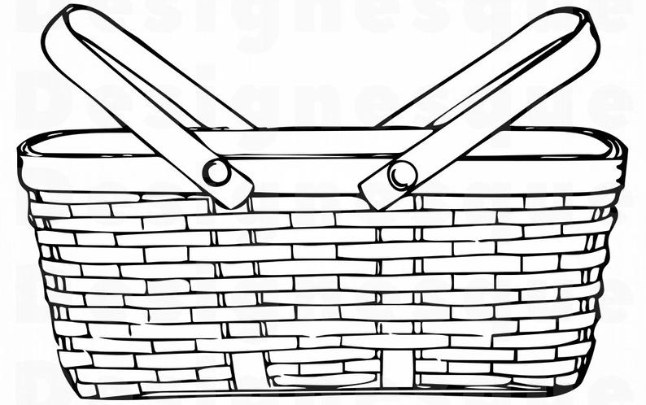
Using the basket outline below, draw some of the fruits or vegetables that you have tried this week and underneath, using your warm up activity to help, can you write some sentences describing the different foods you have tasted?

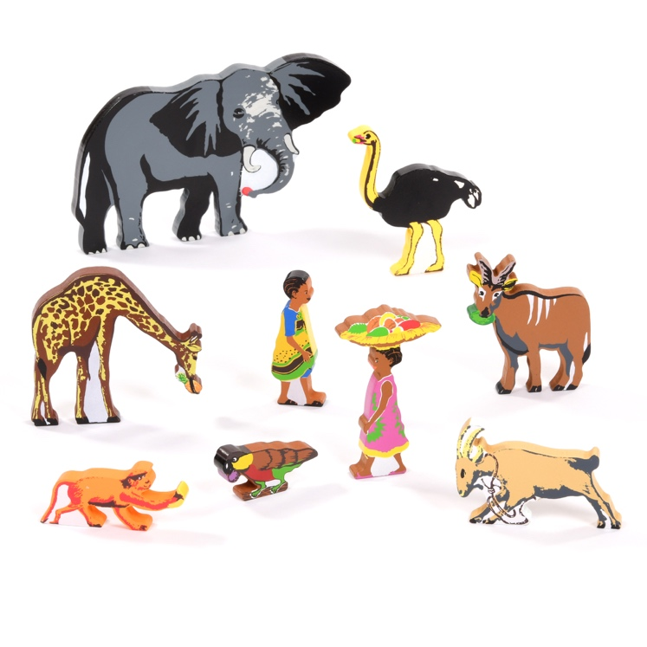
Activity 3: There are many animals in our story this week. Listen to this clip http://bbcsfx.acropolis.org.uk/ and see if you recognise any of the animals from the noises that they make. Can you name the different animals that were in our story? If you are unsure of what any of the animals are in the story, spend some time looking at pictures or videos of them, you can find lots of information about African animals on the London Zoo webpage!

We would like you to write about your favourite animals in the story. Can you describe what they look like? How do they move? Tell us about what they like to eat? Afterwards you could paint a picture of the animal you have chosen.

Challenge: Create your own story of Handa’s Surprise! Using the ideas you have come up with already, such as the gift you would take a special friend and the animals you might see, can you write your own version of the story. Include pictures to go with each page!

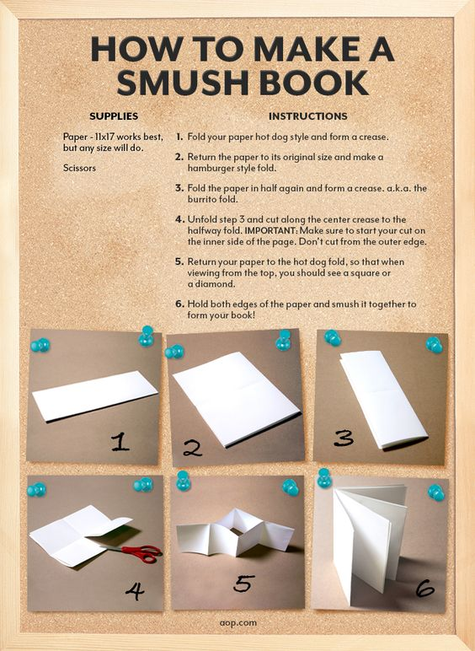

Maths Activities Week 6

L.O. We are learning to use everyday language about the size and weight of objects.

Warm up: https://www.youtube.com/watch?v=idsrFnyOqr4 This is a great introduction to measure and will help to remind us of the learning we have previously done!
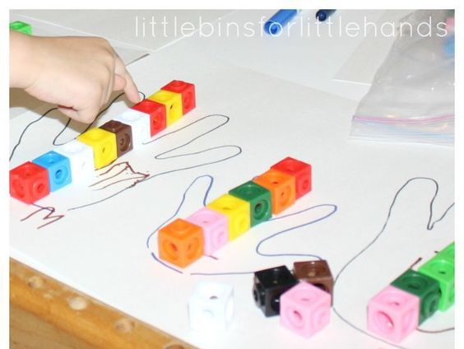

Activity 1: Your first activity is all about measuring the size of different people’s hands using non-standard measurements (this means you can use anything you can find in your house to measure). First you will need to draw round the hands of different people in your house. Next, find something you would like to use to measure with, dried pasta would work well. Have a go at estimating how many pasta pieces long you think each hand will be before measuring e.g. 5 pieces long.

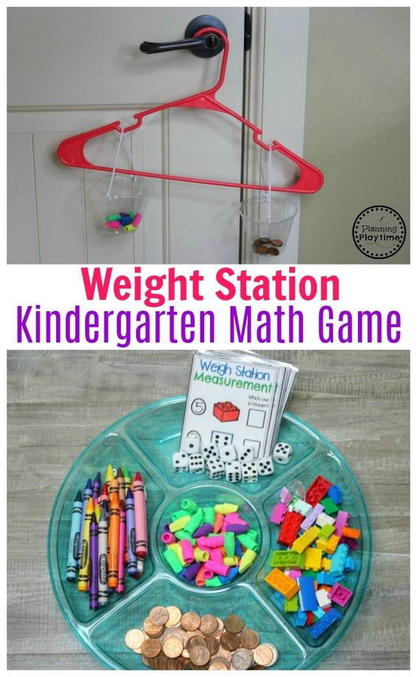

Activity 2: This activity is about comparing the weight of different objects around your house. You will need a clothes hanger, some string and two cups or something similar which can hold the objects. Hang your clothes hanger on a door handle and place different objects in each cup. The cup that drops will be the heavier object. Explore the weight of different objects around you house!

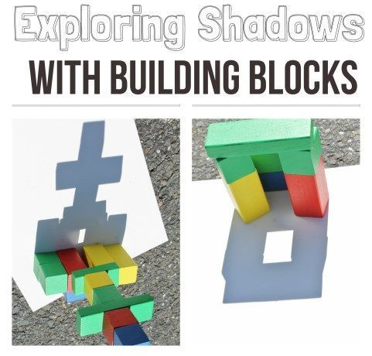
Activity 3: For your final activity you will need to build a model first (one that is quite tall!). This could be out of Lego or any other materials you have available in your house. Place your model on a piece of white paper and place it somewhere in your garden or near a window that receives lots of sunlight. We would like you to draw around the shadow of the object multiple times throughout the day, paying close attention to the changes you can see. Is the shadow getting taller? Or shorter? Is it wider? Or is it thinner? Is the shadow’s change in size a surprise to you?

Project Week 6

Basket Weaving

L.O. We are learning to select tools and techniques needed to shape, assemble and join materials we are using.

This week, we thought that you would enjoy making a basket, like Handa had, to put your fruit or special gift in. Then you could surprise someone with it just like Handa did!

Things that you will need to make the basket
2 pieces of different coloured paper
Scissors
Glue
Stapler
Steps:
1. Cut both pieces of paper into 8 equally long and wide strips.
2. Put 5 blue colour strips vertically.
3. For the yellow colour strips, put them alternately as the picture.
4. Put 5 yellow strips alternately with the blue strips.
5. The base of the basket is formed.
6. Stick the sides of the basket.
7. Bunch the extra parts of the base and staple them. Repeat this step for the remaining sides.
8. Form the handle of the basket by stapling the other 2 strips on the top of the basket.



