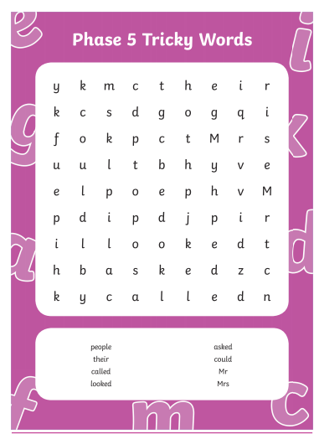

Common Exception Words
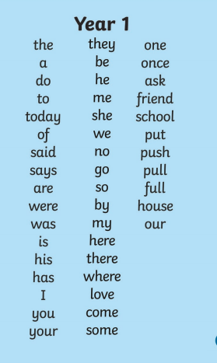

4 in a Row Game

This game is for 2 people so play with someone at your house. You will need a set of two different coloured counters (around 10-15 of each colour). If you don’t have counters, coloured sweets, small toys or coins will do. Cut out the list of common exception words and put them into a hat, bag or bowl. Take it in turns to pull out a word. One of you reads the words out loud, the other one has to write it with correct spelling. If you can spell it correctly, you can place a coloured counter on the board. The aim of the game is to get four counters in a row, horizontally, vertically or diagonally.

