
Saxon Primary School
Briar Road
Shepperton TW17 0JB
Friday 29th May 2020

Dear Year 1 children,
How are you? We hope you are all well at home and enjoying the sunshine. We are missing you all and thought it would be nice to share with you what we have been doing whilst you have been away from school.
First, we went to stay with Miss Parsons and had great fun but then we returned to school to star in the videos for you of the teachers reading Giraffes Can’t Dance. We hoped you enjoyed it and did you spot us in the classrooms? It was very funny being there without all of you chatting and laughing and making so much noise! We thought we did very well in the filming – Miss Doughty and Mrs Morley kept on giggling and Miss Parsons loved it!
Next, we have been having a lovely time in gardens. Sunbathing, riding bikes, having barbecues (Fraser and Rosie love toasting marshmallows!) We have all been eating rather too much, especially ice-cream! Have you had any ice-creams or lollies? Which ones are your favourites?
Our learning this week is all about plants, so if any of you want to grow one, or have planted a seed already perhaps you could keep a diary of how it is growing and send us some pictures. We have been lucky with the weather so thought we would plant some sunflowers. See the pictures for how they are growing. Bob kept getting a bit muddled about the order of things and his seed hasn’t started growing yet. He might need some helpful instructions on how to plant a seed and start again! Perhaps you could help him?
Well, that is it for now Year One. We would love to hear what you have all been doing so perhaps you could write us a letter to let us know.
We look forward to seeing you all very soon,
Love from

Fraser (1DM) and Bob and Rosie (1P)


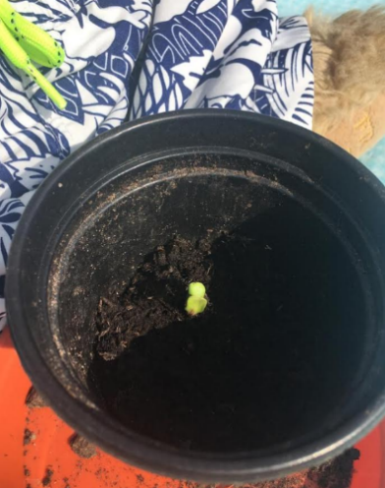
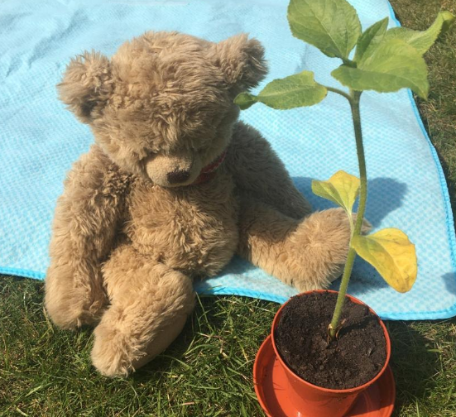
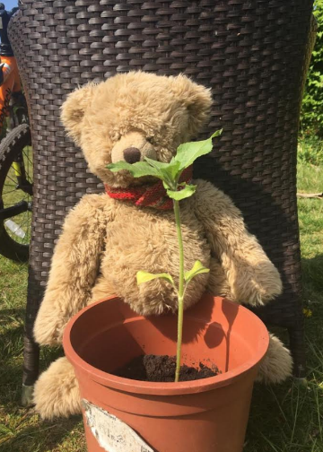
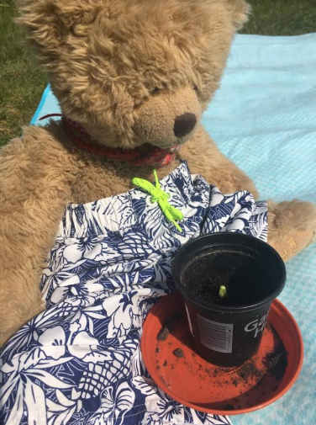
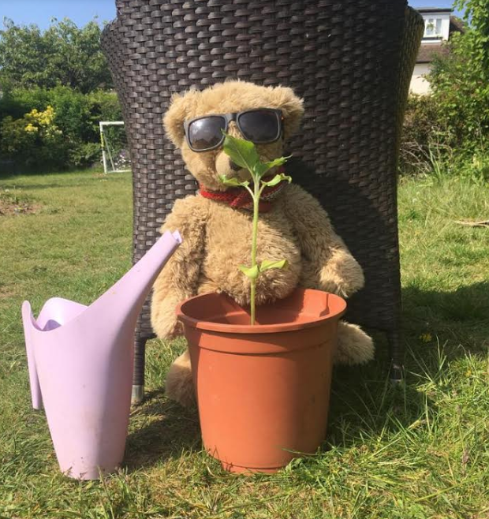

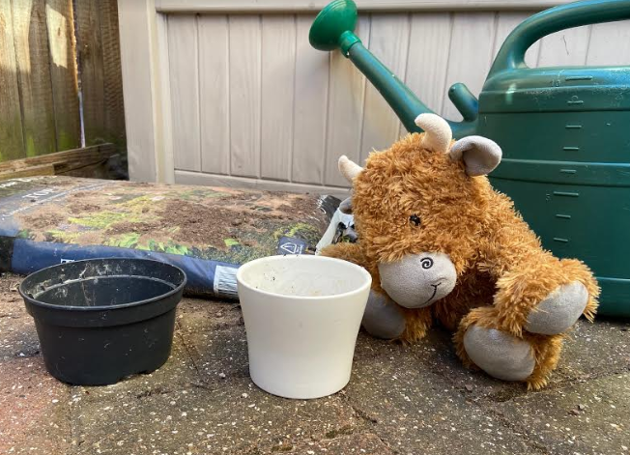
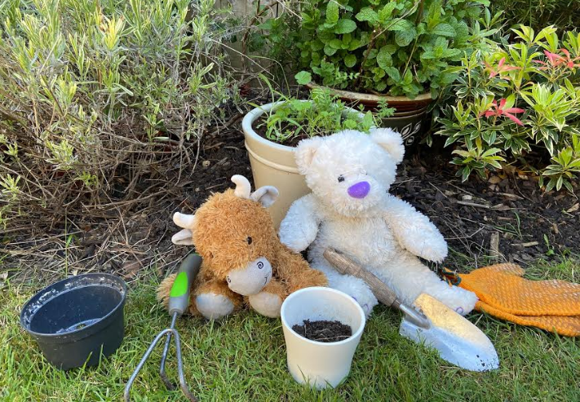
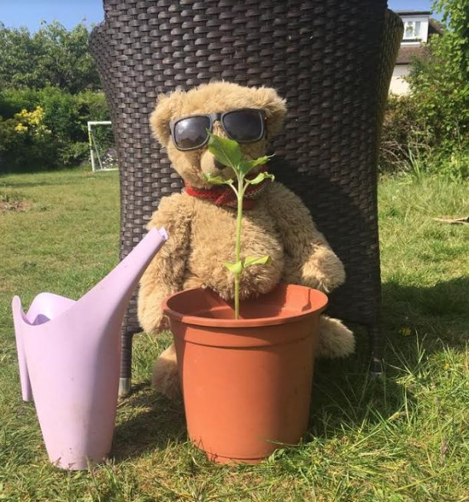
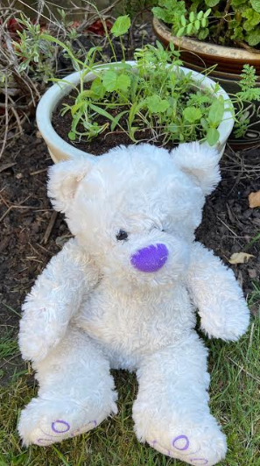
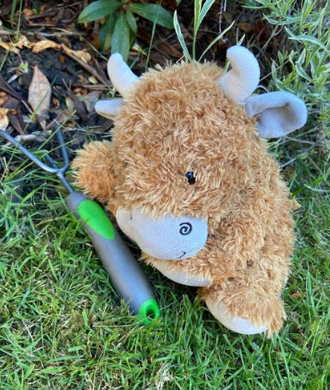
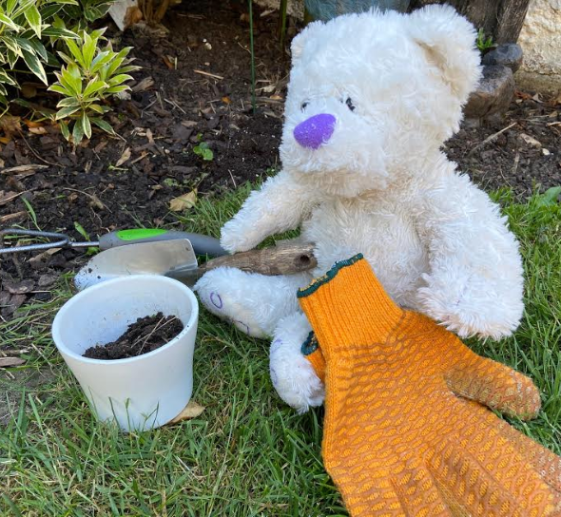
Can you help me?

