Maths Week One.
This week your Maths learning videos are on the White Rose Website and the learning sheets are below (just like last week). The learning sheets can be accessed through the BBC Bitesize if you would like to download them directly. There will be three different sessions - see how many you can do! The learning all links to BBC’s Daily lessons from week beginning 18th of May.
Session 1.
Warm up | Our focus this week is measure. It is still important to keep practising our counting. Make sure you are pronouncing ty and teen numbers correctly.  https://www.youtube.com/watch?v=e0dJWfQHF8Y
Main activity | Go to the White Rose Maths website.  https://whiterosemaths.com/homelearning/year-1/  Select lesson Summer Term Week 5 Lesson 1. ‘Compare length and height’.  Watch the video and join in with the activities it asks you to do.  Complete the learning sheet below or you can download it here. https://www.bbc.co.uk/bitesize/articles/zf4vbdm  There are also extra activities on BBC Bitesize lesson 18th May, if you would like to do those too!
Game | Choose between these online games for length and height. Your adults will need to sign up to log it (it is free).  https://www.splashlearn.com/measurement-games  Alternatively, you can challenge a member of your family to see who can find the shortest and tallest object in the room.
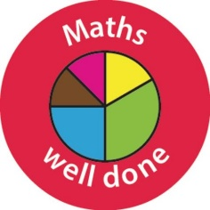 Well done Year One!

Session 2.
Warm up | Our focus this week is measure. It is still important to keep practicing our counting. Make sure you are pronouncing ty and teen numbers correctly.  https://www.youtube.com/watch?v=yTeUqWGCKjA
Main activity | Go to the White Rose Maths website. https://whiterosemaths.com/homelearning/year-1/  Select lesson Summer Term Week 5. Lesson 2 ‘Measure length (1)’.  Watch and join in with the video, then complete the learning sheet below.  You can download the learning sheet here on the BBC Website (Lesson 19th May).  https://www.bbc.co.uk/bitesize/articles/zbwc92p  If you don’t have cubes at home don’t worry! Use paperclips, a coin or ask adult to help you think of something you have at home that you could use to measure.
Game | For today’s game, I am challenging you to see how many objects you can find that measure smaller than 10 cubes/paperclips fingers. What are the objects?  Or, you can play this game measuring using cm.  https://www.topmarks.co.uk/maths-games/measuring-in-cm

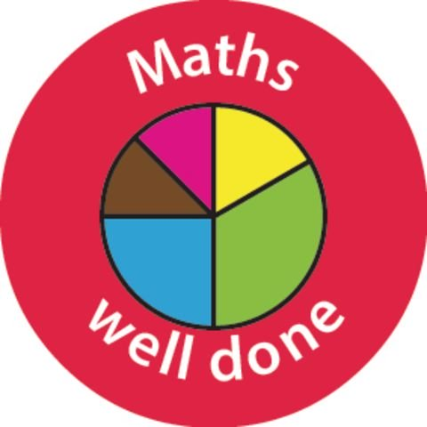

Session 3.
Warm up | Our focus this week is measure. It is still important to keep practicing our counting. Make sure you are pronouncing ty and teen numbers correctly.  https://www.youtube.com/watch?v=3txltaYkTyE
Main activity | Go to the White Rose maths website: Week 5 lesson 3. ‘Measure length 2’.  https://whiterosemaths.com/homelearning/year-1/  On BBC Bitesize, lesson 20th May. You can download the learning sheets here too.  https://www.bbc.co.uk/bitesize/articles/zrq98xs  Get your thinking caps on today Year 1. Remember to write down number sentences to help you to solve these questions.
Game | Choose your measure game today. Maybe you would like to practise telling the time. Or you can continue with length and length and height.  https://www.topmarks.co.uk/maths-games/7-11-years/measures

Well done Year One! You have done so well this week.
Have a brilliant half term!



