Introduction to Symmetry

Something is symmetrical when it is the same on both sides. A shape has symmetry if a central dividing line (a mirror line) can be drawn on it, to show that both sides of the shape are exactly the same.

Identifying lines of Symmetry in 2D Shapes
In Year 4, children are asked to identify lines of symmetry in 2D shapes presented in different orientations. They will need to become aware that shapes have more than one line of symmetry. They may be asked to look at these regular shapes and think about how many lines of symmetry they can find. It is helpful for them to cut out the shapes and fold them in half, then look at how many folds they have made.
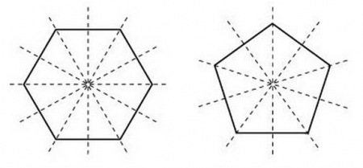

They might also be asked to classify shapes according to various properties, including line symmetry. They may be given a group of shapes and asked to put them into a Carroll diagram as follows:
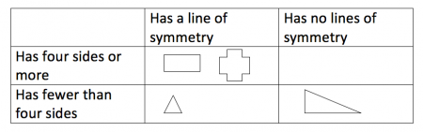

Completing a symmetrical figure
Children begin to reflect shapes in a mirror line. They may be asked to complete the shading in a shape after reflecting it in a mirror line, or be given half a shape with a mirror line and asked to draw the other half. 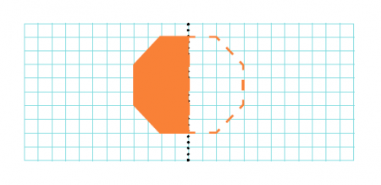

Maths Activity 1: Identify the lines of symmetry in the following 2D shapes

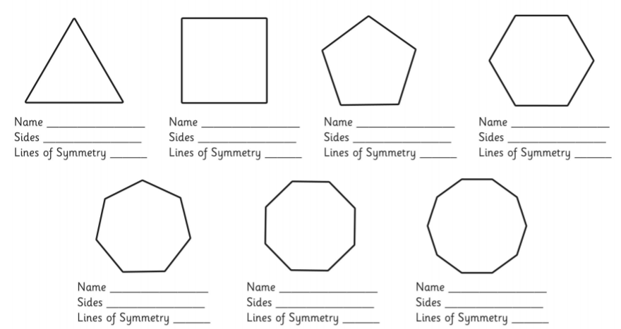
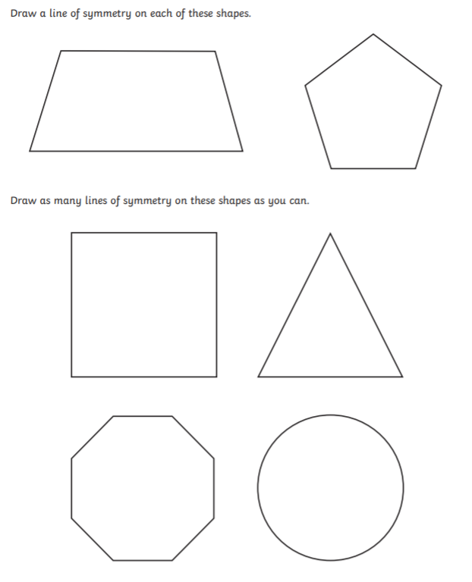

Identify the lines of symmetry in each of the following shapes (Hint: some shapes have no lines of symmetry and some have many):

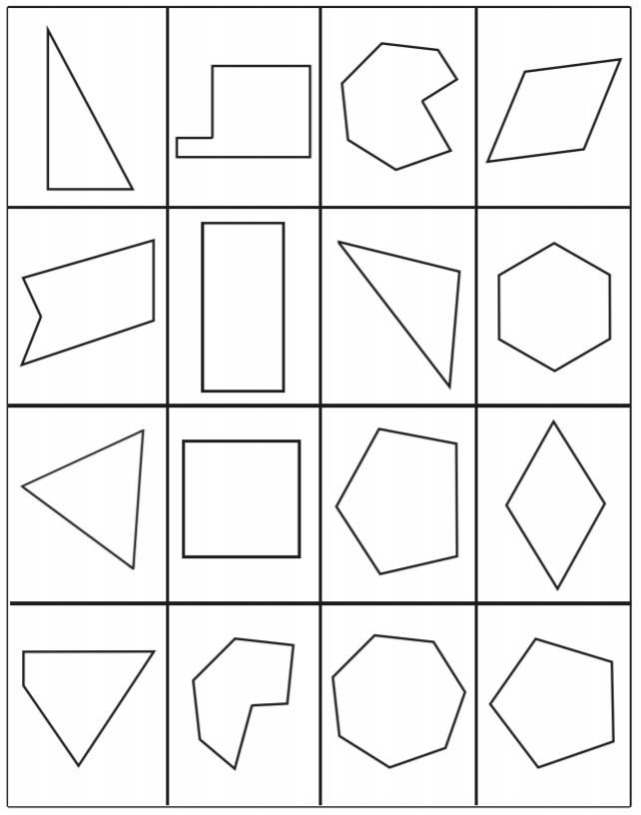

Maths Activity 2:Sort the following shapes into the below Carroll Diagram

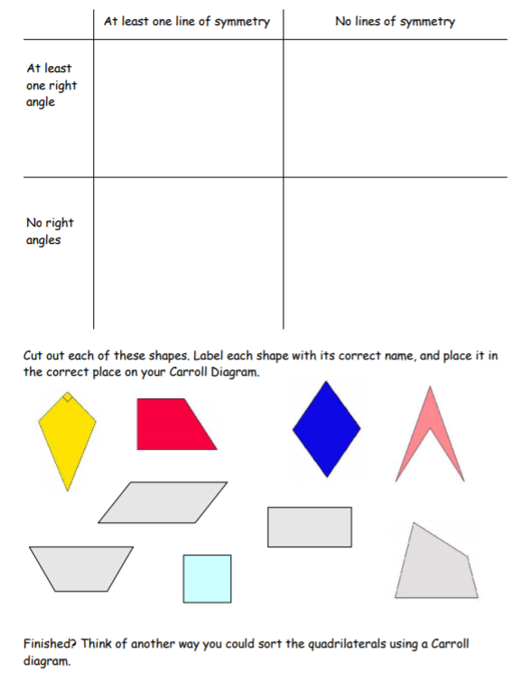
Maths Activity 3: Complete the symmetrical figures using the indicated line of symmetry.
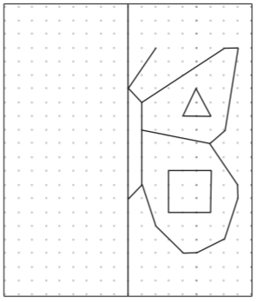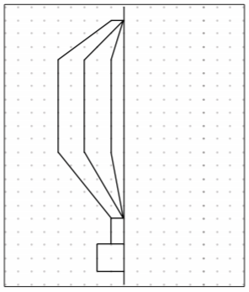
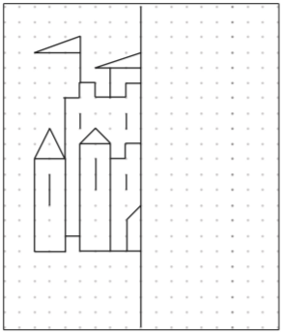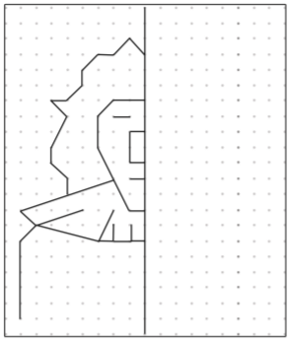
Design your own shape using lines of symmetry:

