Physical Education Project

This week we will be looking at physical education for our project. You will need to complete as many of the PE at home games as possible then design your own PE game.

Knowledge Building:
Give the following activities a go. Below each of the instructions is a video link that has a demonstration of how to complete the activity.

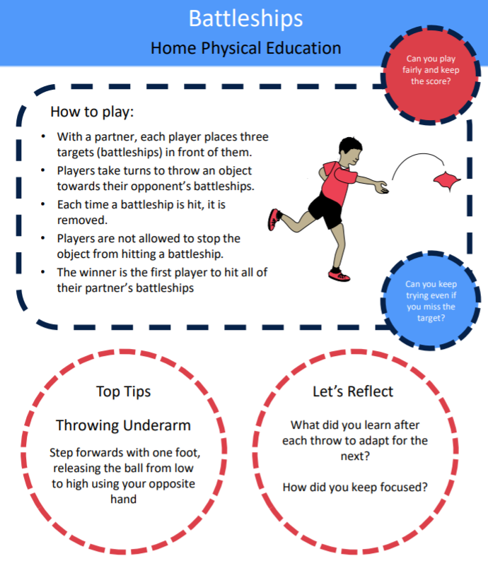

https://www.youtube.com/watch?v=ltZDzlEeP_4&list=PLnwoPgo24bhmqV8Y76iXnwYw9T9AlxbqJ&index=4&t=0s
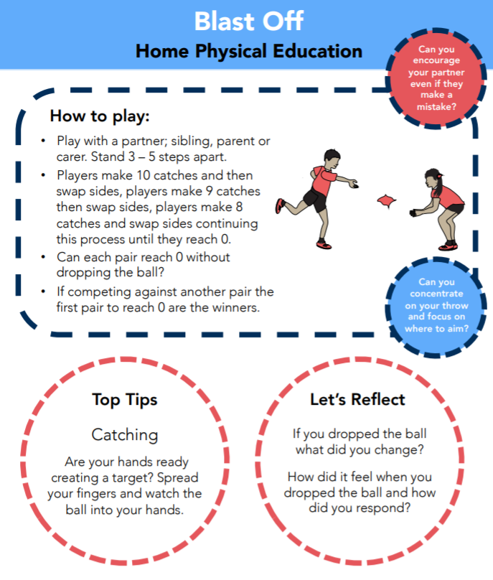
https://www.youtube.com/watch?v=lLBI5KvarD8&list=PLnwoPgo24bhmqV8Y76iXnwYw9T9AlxbqJ&index=24&t=0s

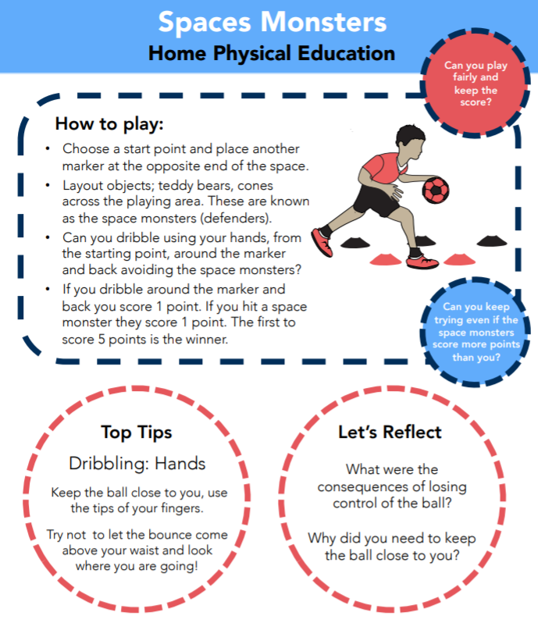
https://www.youtube.com/watch?v=Wj0RwCe2uxM
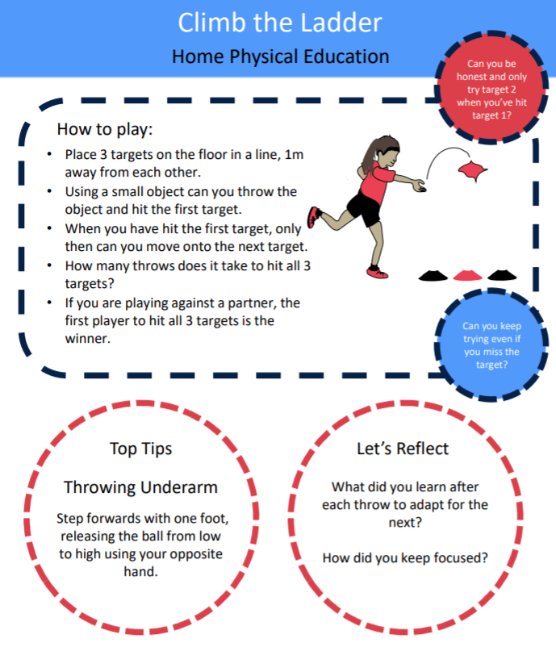
https://www.youtube.com/watch?v=tDKKTWrIyUY&list=PLnwoPgo24bhmqV8Y76iXnwYw9T9AlxbqJ&index=6&t=0s

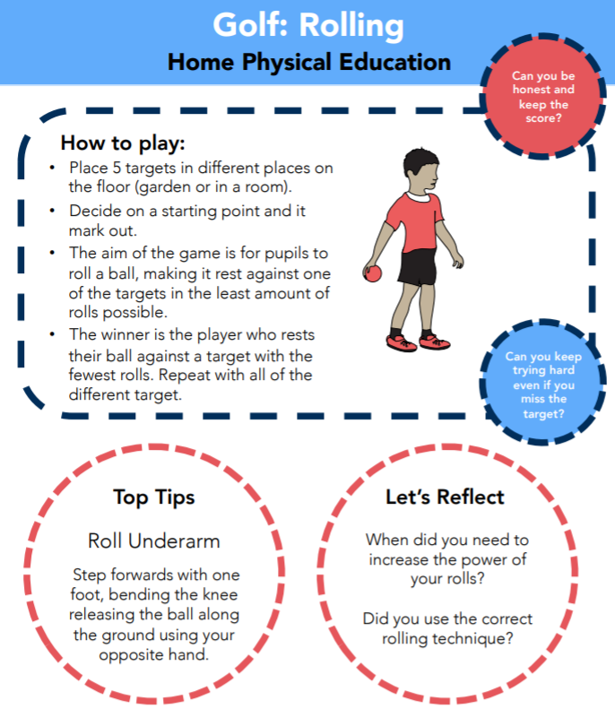

https://www.youtube.com/watch?v=Loyh6M01S7k
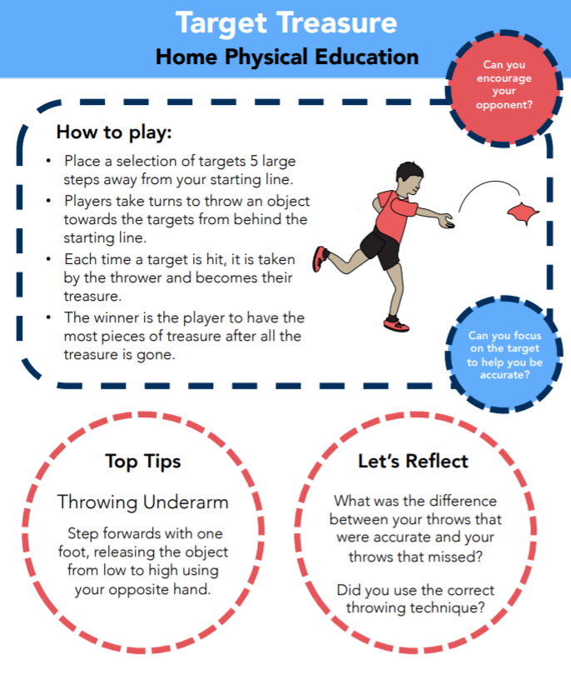
https://www.youtube.com/watch?v=N9XU5YKLbx8&list=PLnwoPgo24bhmqV8Y76iXnwYw9T9AlxbqJ&index=32&t=0s
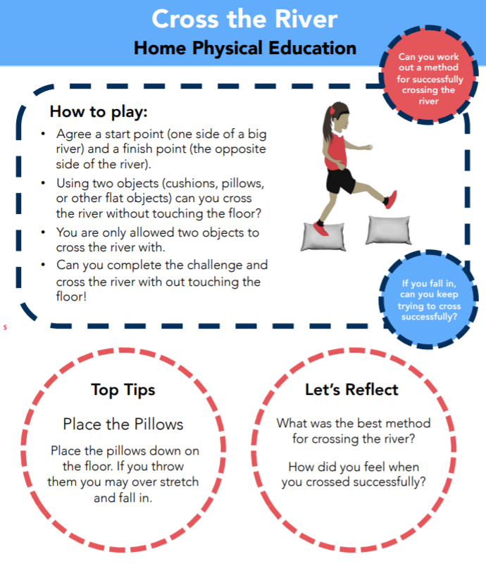
https://www.youtube.com/watch?v=xp5ClsXs-b8&list=PLnwoPgo24bhmqV8Y76iXnwYw9T9AlxbqJ&index=8&t=0s

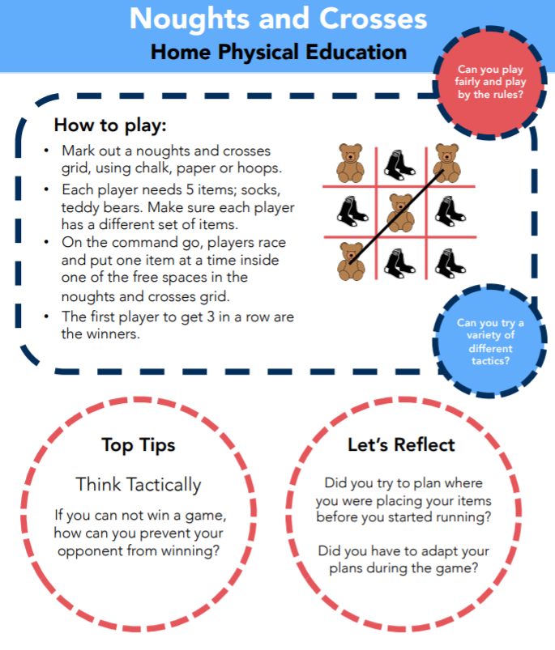

https://www.youtube.com/watch?v=EG4ju1KmG0g&list=PLnwoPgo24bhmqV8Y76iXnwYw9T9AlxbqJ&index=40

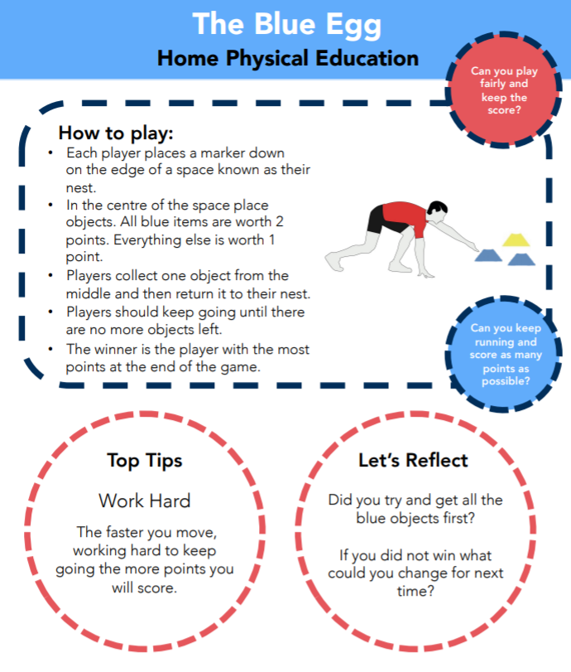

https://www.youtube.com/watch?v=8E3ZHUGKek8&list=PLnwoPgo24bhmqV8Y76iXnwYw9T9AlxbqJ&index=19&t=0s

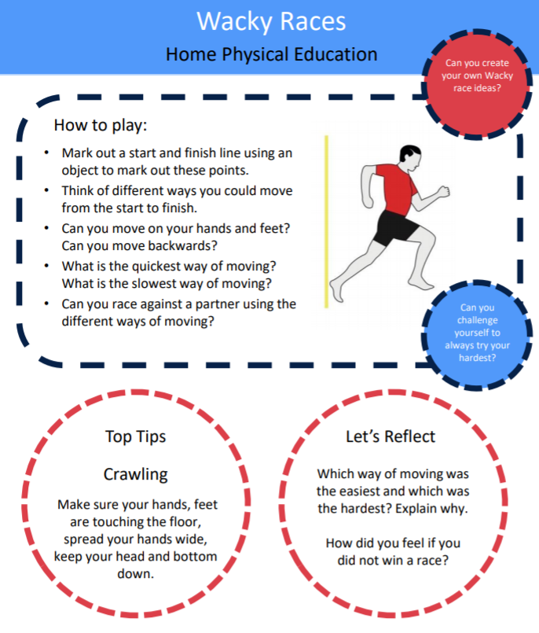
https://www.youtube.com/watch?v=juEOiVZgW84&list=PLnwoPgo24bhmqV8Y76iXnwYw9T9AlxbqJ&index=35&t=0s

Project Task:
Design your own PE from home activity.
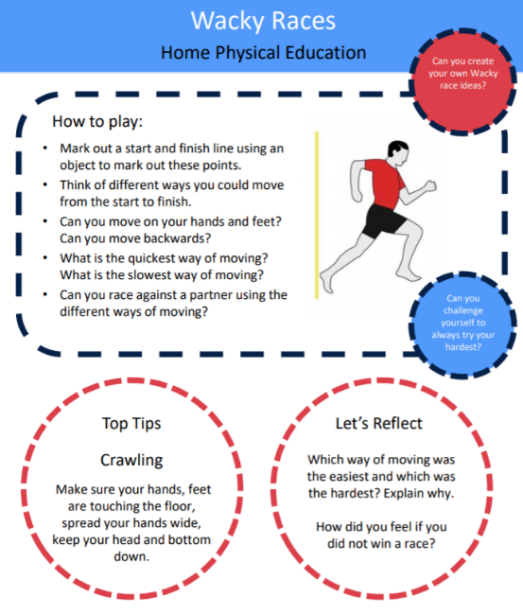
You will need to design a game that uses skills such as throwing, running, catching, kicking etc.

You will need to create an instruction guide for your game that includes a how to play section, top tips section and a lets reflect section (like the guide to the left).

You will need to film a how to play instructional video such as the one linked below. https://www.youtube.com/watch?v=ltZDzlEeP_4&list=PLnwoPgo24bhmqV8Y76iXnwYw9T9AlxbqJ&index=3

Remember to get creative and think outside the box!

