The Iron Man Reading Activity
Chapter 4
Read chapter 4 of The Iron man by Ted Hughes
(Available to download in this week’s learning activities)

Remember to answer directly from the text in full sentences. An example is provided:

Questions:
- At the start of page 22, what was the big news that everybody is talking about?

The big news that everyone was talking about is…..

- What would have happened if the star had hit the Earth at the speed it was travelling?

- What appeared to come out of the star on the fifth night?

- What did the the space-bat-angel-dragon want when it finally spoke?

- After the humans attacked the monster, how did it react? How do you think this made people feel?

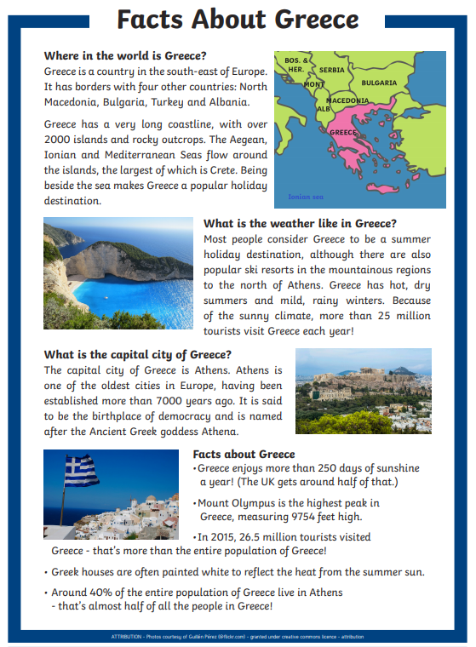

Greece Fact file questions:

- Where is Greece?

- Name the four countries that border Greece?

- What is the capital of Greece?

- How did Athens get its name?

- What is the highest mountain in Greece?

The Iron Man Reading Activity
Chapter 5
Read chapter 5 of The Iron man by Ted Hughes
(Available to download in this week’s learning activities)

Remember to answer directly from the text in full sentences an example is provided:

Questions:

- How was the Iron man transported to Australia? Why did they need to use this method?

- How did the space-bat-angel-dragon react to the Iron man’s challenge of strength?

- What was the Iron man’s challenge for the space-bat-angel-dragon?

- Describe what happened to the space-bat-angel-dragon after landing on the sun for the first time.

- Challenge: Find 3 interesting adjectives (adjectives describe nouns) that the author has used to engage the reader.

