Learning Objective:
We are learning to organise paragraphs around a theme.
Paragraphs are a collection of sentences. They are used in writing to introduce new sections of a story, characters or pieces of information. Paragraphs help readers to enjoy what has been written because they break the text up into easy-to-read sections.

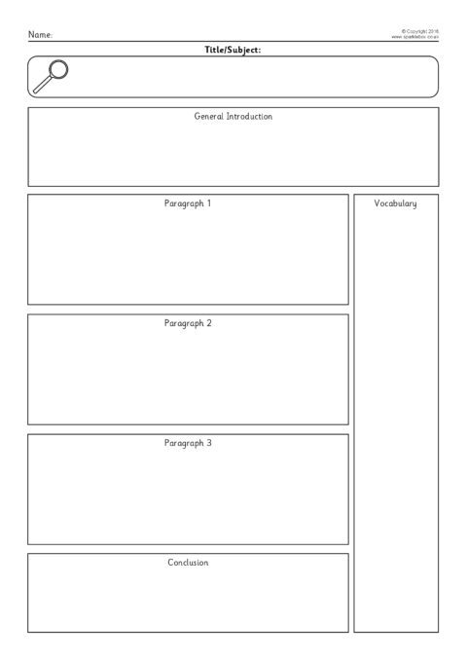
To support you with organising you paragraph, you can use tree map plan, a story map or the planning template below:
Writing task 1:

LO: We are learning to organise paragraphs around a theme.
Task: Write a creative story: For this piece of writing, we would like you to write an adventure story based on the video provided:
Link: https://www.literacyshed.com/spyfox.htmlStop at 2:52
Organise the story into paragraphs and complete the story using your own imagination.
Questions to support your writing:
Does Spy Fox save the world? If so, how?
What happens to Dr Hammer and his sardines?
How does he save Lily?
What happens when the countdown reaches 0?

- If you are unable to watch the video, please use the story starter and pictures below to help you create an adventure story.
Story Starter:
All is peaceful on the Southern ocean as the penguins relax on their icebergs. As the penguins float joyfully, a piercing red laser beam surges towards them. Dr Hammer- and his evil crew of sardines- are testing their weapons of mass destruction, in a plot to destroy the world.
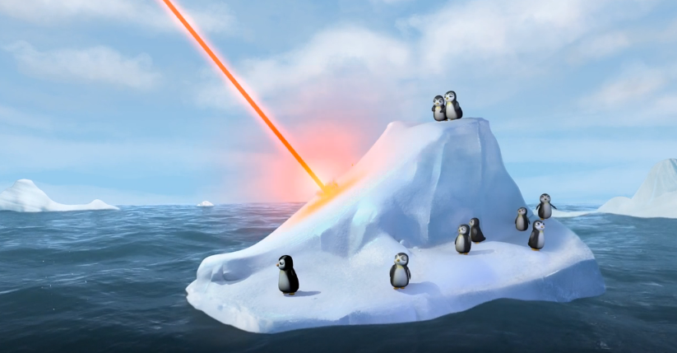
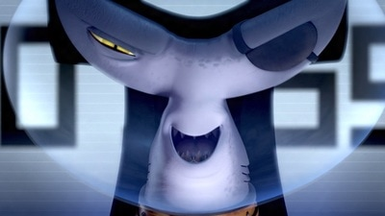
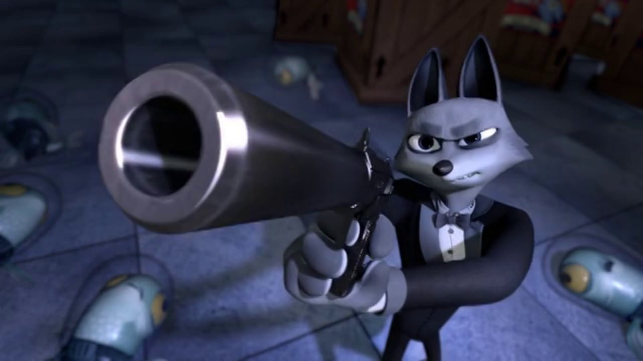

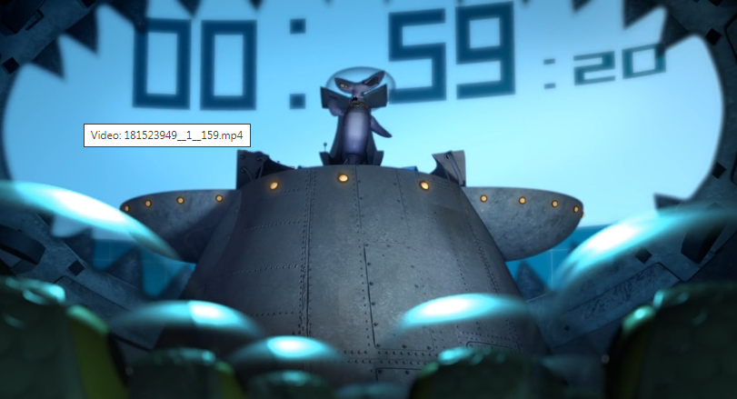

Writing task 2:

LO: We are learning to organise paragraphs around a theme.
Task: For this task, we would like you to write a letter to a family member or friend of your choice; this can be someone you have missed over the last couple of months or someone you speak to regularly.

Checklist for a letter:
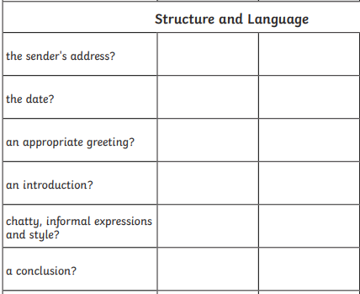
*Remember to organise the themes of your letter in paragraphs

What you could include:
- An introduction explaining why you are writing the letter
- A section about the individual you writing to (what do you miss? What do you want to know?) .
- A section detailing the fun activities you have been doing
- A section about learning from home
- A conclusion (what would you like to happen in the future?)

Writing task 3

LO: We are learning to organise paragraphs around a theme.
Task: This week our project learning is PE focused. For your last writing task, we would like you to create a PowerPoint presentation, poster or fact file about a famous athlete of your choice.
List of potential athletes:
Mo Farah Usain Bolt Ellen MacArthur Linford Christie
Jessica Ennis David Beckham Sir Steve Redgrave Lewis Hamilton
Questions to answer:
Who are they? Where were they born?
What sport do they play?
Who were their family?
How did they become a sports star?
What are they most famous for?
What is their personality like? What traits to people admire?


Please remember to plan your learning and organise your themes into paragraphs. As this is a non-fiction piece of writing, you may decide to use subtitles to make it clearer for the reader.

