- William ____________ as he walked down the street.
Words which contain a silent letter t

Use these words to complete the sentences below…
Glisten, castle, fasten, rustling, listen, whistled, soften, whistle
Have a dictionary or access to the internet nearby so that you can check the meaning of the words to fit them into the sentences below!
Year 5 – Week 3 - Spellings
- ____________, can you hear the mouse?
- She heard the leaves ____________ in the wind.
- If you buy this product it will ____________ your clothes.
- Ed looked up to see the ____________ on the hill.
- Moana saw the sea __________ in the sunshine.
- Make sure you ____________ your seatbelt when you board the plane.
- The dog responded when you blew the ____________.
Write a paragraph using as many silent t words as you can! Try and make it as silly as possible!
CHALLENGE – Use a different suffix to change the word (e.g. listen – listener or glisten – glistening)

Spelling, Grammar and Punctuation Challenge Tasks:
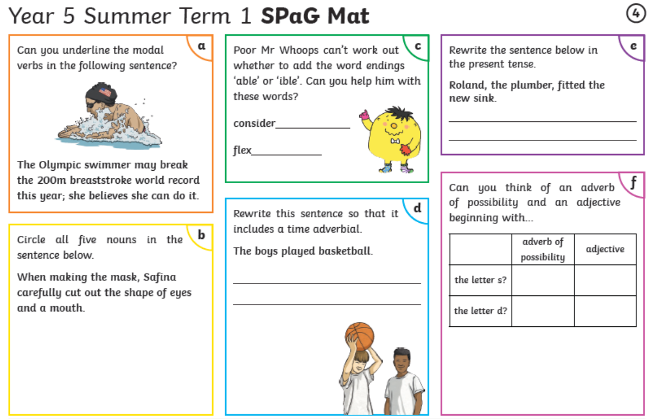
Year 5
Reading Activity – Week 3
LO: We are learning to retrieve information from a non-fiction text.
You might have noticed in the news that there have been anti-racism protests happening all over the world. Your reading today is based on a non-fiction piece of writing on Martin Luther King Jr. He was a social activist that played a key role in the American civil rights movement over 70 years ago. Please read the non-fiction text and then answer the questions below.
- What profession was Martin Luther King Jr.’s father?

- What were the aims of the African-American civil rights movement?

- Find and copy one word that means separation based on race.

- Why do you think the protestors chose to travel towards the Lincoln Memorial during the Washington DC march? Use evidence from the text to support your answer.

- What was Martin Luther King Jr.’s dream? Use evidence from the text to support your answer.

- What do you think Martin Luther King Jr. meant when he said that he hoped his children ‘…will not be judged by the colour of their skin but by the content of their character.’

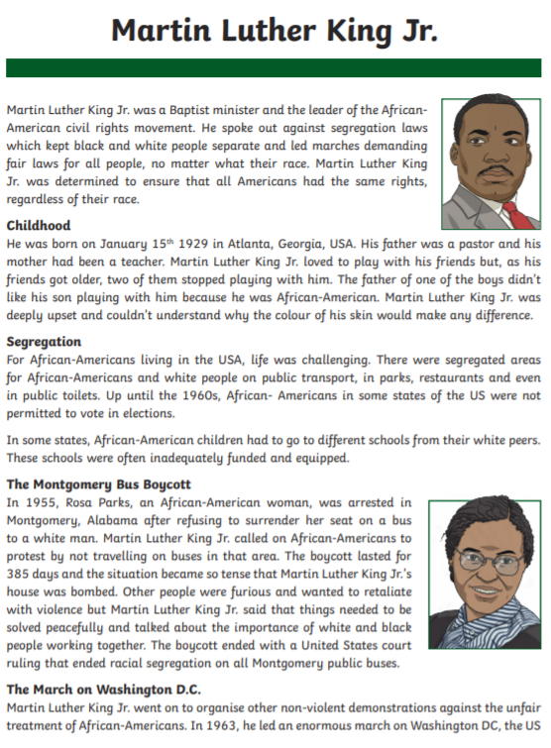

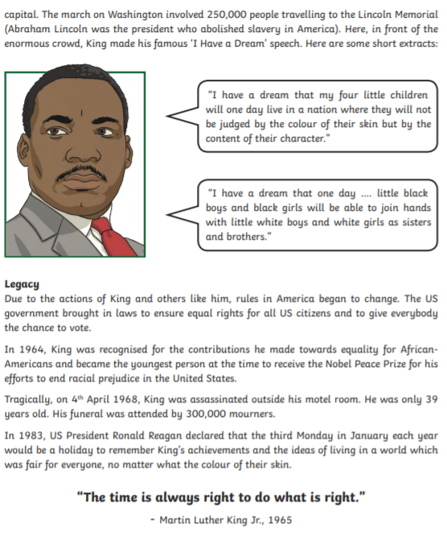

Year 5
Writing Activity – Week 3
Learning Objective:
We are learning to write narratives, describing settings, characters and atmosphere.

If we were all still at school, it would have been Sports Day this week! Because of this, the writing this week is to create a short story based on you/ a character running your/ their Sports Day race.

Ideas of events to include in your plan:
Waiting to race
Approaching the line
Standing on the line
Race starts
End of the race

Remember to really slow down your story, there are only a few events, but try to describe the characters and create atmosphere. Choose a sentence starter below to start your short story:

- The piercing hot rays of the sun beaming down on the crowd of participants...

- A crowd of anxious children stood under the marquee, knowing that their name would soon be called…

- All eyes were fixed on the finish line, I waited for my name to be called…

- Gulping my water down, I looked around, eyeing up my competition…

- The sound of children stampeding across the earth like raging bulls filled the air, she was bellowing cheers of luck, excited to have her chance to run.

Vocabulary – fill in the vocabulary table with idea of figurative language, phrases and great vocabulary to use before you start writing!

Participants | Anxious | Smooth green grass
Colossal crowd | Tense mood | Nervous racers
Thirst-quenching | Curled brown hair | Green and white patterned floor
Knees bent at the starting line | Running like a cheetah | T-Shirt blowing in the wind
victory | Threw my arms up and cheered | Sizzling sun

