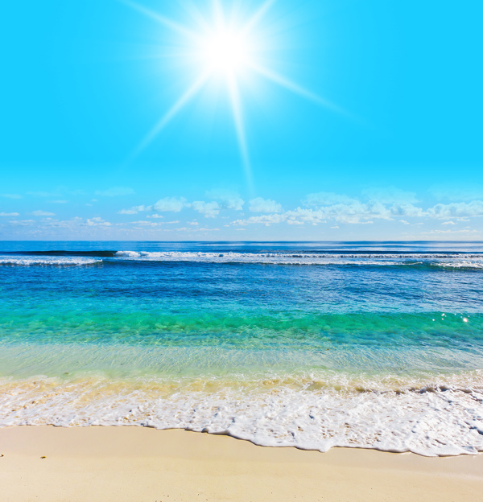
Vocabulary to appeal to the reader and bring the scene alive
What other precise words could you include?
clouds floating warmth of the rays sand as soft as …., grains transparent
abandoned tranquil lapping waves foam shore
illuminate dazzling beaming turquoise
Questions to help plan the writing. Don’t forget to include conjunctions!
What time of day is it? What happened before? What will happen next? What is on the sand behind the photographer? Why is it quiet? What sounds can be heard and why? What would the people be wearing and why?

