We are learning to multiply using arrays.
Please look at the ‘Progression in calculation for multiplication and division’ document and watch Mrs Hartshorn’s video before having a go at this activity – it has been quite a long time since we have done multiplication!
Remember: = means equal to or the same as.
2 x 4 is the same as 4 x 2. That is what 2 x 4 = 4 x 2 means – it looks much trickier than it is, so don’t let it confuse you! If it helps, just hide the second part of the calculation (so that you can only see 2 x 4)

Part 1:
Find and tick the array that shows 2 x 5 (or 5 x 2!)

Find and tick 2 x 4 = 4 x 2

Find and tick 3 x 2 = 2 x 3

_____________________________________________________
Part 2:
Complete the number sentences to describe the arrays.

5 x 3 = ___ x ___ 2 x 6 = ___ x ___

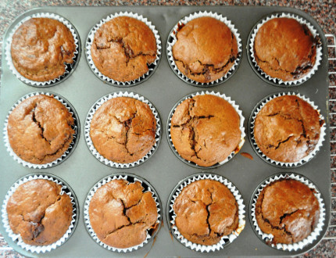

___ x ___ = ___ x ___
___ x ___ = ___ x ___

_____________________________________________________

Part 3:
Draw an array to show:
3 × 5 = 5 × 3

2 lots of 10 = 10 lots of 2

Challenge: Use 6 toys, pencils or snacks, how many arrays can you create? Draw them below.

Once you have created your array complete the calculations:

___ x ___ = ___ x ___

___ x ___ = ___ x ___
___ x ___ = ___ x ___
___ x ___ = ___ x ___
We are learning to divide by sharing equally.
Part 1:
Share (or divide!) these sweets into 5 equal groups. Show your working by using the empty boxes to help you. You may like to use real sweets and move them physically into 5 equal groups.

20 ÷ 5 =

Share these bananas into 2 equal groups:
12 ÷ 2 =

Share these cakes into 10 equal groups:
20 ÷ 10 =

Share these cherries into 5 equal groups:
5 ÷ 5 =

_____________________________________________________

Part 2 (see the next page):

A Perfect Picnic!
Miss Glaves, Mrs C, Mrs Edwards and Mrs Croxford are planning a picnic for when the lockdown is over! Can you work out how much food we’ll get each if we share it equally between us? Draw the food on our plates and fill in the sentences below.
Mrs Edwards
Mrs C
Miss Glaves
Mrs Croxford
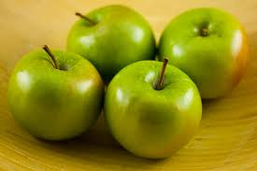
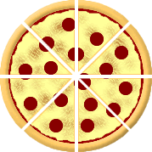
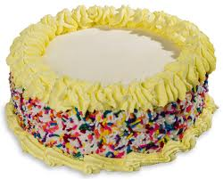
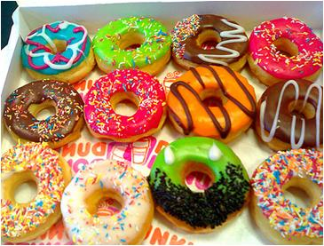
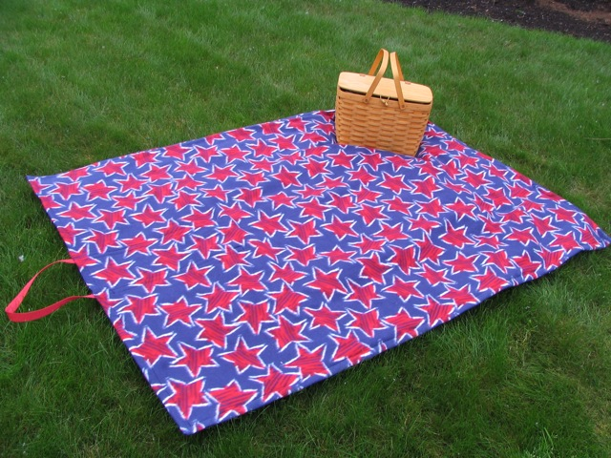
Pizza Slices
There are ______ pizza slices altogether.
I share them between 4 people.
Each person gets ________ slices.
Apples
There are ______ apples altogether.
I share them between 4 people.
Each person gets ________ apple.

Cake (you will need your knowledge of fractions to help you with this one!)
There is ______ cake altogether.
I share it between 4 people.
Each person gets ________ cake.
Doughnuts
There are ______ doughnuts altogether.
I share them between 4 people.
Each person gets _______ doughnuts.
Part 3:
Now it’s time to plan your own picnic! This time it’s for you and 2 friends (3 people altogether). Fill in the sentence boxes first, then draw your picnic. You can choose what food to have! You may need practical resources to help you with this activity.
Food: _________

There are 6 ________ altogether.
I share them between 3 people.
Each person gets ___ __________.
_________

There are 3 ________ altogether.
I share them between 3 people.
Each person gets ___ __________.

_________

There are 12 ________ altogether.
I share them between 3 people.
Each person gets ___ __________.
_________

There are 9________ altogether.
I share them between 3 people.
Each person gets ___ __________.

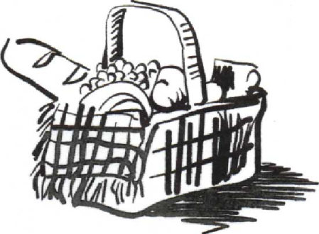

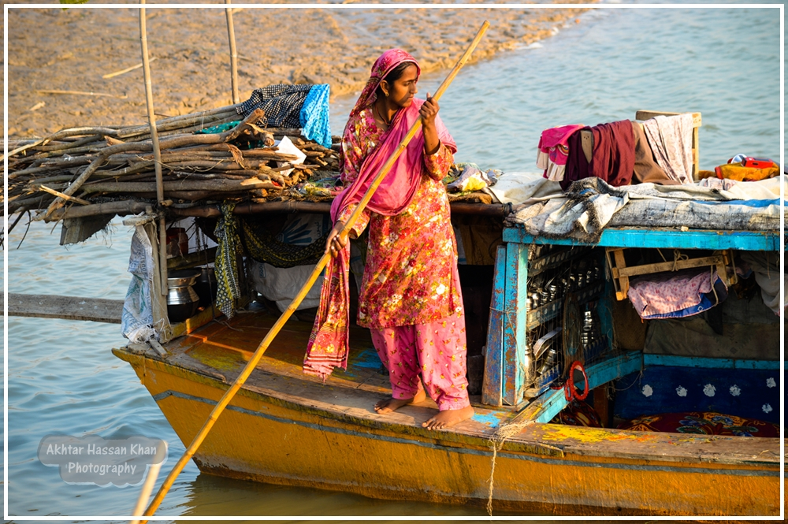
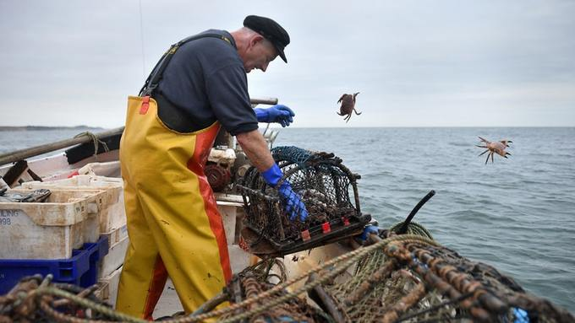
Writing – photographs to support character profiles.
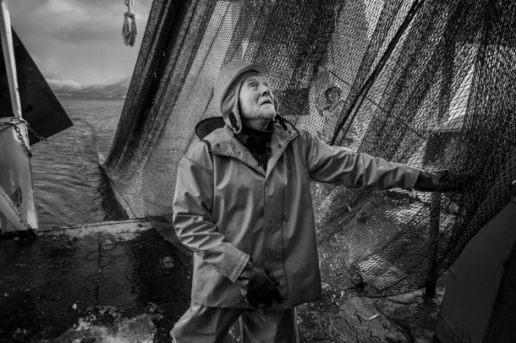
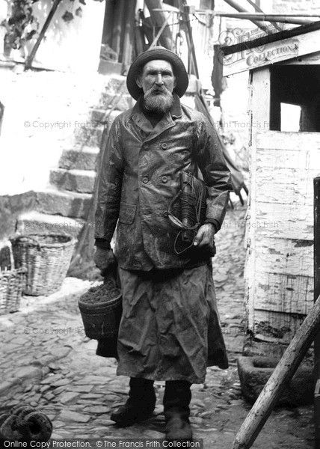
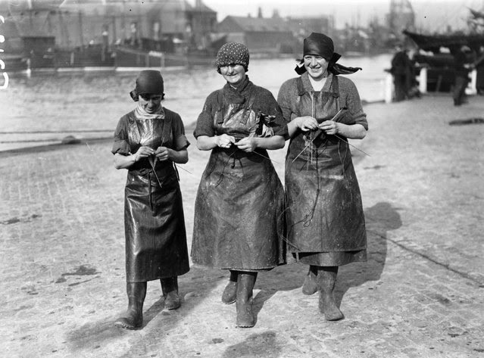
a  adorable  athletic  ambitious  amusing  ancient | b  brave  bright  bold  busy  beautiful | c  calm  charming  cheerful  cunning  courageous  creepy  clever | d  dashing  dazzling  devilish  delightful  determined  diligent  dedicated | e  eager  enchanting  energetic  entertaining  enthusiastic  excellent  excited  exhausted | f  fabulous  fair  fantastic  fearless  friendly  funny | g  generous  gentle  glorious  grumpy  gorgeous  gloomy
h  happy  helpful  hilarious  honest  hardworking | i  important  imaginative  independent  intelligent | j  jolly  joyful  jealous | k  kind  kind-hearted  knowledgeable  keen | l  likeable  lively  lovely  loving  lucky  lonely | m  mature  mighty  merry  mischievous  mysterious | n  noble  naughty  noisy  neat
Adjectives – personality and character traits
o  organised  outgoing  old | p  peaceful  perfect  pleasant  productive  protective  pretty | q  quiet | r  responsible  relaxed  reliable | s  sensitive  silly  strong  smiley  splendid | t  talented  thoughtful  trustworthy  tall | u  unusual  upbeat  understanding  ugly
v  vicious | w  wise  witty  wonderful  weary | x | y  youthful  young | z  zany  zealous

Facts about Fishing and Fishermen
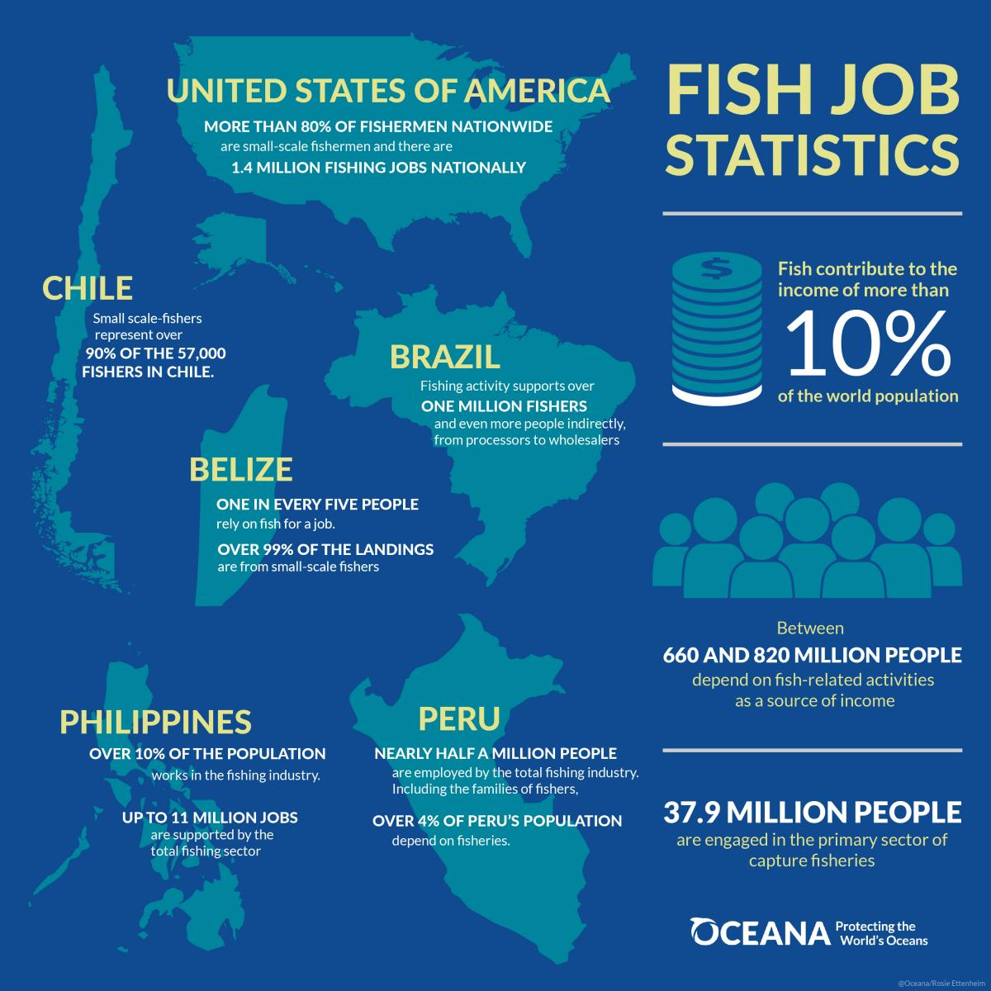
A fisherman or fisher is a person who catches fish, and sometimes other animals that live in water. Catching fish is known as fishing. There are about 38 million fishermen. Fishermen usually catch fish so that they can sell the fish to make money, or so that they can eat the fish. Some fishermen do not fish for money or food, and instead fish as a hobby.
