The Beatles
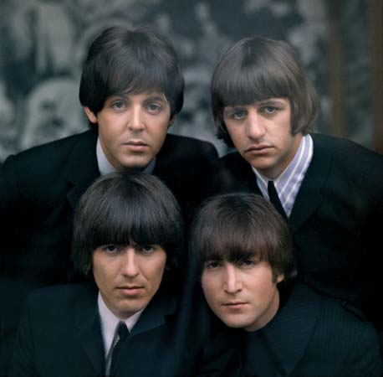
The Beatles were one of the most successful and influential pop-music groups of the 1960s. This quartet of British musicians were: rhythm guitarist John Lennon (October 9, 1940–December 8, 1980); bass guitarist Paul McCartney (born June 18, 1942); lead guitarist George Harrison (February 25, 1943–November 29, 2001); and drummer Ringo Starr (originally Richard Starkey; born July 7, 1940).

Lennon formed a band in Liverpool, England while in high school in the mid-1950s. McCartney and then Harrison joined the group in the late 1950s. In its early years the band also had several other members. In 1962 they signed a recording contract with a large music company. At about this time they chose Starr to replace drummer Pete Best.
At first, the Beatles’ songs were upbeat and fairly simple. The first song recorded by the Beatles was “Love Me Do” in 1962. Their first hit came the following year, when “Please Please Me” climbed to the top of the British music charts

The Beatles became very famous in Britain. People started calling the excitement over the band ‘Beatlemania’. The Beatles became wildly popular in the United States too after appearing on Ed Sullivan’s television program in February 1964. Teenage girls across the country screamed and fainted over them, and boys copied the Beatles’ look. By April 1964 the top five hits in the United States were all Beatles songs.

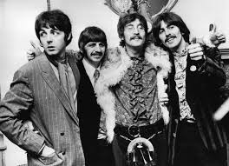
In the late 1960s the Beatles began creating more adventurous music, combining different musical styles. The album Sergeant Pepper’s Lonely Hearts Club Band (1967) showed a new complexity. The band also recorded the albums The Beatles (1968), Abbey Road (1969), and Let It Be (1970).
The pressures of fame led the Beatles to break up in 1970. All four continued their musical careers—Lennon with his wife, Yoko Ono; McCartney with the band Wings and later as a solo performer; and Starr and Harrison mainly as solo artists.

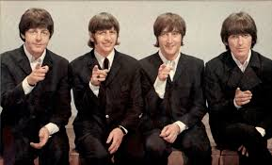

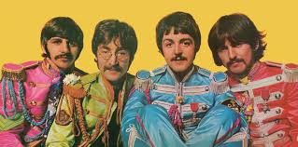

ABBEY ROAD STUDIOS
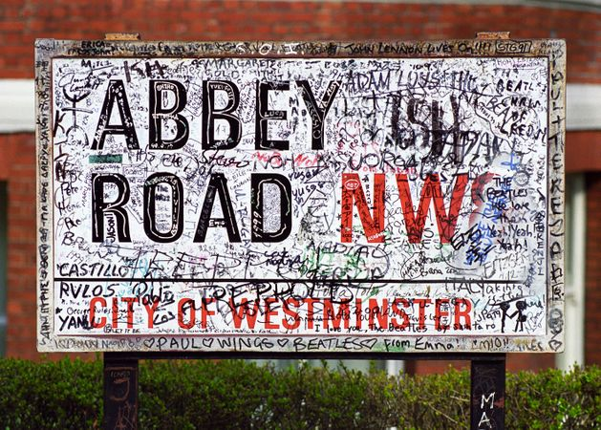
Abbey Road Studios was made famous because lots of bands and artists recorded there. It is in London. The Beatles recorded many of their songs there. Their eleventh album was called ‘Abbey Road’ and was released in September 1969.
The photograph below is one of the many iconic images of the band. Here they are walking across the zebra crossing outside Abbey Road Studios which is in St John’s Wood, London. You can visit it and try to recreate the image… be careful of the traffic though!!
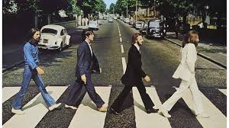

The Beatles got the idea for their name from Buddy Holly and The Crickets
The band liked the idea of using the name of an insect as a band name, and they were fans of Buddy Holly and the Crickets. Because John Lennon loved puns, he altered the spelling of “Beetles” to “Beatles”.

Paul McCartney and Ringo Starr were not the original rhythm section
A friend of John Lennon’s from art school, Stu Sutcliffe, handled the bass duties when the band was living and working in Hamburg, Germany during the early 1960s, while McCartney stuck to rhythm guitar.

The Beatles were nervous about playing Carnegie Hall
When the Beatles toured in the United States, Beatlemania ensued everywhere they performed. However, when they were booked to play at the prestigious Carnegie Hall in New York City, they were scared that the audience might be made up of stuffy older people who would look down on their rock and roll.

Famous Beatles Songs
The Beatles made over 112 songs and 17 number one singles. So many of their songs have become anthems in people’s everyday lives.
Below is a list of just some of their hits:
Hey Jude
Here Comes the Sun
Come Together
Something
A Day in the Life
Twist and Shout
While My Guitar Gently Weeps
Blackbird
Eleanor Rigby
Yellow Submarine
Don’t Let Me Down
Penny Lane
Lucy In the Sky with Diamonds
The Long and Winding Road
Let it Be
Help!
I am the Walrus
Strawberry Fields Forever
Get Back
Ob-La-Di, Ob-La-Da
If you have access to an online music library, youtube or other music sources then please ask your parent/guardian’s permission and have a go at listening to some Beatles songs.
I bet you know more of them than you realised!
If you would like to learn your favourite Beatles song then please do, record it if you like and send it in to me at:
learning.saxon@lumenlearningtrust.co.uk
I have recorded one of my favourite Beatles songs for you to listen to. If you would like to learn it then that would be great. Then when we are all back together we can learn it properly and sing it!
Check the Saxon Learning drop down and you will see the song there.

The lyrics to Let It Be are below:
When I find myself in times of trouble, Mother Mary comes to me
Speaking words of wisdom, let it be
And in my hour of darkness she is standing right in front of me
Speaking words of wisdom, let it be
Let it be, let it be, let it be, let it be
Whisper words of wisdom, let it be
And when the broken-hearted people living in the world agree
There will be an answer, let it be
For though they may be parted, there is still a chance that they will see
There will be an answer, let it be
Let it be, let it be, let it be, let it be
Yeah, there will be an answer, let it be
Let it be, let it be, let it be, let it be
Whisper words of wisdom, let it be
Let it be, let it be, let it be, yeah, let it be
Whisper words of wisdom, let it be
And when the night is cloudy there is still a light that shines on me
Shine until tomorrow, let it be
I wake up to the sound of music, Mother Mary comes to me
Speaking words of wisdom, let it be
Let it be, let it be, let it be, yeah, let it be
There will be an answer, let it be
Let it be, let it be, let it be, yeah, let it be
There will be an answer, let it be
Let it be, let it be, let it be, yeah, let it be
Whisper words of wisdom, let it be

Use the following piece of music to practise your note learning. Look at the notes, the note names are on there for you. Look, learn and remember where they sit on the stave.
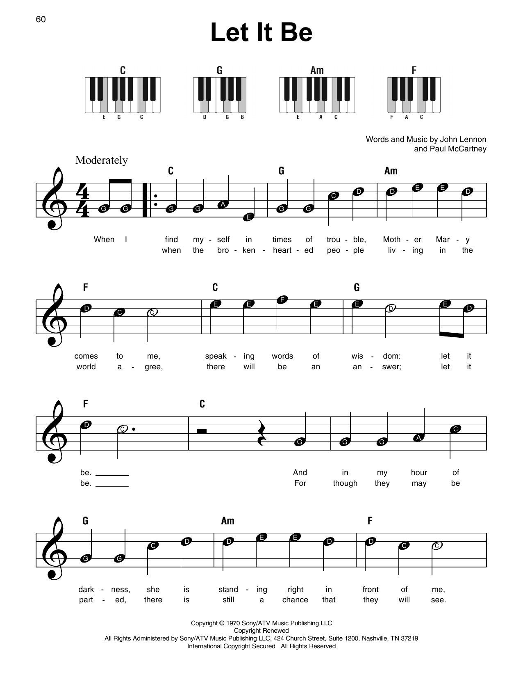

Every Good Boy Deserves Fish
F A C E
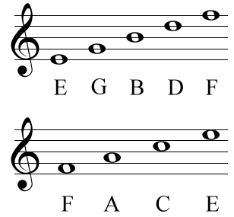

A little Beatles Quiz for you and your lockdown family!
Who were the Beatles?
A: The Beatles were an English rock band, formed in Liverpool in 1960.
What were the names of the members?
A: John Lennon, Paul McCartney, George Harrison and Ringo Starr.
The Beatles became widely regarded as the foremost and most “what" of the rock era?
A: Influential act.
From 1960 to 1963, where did the Beatles build their reputation?
A: Playing clubs in Liverpool and Hamburg.
The core of Lennon, McCartney and Harrison went through a succession of what?
A: Drummers.
During that period who was their bass player?
A: Stuart Sutcliffe
Who was the Beatles’ manager?
A: Brian Epstein.
Who was their producer?
A: George Martin.
What was their first hit in the United Kingdom?
A: "Love Me Do".
What nickname did they acquire at that time?
A: "the Fab Four".

