**Activity 1: Puzzles**

Have a go at these puzzles and then try to explain your reasoning and thinking in a paragraph.

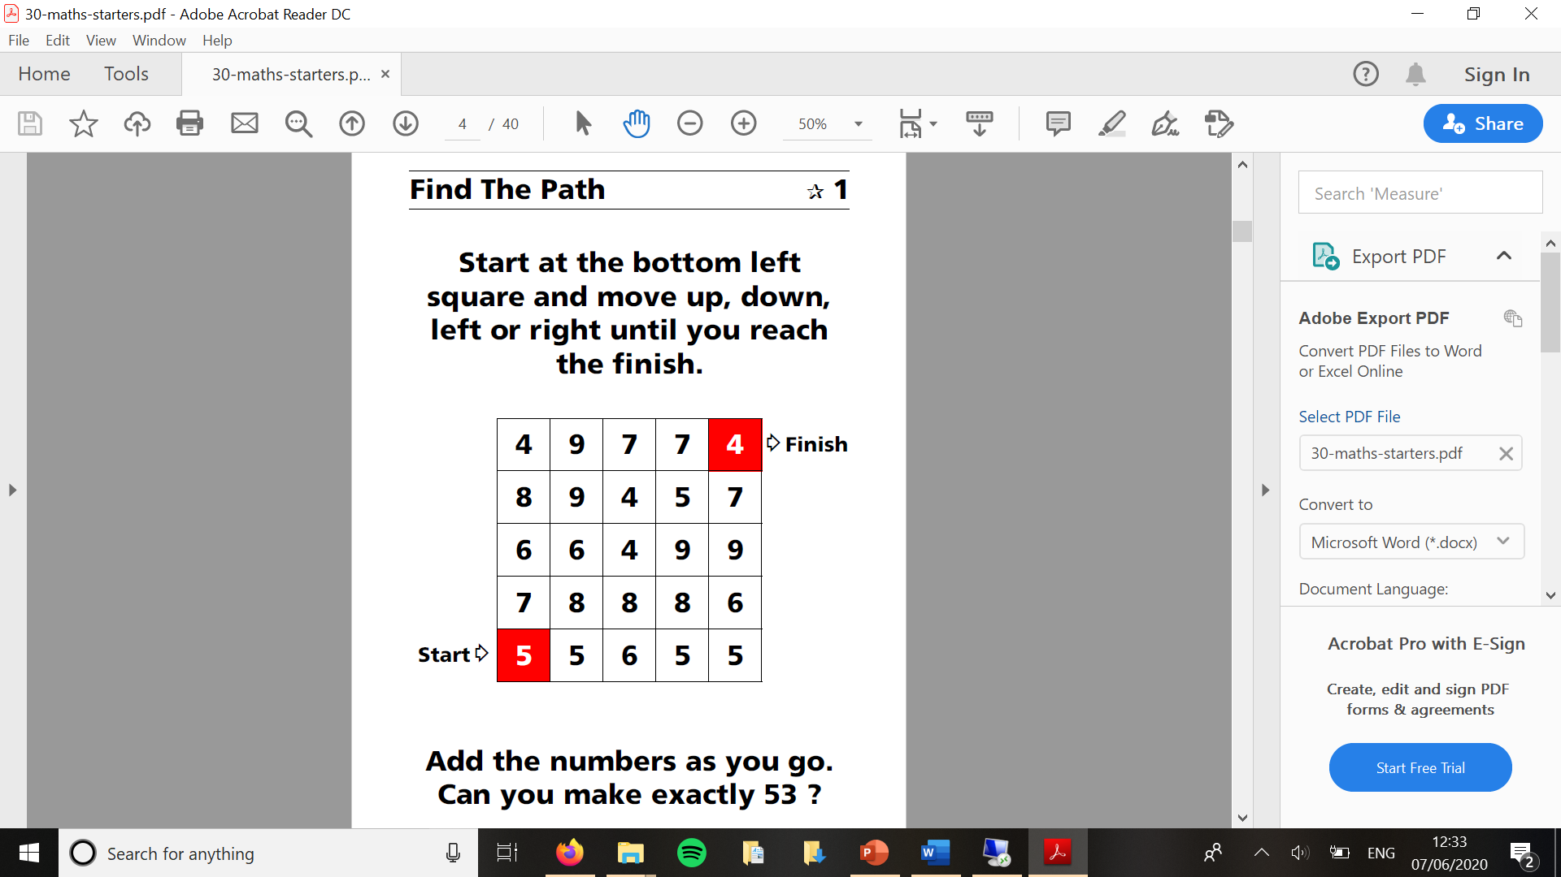

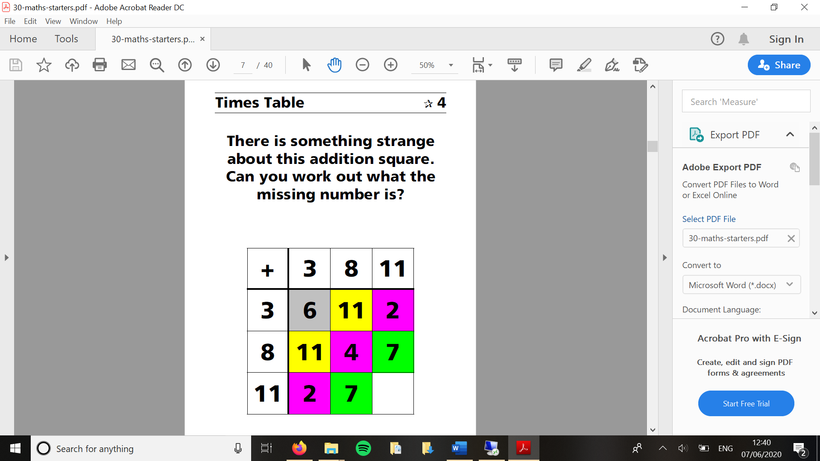

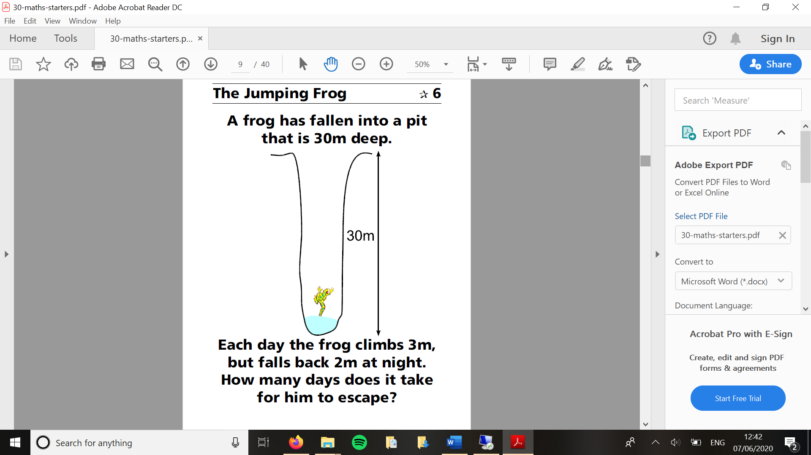**Activity 2: Ring a Ring of Numbers**

Here is a picture of four numbers placed in squares on a circle so that each number is joined to two others:

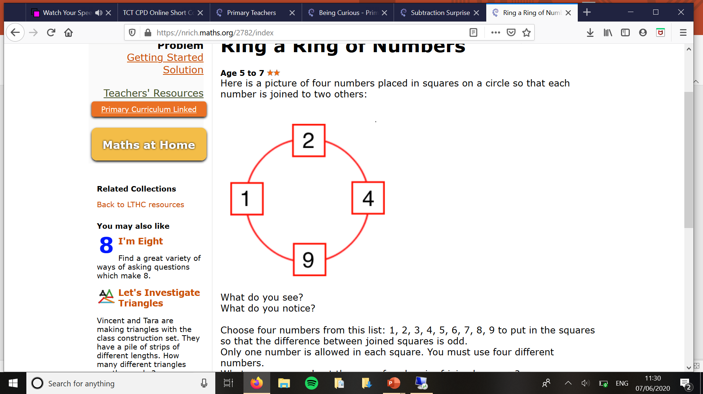

* What do you see?
* What do you notice?

**Task**

* **You can use the templates on the next page to record your working out**
* **Choose four numbers from this list: 1, 2, 3, 4, 5, 6, 7, 8, 9 to put in the squares so that the difference between joined squares is odd.**
* **Only one number is allowed in each square. You must use four different numbers.**
* *What can you say about the sum of each pair of joined squares?*
* *What must you do to make the difference even?*
* *What do you notice about the sum of the pairs now?*

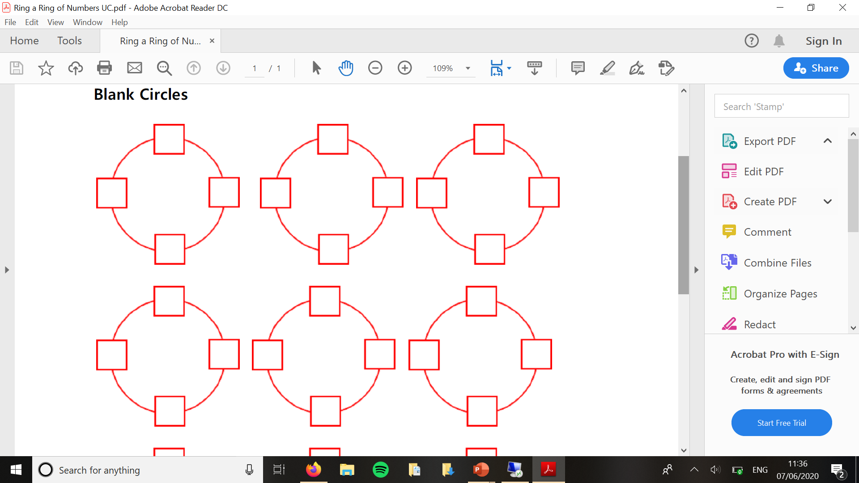



**Activity 3: Reach 100**

Here is a grid of four "boxes:

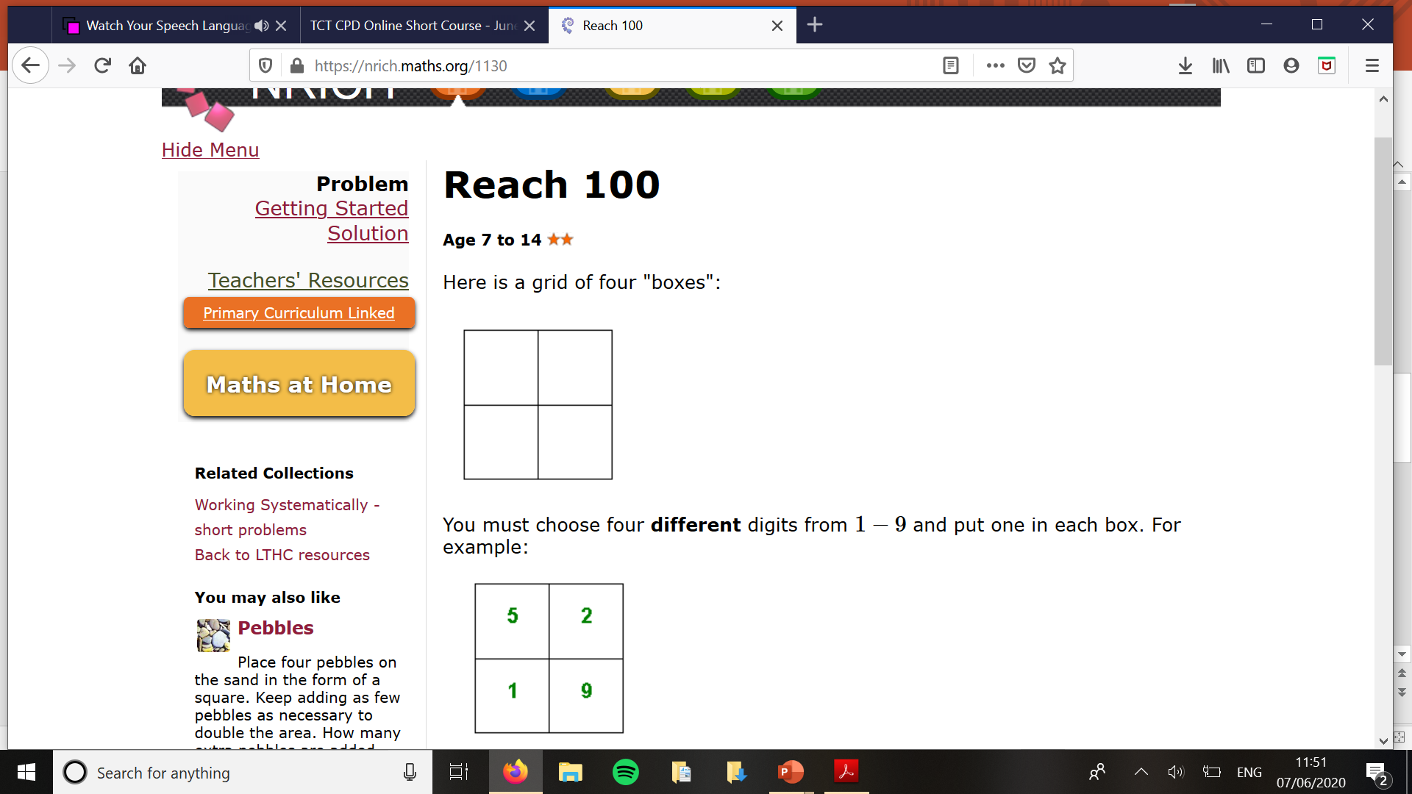

You must choose four different digits from 1−9 and put one in each box.

***For example:***

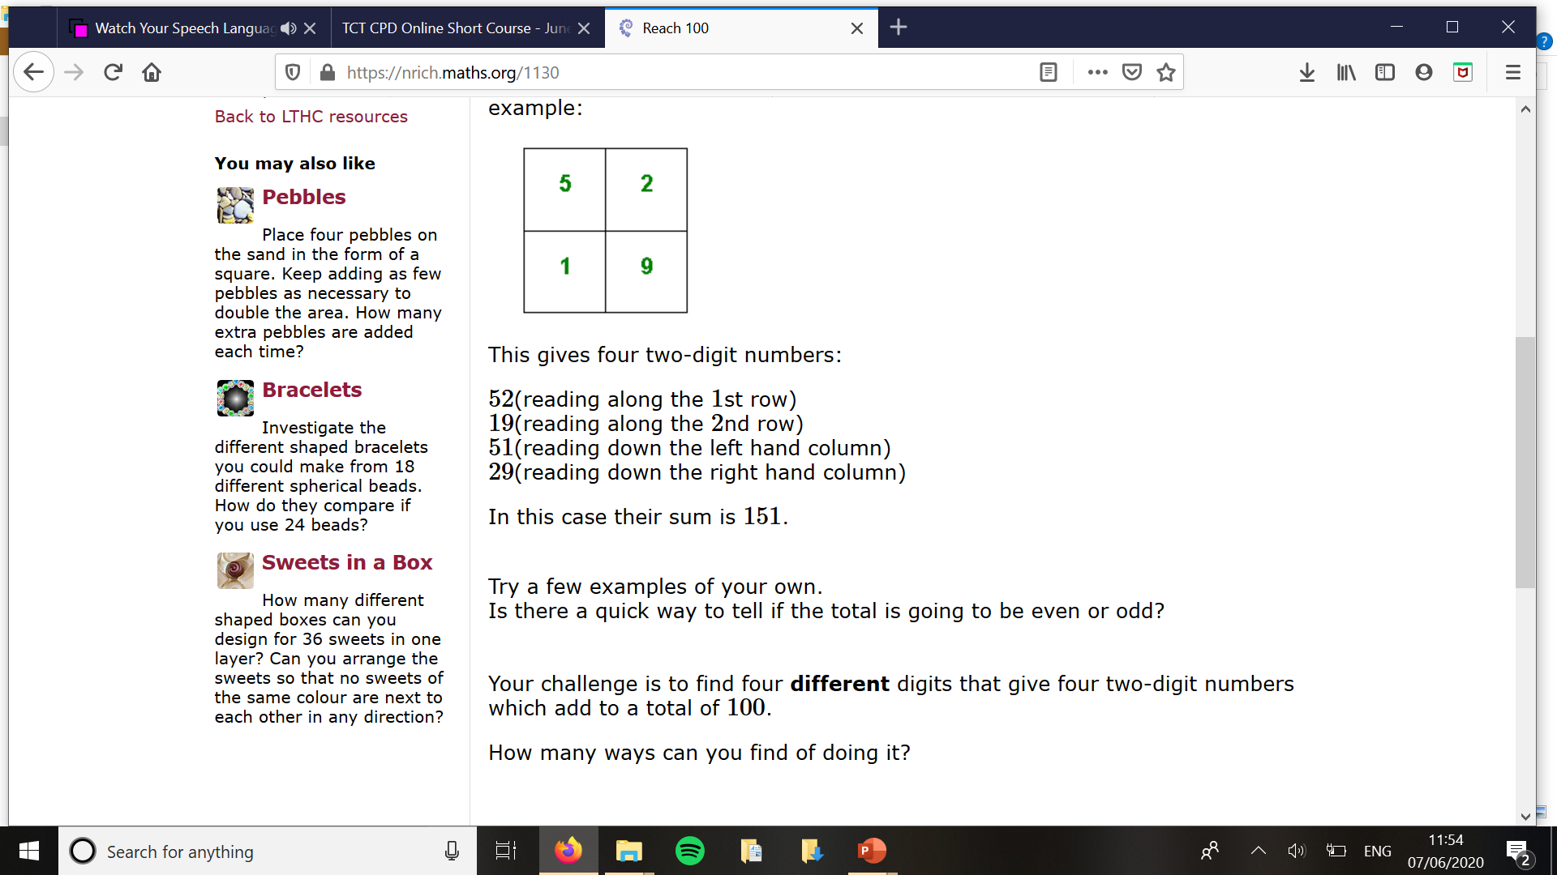

This gives four two-digit numbers:

|  |  |
| --- | --- |
| 52 | (reading along the 1st row) |
| 19 | (reading along the 2nd row) |
| 51 | (reading down the left hand column) |
| 29 | (reading down the right hand column) |

In this case their sum is 151.

**Try a few examples of your own.**

Is there a quick way to tell if the total is going to be even or odd?  
  
Your challenge is to find four **different** digits that give four two-digit numbers which add to a total of 100.

How many ways can you find of doing it?

**Activity 4: Ice Cream Investigation**



The ice cream stall sells chocolate, peach, mint, lemon, strawberry and vanilla flavour.

**What combinations can be created for a double cone?**

Be sure to work systematically and record your solutions in an order.

**How will you know once you have found all the possibilities?**

**Activity 5: Sticks Investigation**

See if you can work out the number of intersections for up to at least 10 sticks.